MyDispense Validation Exercise

User Guide

About MyDispense
MyDispense is an online pharmacy simulation that allows you to develop and to practise your dispensing skills. It provides a safe environment in which you may make mistakes without experiencing the serious consequences of practicing in the real world. For your maximum benefit use MyDispense as seriously as you would when dispensing medicines in real practice.
You will access a number of exercises, grouped into tutorials, each designed to support specific learning outcomes. At the end of each exercise you will receive feedback to indicate how well you did and to outline any mistakes you might have made. You may also undertake marked assessment exercises in MyDispense.

An important note about Web browsers
MyDispense will run very well in all of the mainstream web browsers, however, we recommend that you use the Firefox browser for the best experience. Do not use Internet Explorer we recommend that you install another browser such as Firefox or Chrome - both of which are free to download and install. Internet Explorer is not supported by MyDispense.

The introduction Screen
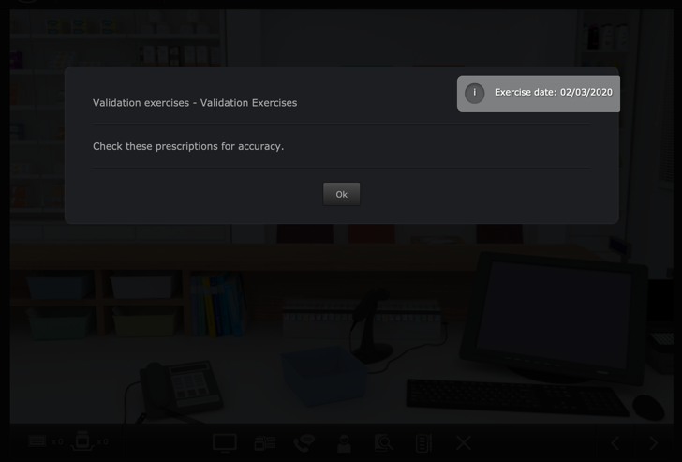
Once you have selected an exercise you will see the Introduction screen. This screen gives some background information and provides context for the exercise.
Click on the OK button to continue.
If you want to see the Introduction screen again just click on the i button in the top right corner of the screen as seen below.

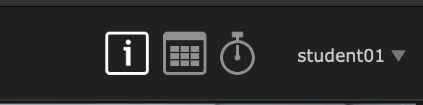

Exercise screen
The main exercise screen is the shopfront of a community pharmacy. You are working at a pharmacy and have been tasked to review prescriptions that are about to dispensed. Each prescription is in its own basket in the pharmacy and can contain the medications, labels and ancillary labels that are about to be dispensed.
You will review each basket you have been given and decide if the items that are to be dispensed are correct or if there is a problem with them. The dispense baskets can be found in on the left side of the pharmacy underneath the counter.
=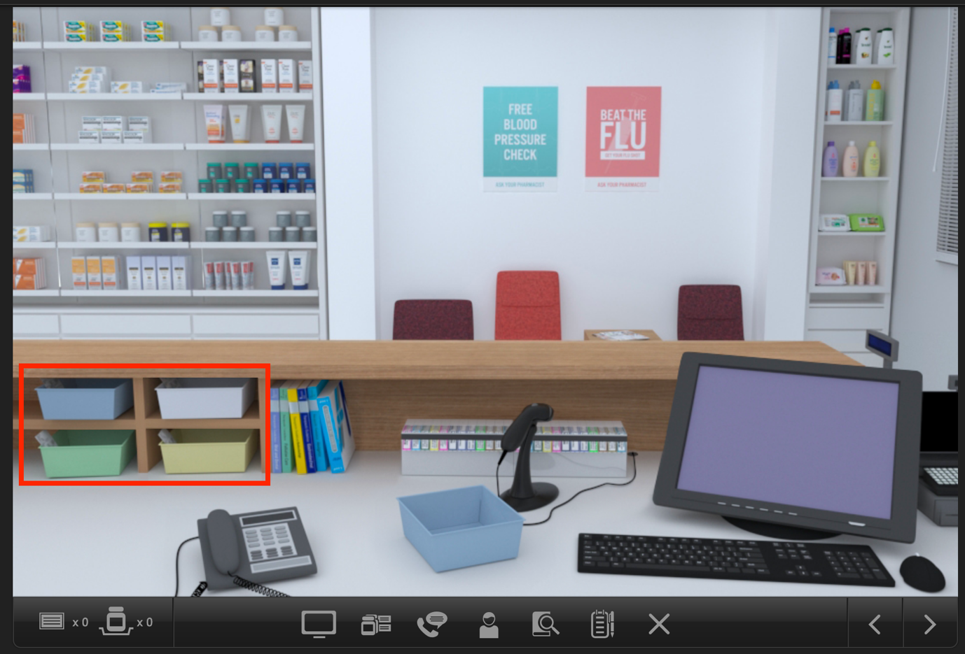
Dispense baskets
Toolbar

Toolbar tools

Accessing information sources
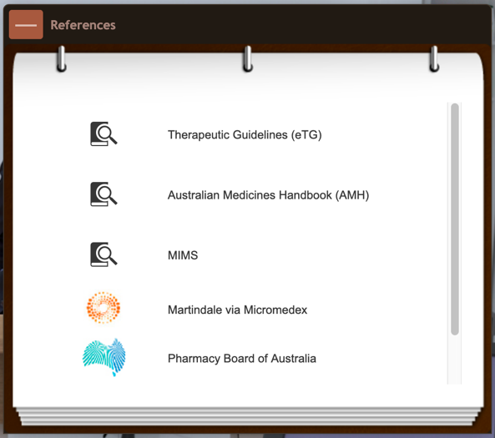
During an exercise you will need to gather information to safely dispense the prescription. There are a number of online resources available within MyDispense which are accessed by clicking on the references icon in the toolbar.

This will show you the references panel.
Click on the relevant link to go to the appropriate online resource.
You may need to enter your Authcate ID and password when accessing resources within Monash University, for example MUSO, Micromedex and Martindale.
You can toggle the references panel visibility by clicking its icon in the toolbar.

Saving and exiting
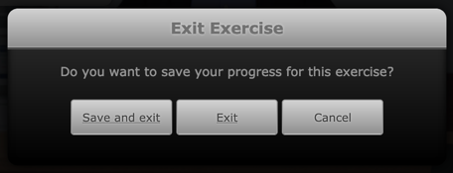
Clicking on the exit exercise icon will open the exit exercise dialog box.

The dialog has three options, save and exit, exit and cancel. Save and Exit will save your current exit progress and return you to the Unit tutorial screen. The next time you open the exercise you will be asked if you want to continue from where you left off.
Exit will return you to the unit tutorial screen without saving your progress. Cancel will close the dialog.

Reviewing prescriptions
In the pharmacy there are four slots under the counter for prescription baskets. Clicking on a basket will open the review screen.
Close button
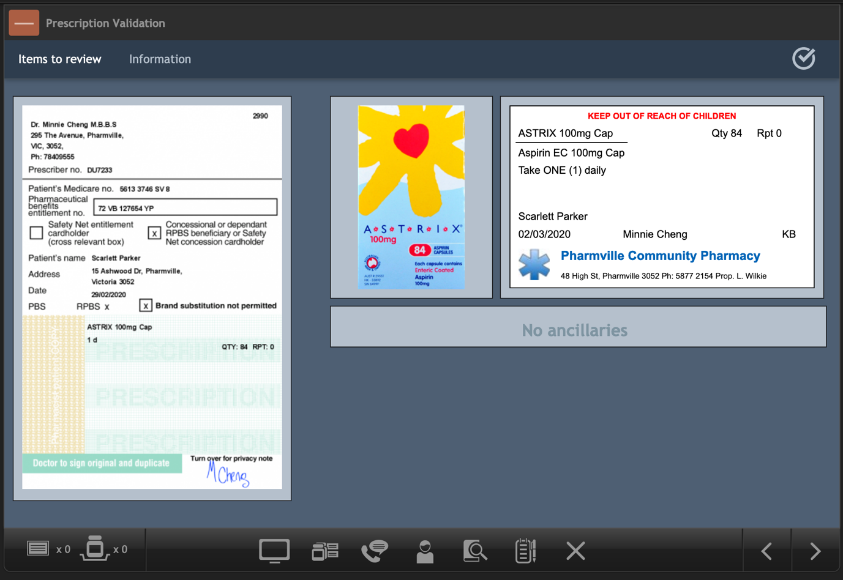
Medication
Ancillaries
Label
Prescription
Information button
Finalise review button
The screen above shows a prescription, a medication and a label that are about to be dispensed to a customer. Some baskets may only have a prescription, while other baskets will have multiple items that are to be dispensed.

Viewing additional information
As you complete each basket in the exercise, you may need to know more background information about the patient on the prescription. To view patient and prescriber details on a prescription, click on the information button.
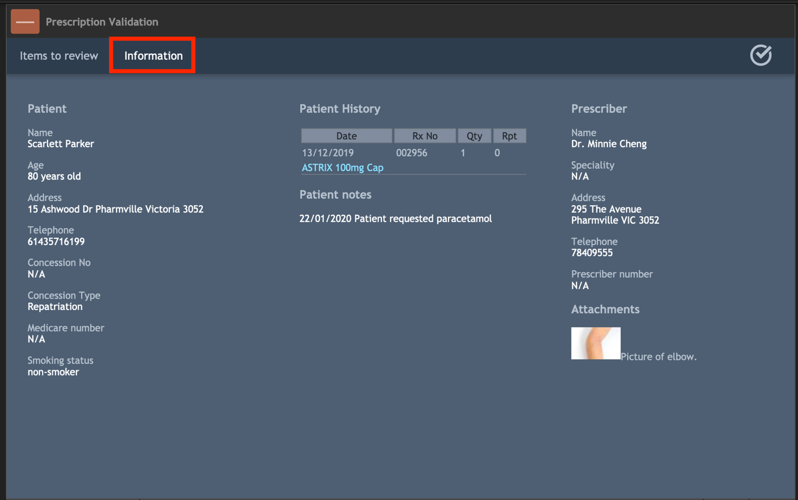
Sometimes the patient may have some patient notes and dispensing records. To view a dispensing record in detail, click on the blue medication name; doing so will display the label from the dispensary.
Clicking on an attachment will expand that attachment so it fills the screen so you can view more details. To return to the items in the basket, click on the items to review button.

Reviewing items
To complete a basket, you must review the items in it. If you think there is something wrong with an item in the basket or would like to view it in more detail, click on it on the items to review screen to bring up more details.
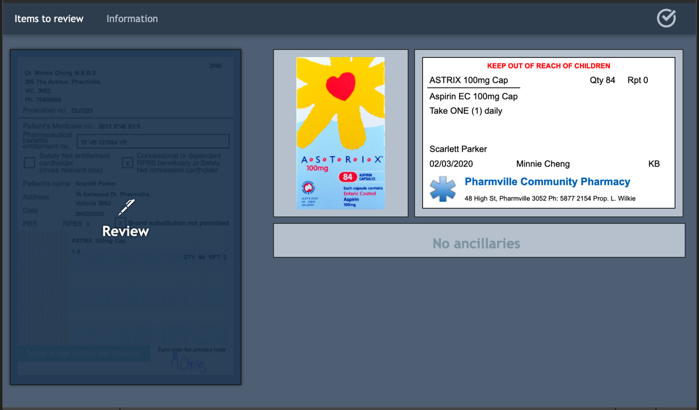
On the items to review screen, you can click on the prescription and any medications, labels or ancillaries. For ancillaries this includes the ‘no ancillaries’ area.

Reviewing a prescription
Clicking on a prescription will display the prescription review screen. To return to the items to review screen, click on the back button in the top left corner of the screen.
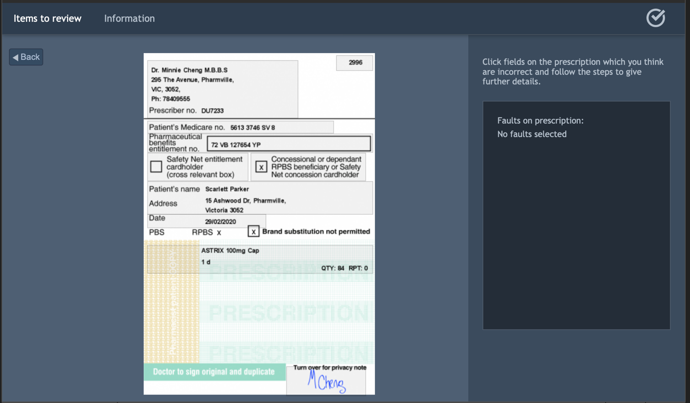
The prescription is now covered in grey boxes over parts of the prescription. If you think that there is something wrong with that part of the prescription, click on the grey box that covers it.
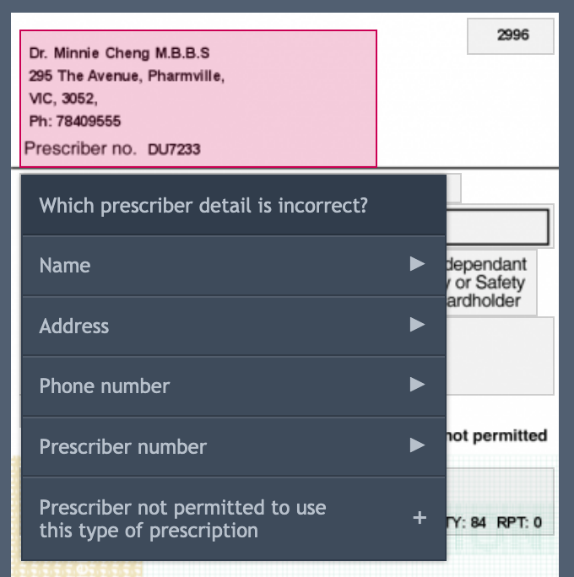
This will open a menu where you can select what is wrong with that area of the prescription. For example, clicking on the prescriber area displays a menu where you can select which prescriber detail is incorrect.
If a problem on the menu has an arrow on the end of it, clicking it will reveal more problems that can be selected. If a problem has a + next to it, it will be added as a fault that the prescription has and will be circled on the prescription (where applicable).

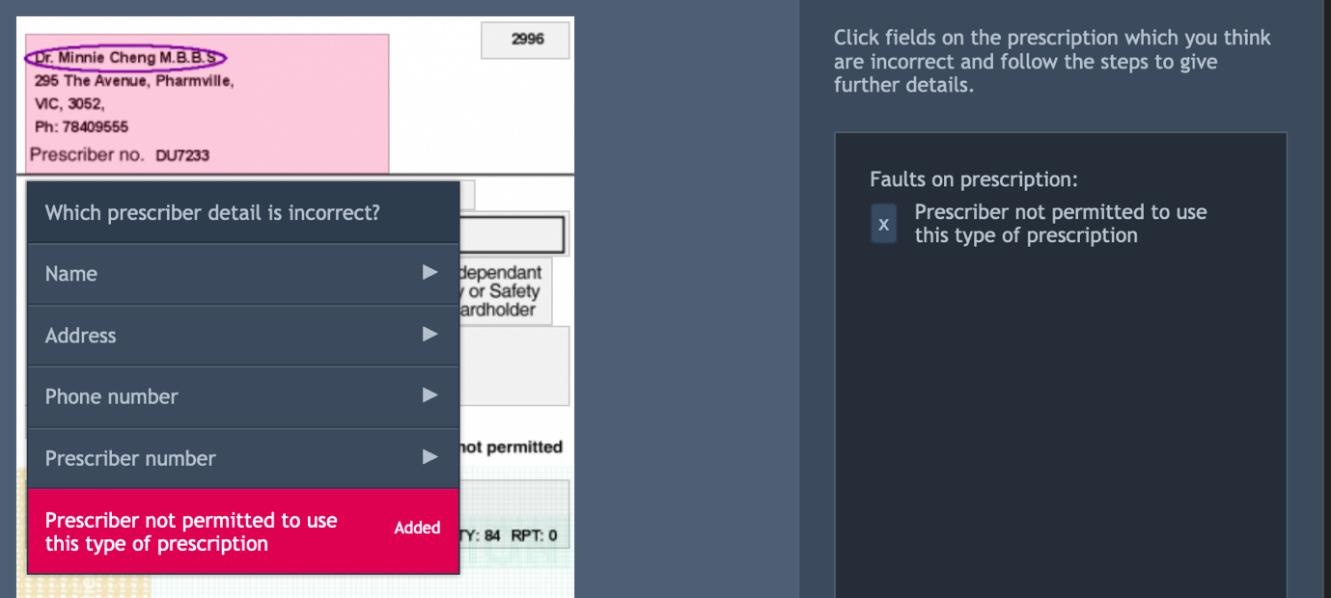
Clicking on the “Prescriber is not permitted to use this type of prescription” fault has highlighted it on the prescription and added it to the list of faults on the prescription. If you want to remove a fault, click on the X button next to the fault in the list on the right.
To close the fault menu, click elsewhere on the screen. You can add as many faults as you like. If you do not think there are any problems with the prescription, do not select any faults. When you have completed reviewing the prescription click on the back button to return to the Items to review screen.

Reviewing a medication
To review a medication, click on the medication product image on the items to review screen to open that medication for review. The medication review screen is similar to the prescription review screen. Note that underneath the medication image there are other details about the medication such as its name and expiration date.
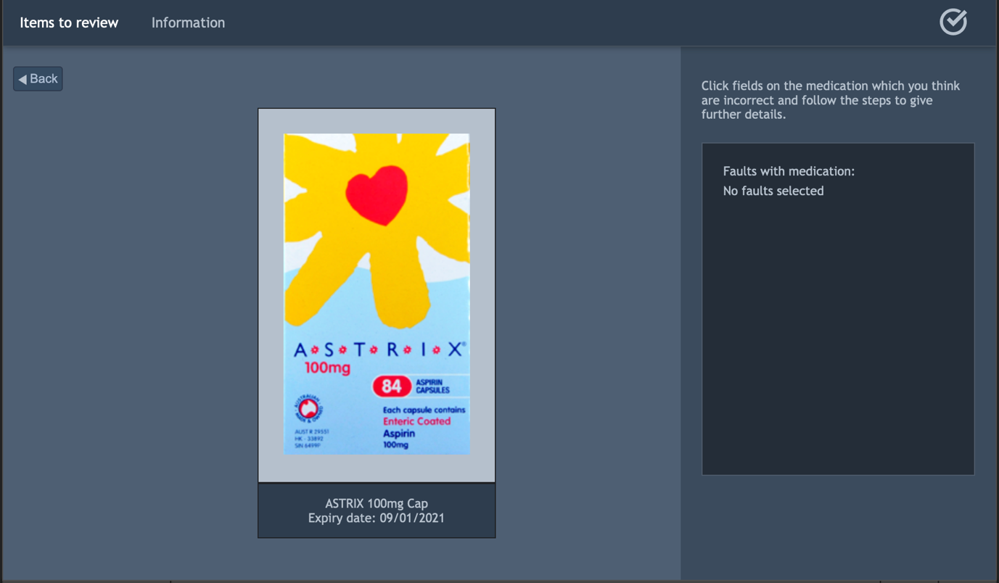
Clicking on the medication image on this screen will display a drop down list of potential faults with the medication. Clicking on a medication fault will add it to the list of faults for this medication, which can be removed by clicking the X button next to the fault you want to remove in the list.
Like with the prescription, if you think there is nothing wrong with the medication, do not select any faults. To return to the items to review page, click on the back button.

Reviewing a label
The procedure for reviewing a label applies to reviewing a prescription. Opening the label will display grey boxes on the label where you can select faults.
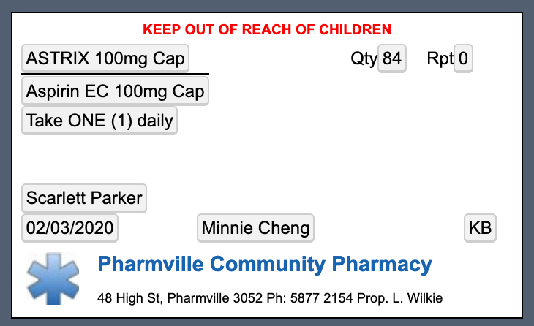

Reviewing ancillaries
A medication being dispensed may not always have ancillaries. If a medication does not have any ancillaries attached to it, a message saying ‘No ancillaries’ will appear on the items to review screen.
If a medication does have ancillaries, the attached ancillaries will appear instead.
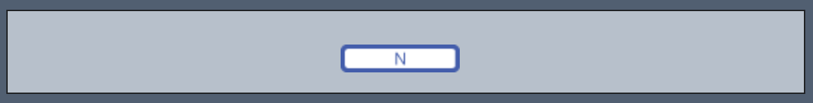
The ancillaries displayed (or lack thereof) are for the label and medication that appear directly above it. Therefore if there is more that one medication in a basket, the ancillaries always belong to the medication above it.
To remove ancillaries, click on the ancillaries that are on the medication already, or on the no ancillaries button. Like the other review sections, more details about the ancillaries are displayed.
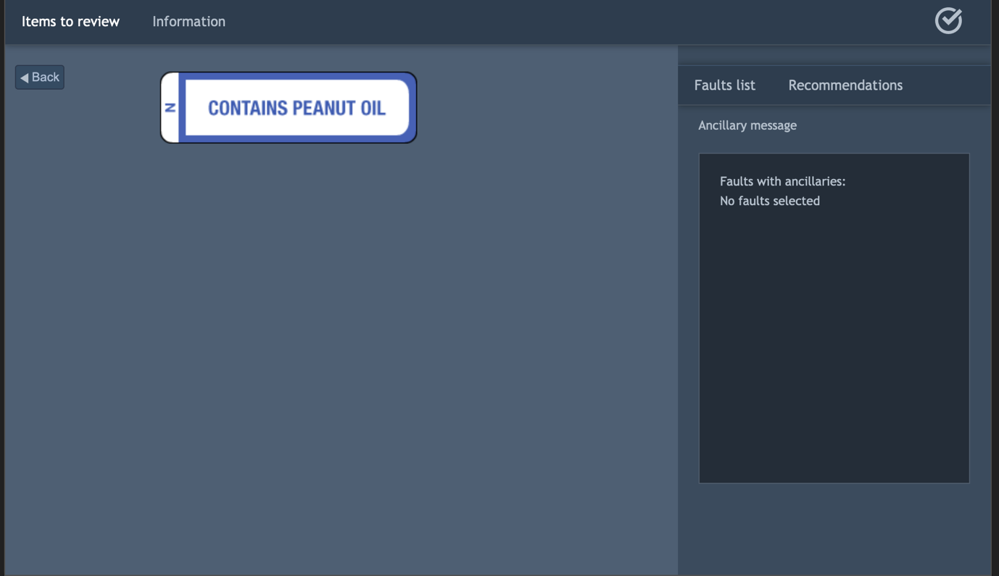
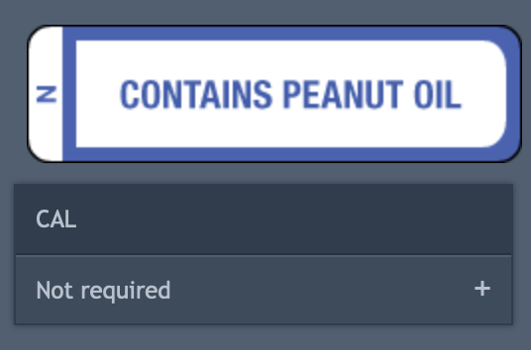
Clicking on an ancillary will display a menu where you can declare that the ancillary is not required for this prescription.
Like with other faults, this will appear on the menu to the right and can be removed by clicking the X button next to the fault.
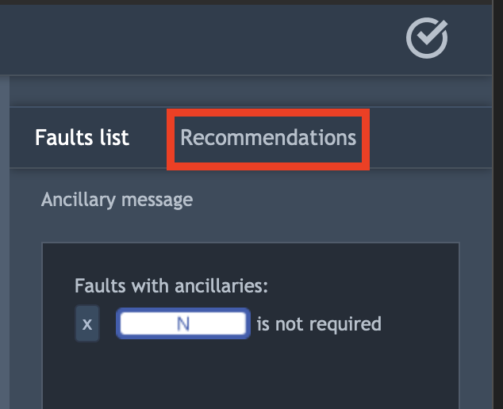
Ancillaries have an additional feature where you can recommend some ancillaries that should have been applied to the medication in the basket.
Above the fault list there is a recommendations button. Clicking it will open the recommendations list. When you first open the list, it will be empty. This is because the list by default shows the ancillaries you have recommended by added to the label.
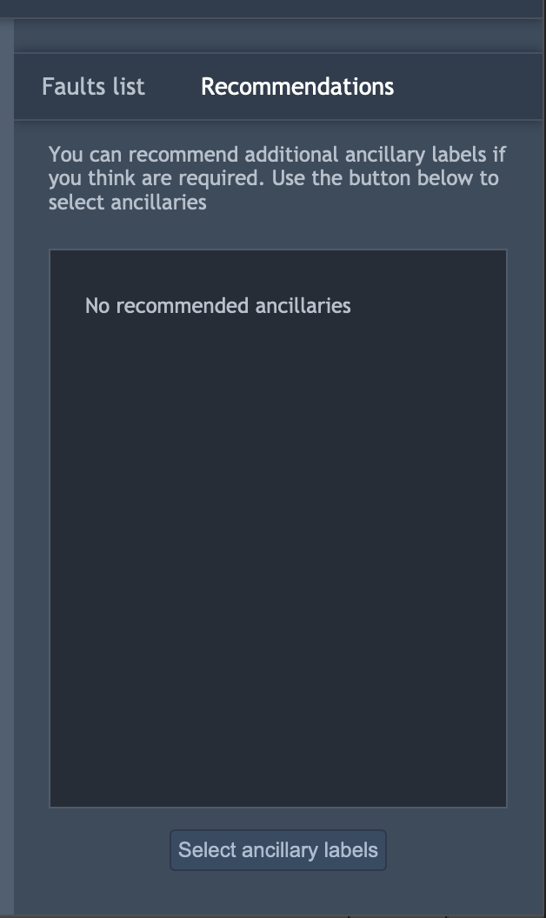
To recommend ancillaries, click on the select ancillary labels at the bottom of the recommendations screen.
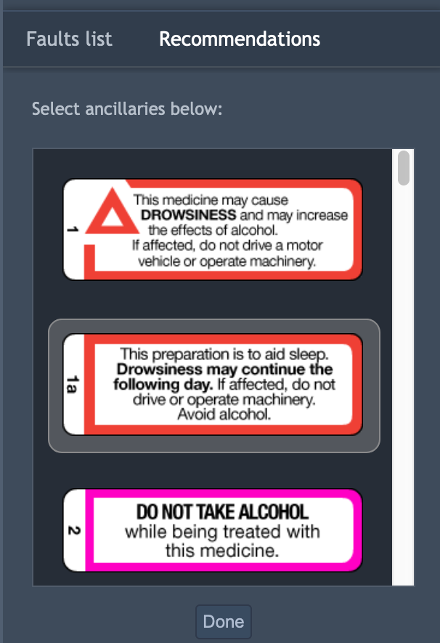
The list of ancillaries will be opened. Clicking on an ancillary will select it as an ancillary you recommend should be added to the product.
You can select multiple ancillaries at a time. When you have finished selecting ancillaries to recommend, click on the done button. This will add the selected ancillaries to the recommended list. If you decide that you no longer wish to recommend that ancillary, click on the X next to that ancillary and it will be removed from the list.
Recommending an ancillary indicates that you think that something is wrong with the dispense basket that needs to be corrected. If you do not think there is anything wrong with the ancillaries for the basket, do not recommend any ancillaries. When you are finished recommending ancillaries click on the back button to return to the items to review screen.
When you go back to the items to review screen, your ancillary recommendations will be displayed on the screen to remind you that you have made ancillary recommendations.
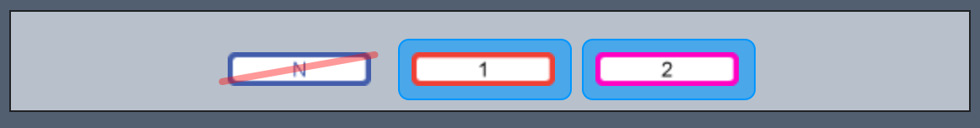

Finalising a basket
Once you have finished your review of a basket you will need to finalise it. To finalise your review, click on the finalise review button in the top right corner highlighted in red.
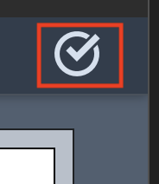
Doing so opens the review panel. On the left side of the screen are the faults that you have selected for this basket. On the right-hand side is a note pad where you can describe your decision making process. 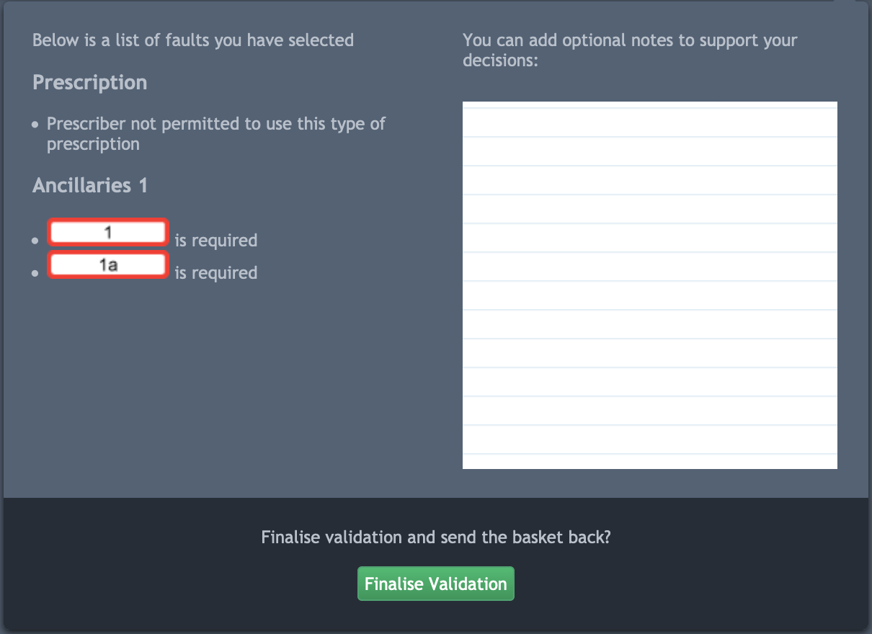
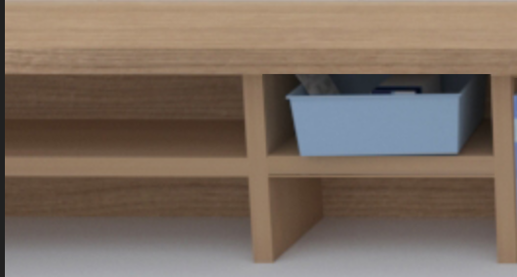
To finalize the basket click on the finalise validation button at the bottom of the review panel. This will close the review basket screen and take you back to the pharmacy. The basket you reviewed will disappear.

To complete the exercise, you will need to complete all of the baskets in the review shelves. An exercise can contain more than 4 review baskets. If there are more than 4 baskets to review and you complete one, the empty space left by a reviewed basket will be immediately filled with a waiting basket.
When you complete all of the baskets, the exercise will end and you will be able to view your feedback. When the exercise complete screen appears, click on exit.
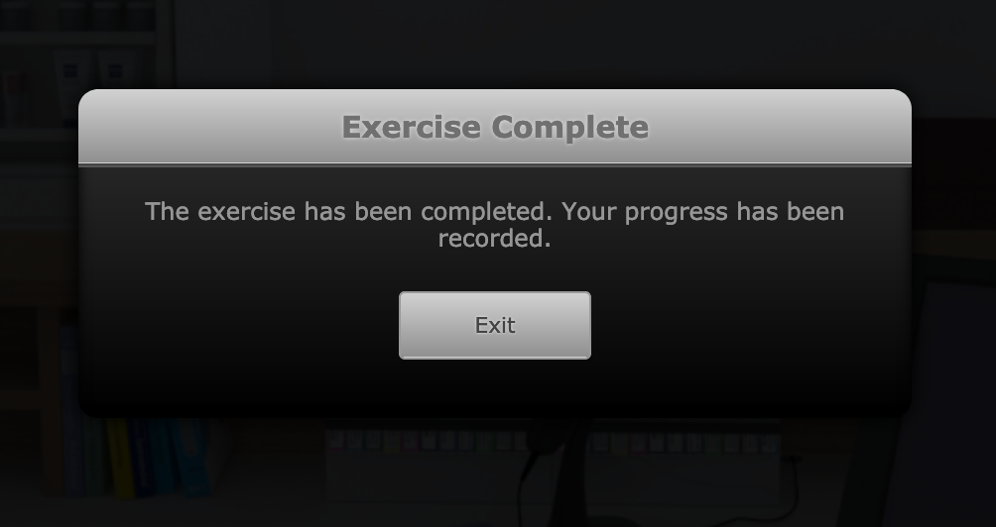

Feedback
Validation exercise feedback displays the feedback for each basket on its own page. The first screen you will see when you open the feedback is the basket list.
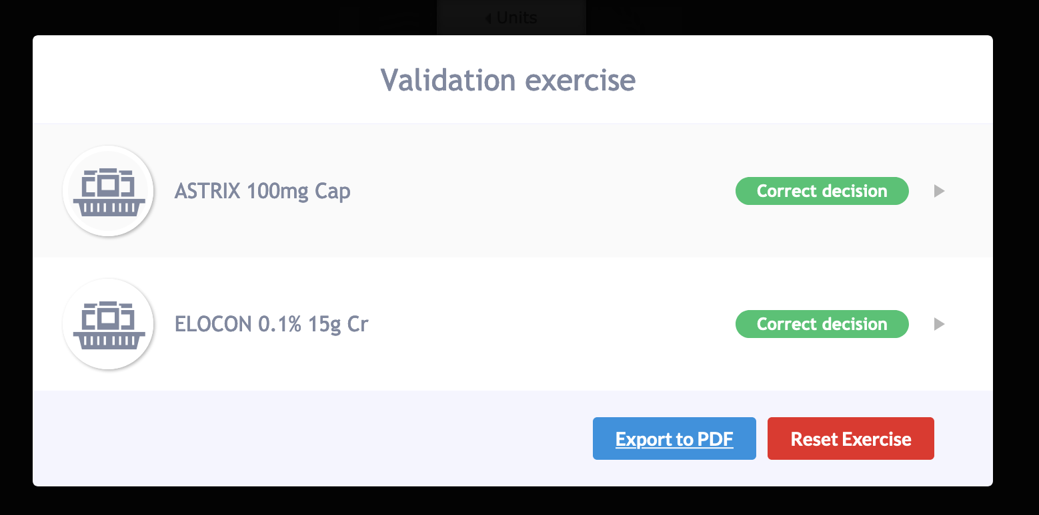
This lists all of the baskets you completed in the exercise in the order that you did them in. The basket has the name of each medication that was on the prescription in the basket. In the example above there were two baskets, one a prescription for Astrix and another for Elocon.
Clicking on the medication name will open the feedback screen for that basket.
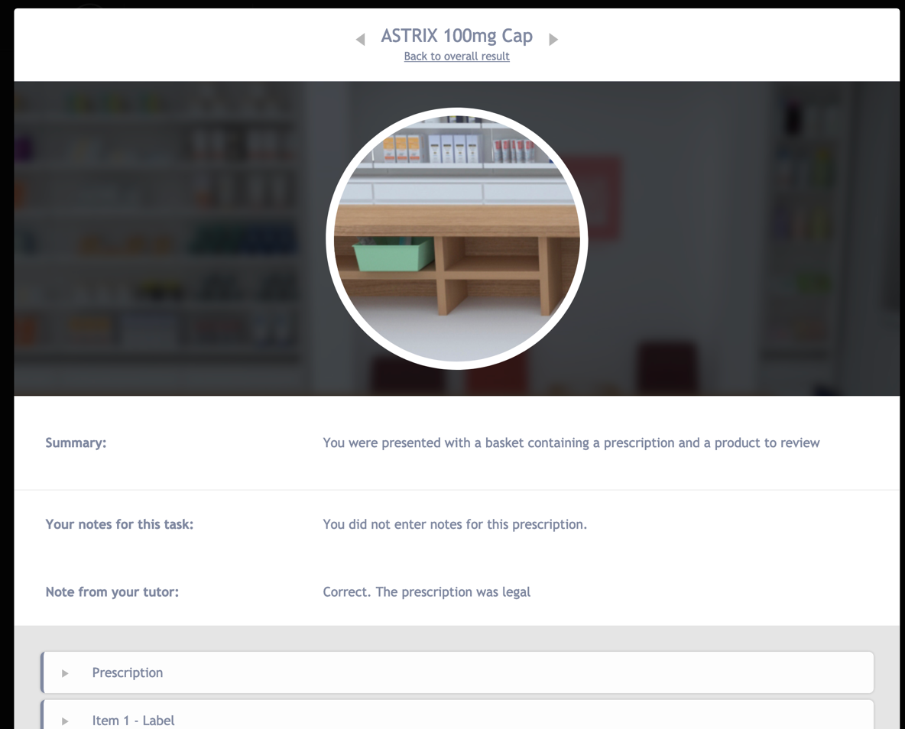
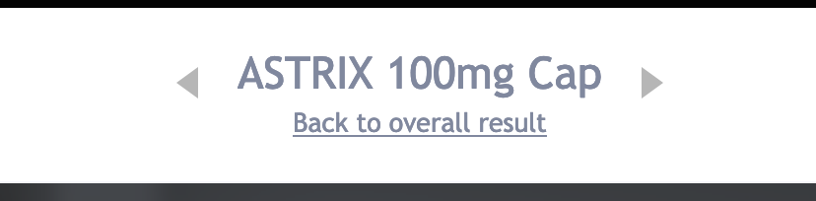
At the top of the screen is the list of medication names seen on the previous screen. The arrows next to the name allow you to navigate to the next baskets feedback. Clicking the back to overall result link will take you back to the first screen.
Each item in the basket has its own drop down section that you can open by clicking on it.
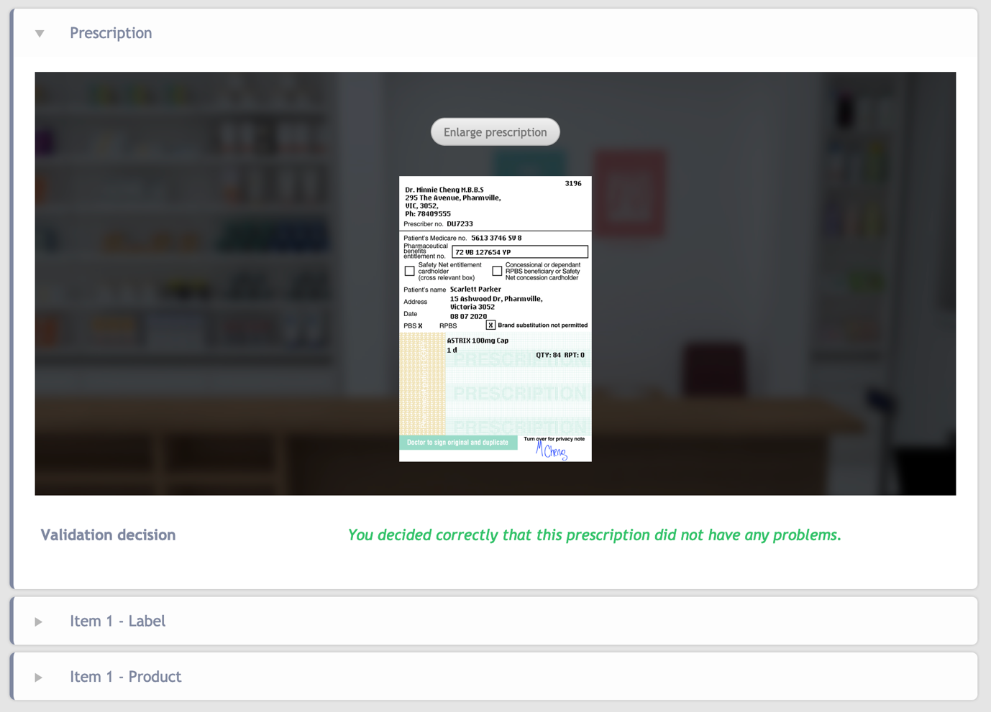
For example, clicking on the prescription section will expand it and display the prescription that you reviewed. The prescription section has an enlarge prescription button so you can view it extra large. The expanded sections will display any faults you selected for the section and what the overall outcome was for it.
If you want to reset the exercise and start again, click on the back button at the bottom of the screen or the return to overall result link at the top of the screen. You can reset the exercise or export the feedback in PDF format from the basket list.

