MyDispense OTC Exercise

User Guide

About MyDispense
MyDispense is an online pharmacy simulation that allows you to develop and to practise your dispensing skills. It provides a safe environment in which you may make mistakes without experiencing the serious consequences of practicing in the real world. For your maximum benefit use MyDispense as seriously as you would when dispensing medicines in real practice.
You will access a number of exercises, grouped into tutorials, each designed to support specific learning outcomes. At the end of each exercise you will receive feedback to indicate how well you did and to outline any mistakes you might have made. You may also undertake marked assessment exercises in MyDispense.

An important note about Web browsers
MyDispense will run very well in all of the mainstream web browsers, however, we recommend that you use the Firefox browser for the best experience. Do not use Internet Explorer we recommend that you install another browser such as Firefox or Chrome - both of which are free to download and install. Internet Explorer is not supported by MyDispense.

The introduction Screen
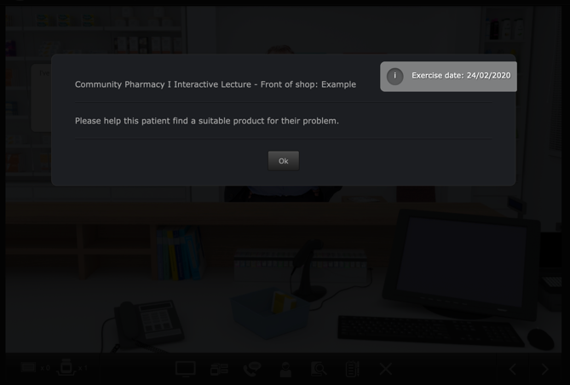
Once you have selected an exercise you will see the Introduction screen. This screen gives some background information and provides context for the exercise.
Click on the OK button to continue.
If you want to see the Introduction screen again click on the i button next to your username in the top right corner of the screen.
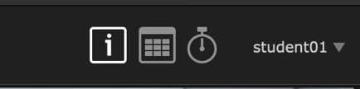

Exercise screen
The main exercise screen is the shopfront of a community pharmacy.
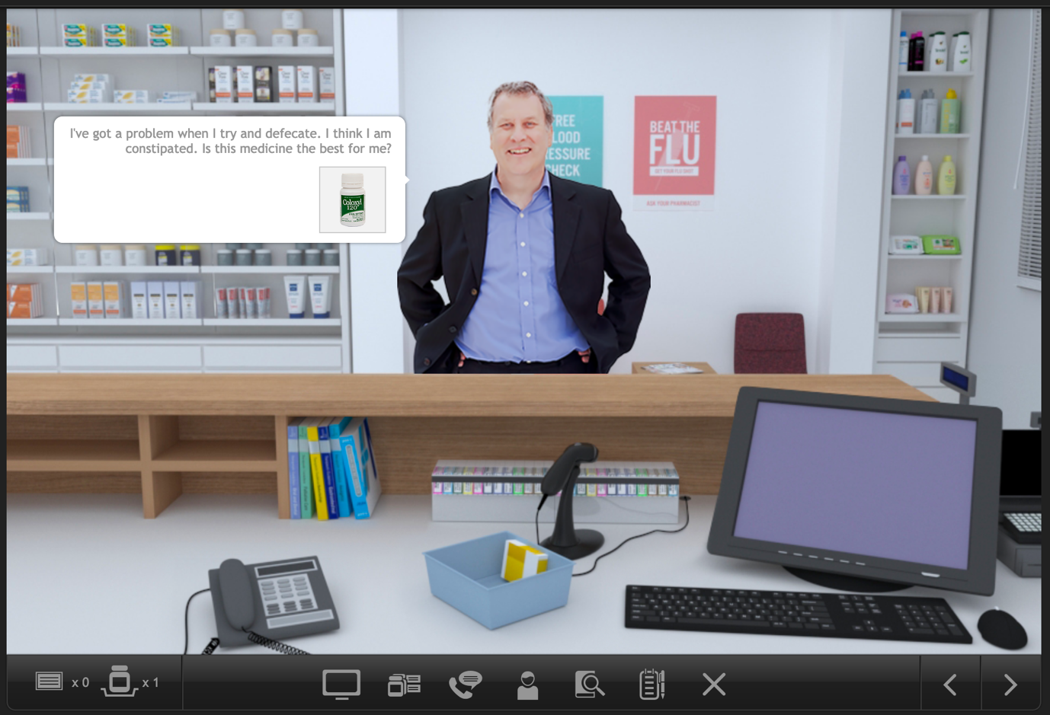
Toolbar

You are working at a dispensary and a patient appears at the counter and asks for help. You will review their symptoms and determine whether you can recommend an over the counter medication or refer them back to their doctor for assistance.

Toolbar tools

Accessing information sources
During an exercise you will need to gather information to safely dispense the prescription. There are a number of online resources available within MyDispense which are accessed by clicking on the references icon in the toolbar.
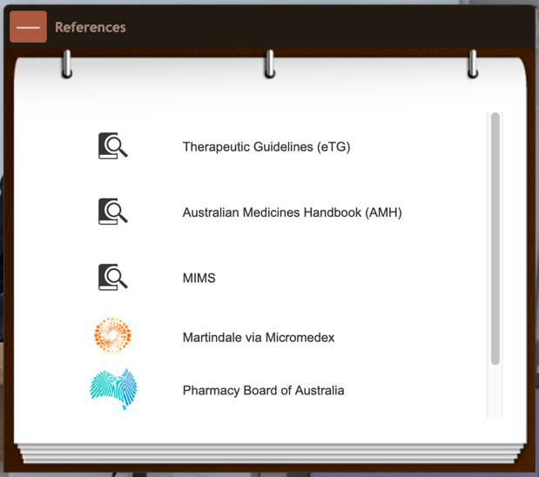
This will show you the references panel.
Click on the relevant link to go to the appropriate online resource.
You may need to enter your Authcate ID and password when accessing resources within Monash University, for example MUSO, Micromedex and Martindale.
You can toggle the references panel visibility by clicking its icon in the toolbar.

Taking notes
Clicking on the notes icon will open the Notes panel.

Make notes here about the dispensing decisions and choices you make. For example, why you chose to use a particular ancillary label.
In an exam situation, the examiner will review the logic of your decisions.

Saving and exiting
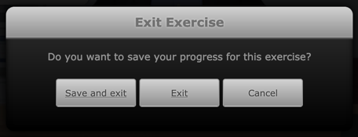
Clicking on the exit exercise icon will open the exit exercise dialog box.

The dialog has three options, save and exit, exit and cancel. Save and Exit will save your current exit progress and return you to the Unit tutorial screen. The next time you open the exercise you will be asked if you want to continue from where you left off.
Exit will return you to the unit tutorial screen without saving your progress. Cancel will close the dialog.

Patient Action Pane
Clicking on the patient or the patient action pane icon on the toolbar will open the Patient Action Pane (PAP). The PAP is where you will interact with the patient and gain as much information about them as possible and where you will submit the exercise.
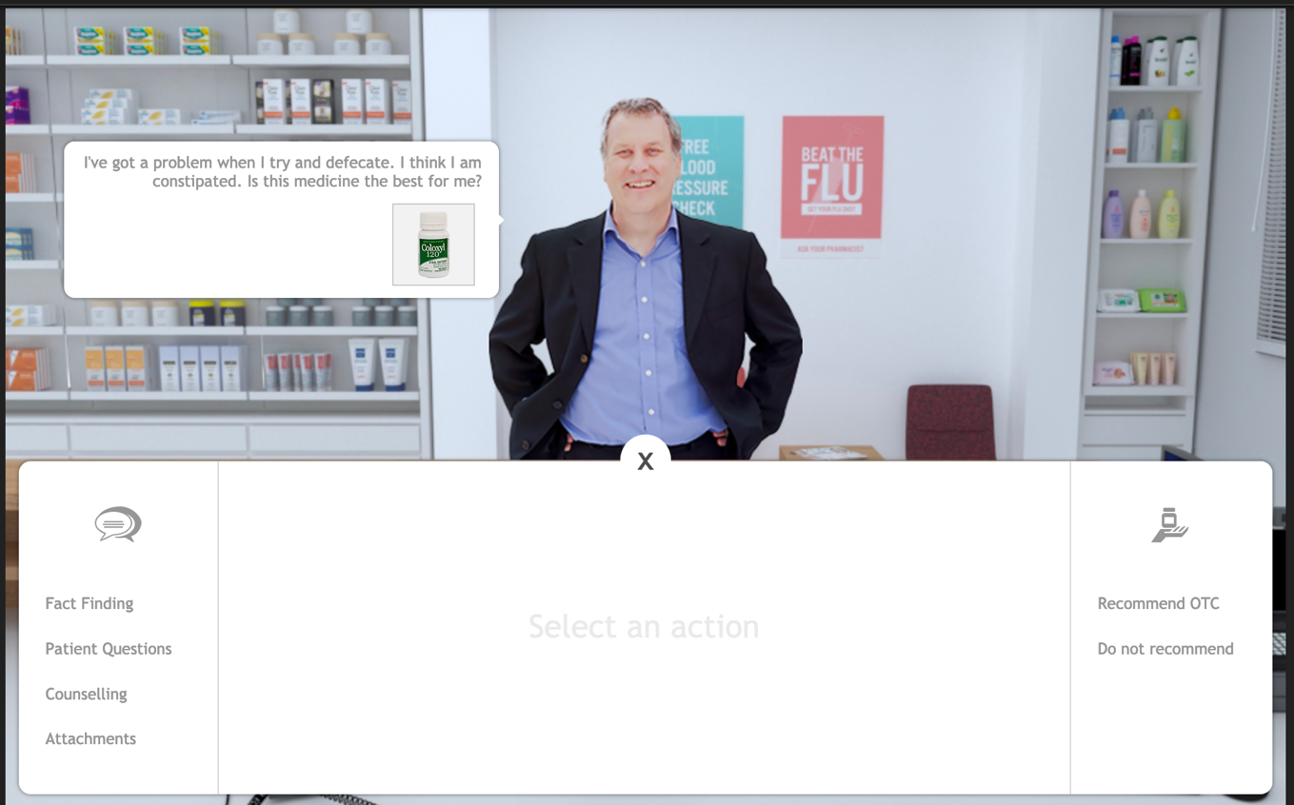
Patient interaction area
Exercise submit
Communications actions
Close button
The patient interaction area is where all interactions with the patient occur. Interactions appear like a conversation. Your questions, replies and question appear on the right hand side of the patient and the patient’s replies and questions appear on the left hand side of the patient.
The initial request by the patient appears at the top of the prompt list. Underneath the initial prompt there may be product image(s) or a binder icon. When product images appear, this means that the patient has selected medications from the shelf and have given them to you. Clicking on a product image will show you that product, which will be covered later.
This indicates that the patient has some extra documentation in the form of attachments and clicking them will open the attachment screen, which will be covered later.

Communication actions
Clicking on a communications action will display that communication action in the middle of the PAP. For instance, clicking Fact Finding will display the Fact Finding screen, Patient questions, the patient questions and so on.

Fact finding
Fact finding is where you may ask the patient some questions about themselves to discover as much as possible about their condition. To ask a question, click on the ask button next to a question in the list.
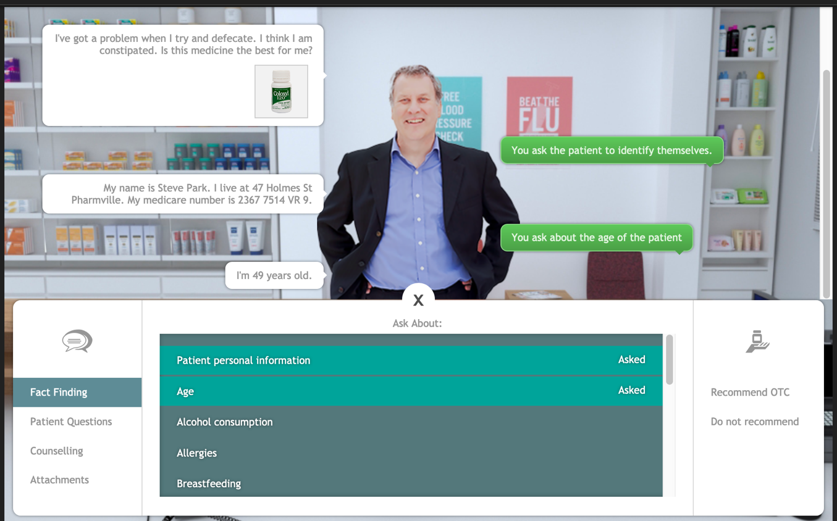
Sometimes it is better to not ask certain questions as it is inappropriate, but not asking certain questions may result in you missing important information about the patient. Sometimes you may be able to ask the patient about their personal information and they might tell you their name and some other details.
You may only ask the questions found in the list.

Patient questions
Sometimes the patient may have questions they want to ask you, but they won’t ask without you prompting. When you first open the patient questions section, it will look similar to this:
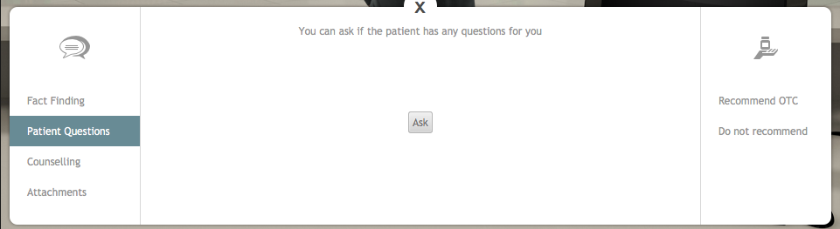

Clicking the Ask button will have you ask the patient if they have any questions. The patient may reply with their question or they will tell you that they have no questions.
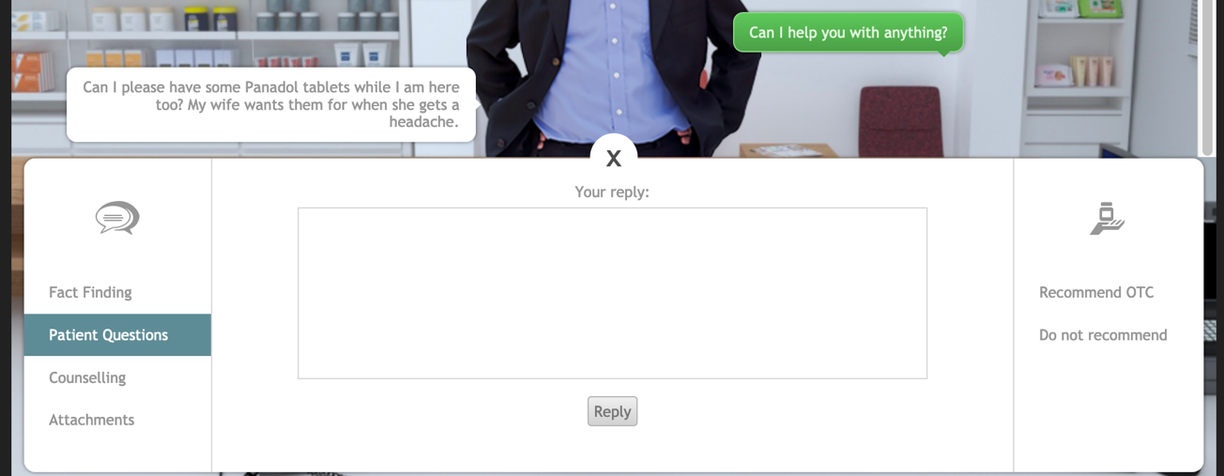
If the patient does have a question, the reply interface appears. In the field provided, enter your response to the patient and click the reply button. You will communicate your reply to the patient and will be able to prompt for another question.
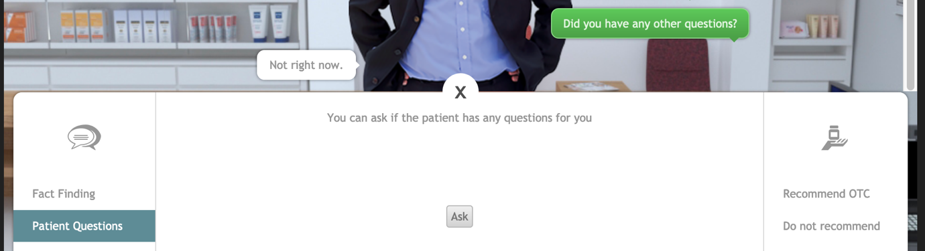
When the patient has no more questions, they will reply that is the case. Please note that a patient may have different questions before you select a medication and after you select a medication, even if they told you that they had no more questions.

Counselling
Using the counseling interface, you may counsel the patient in the use of the medication and about any other details about the dose. Type your counseling advice into the field provided and click the counsel button.
Clicking the counsel button will add what you have entered into your interaction with the patient. Each time you enter something and click the counsel button, it will be added as a new patient interaction. Your previous counselling notes will not be removed, only added upon. So if you need to clarify your counselling, do so by communicating with the patient.

Attachments
Attachments feature any additional documentation the patient may have about their condition. This can range from pictures of their problem to supporting documentation or test results. Clicking the attachments action will display a list of attachments in the exercise and a description of the attachment.
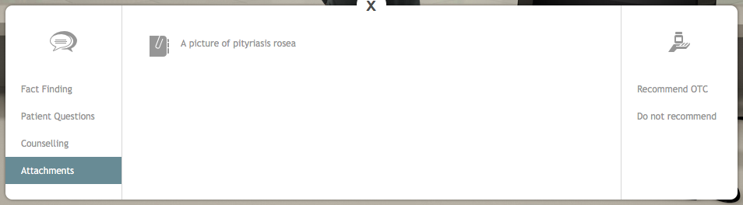
Clicking an attachment in the list will open the attachment in a gallery for you to view.
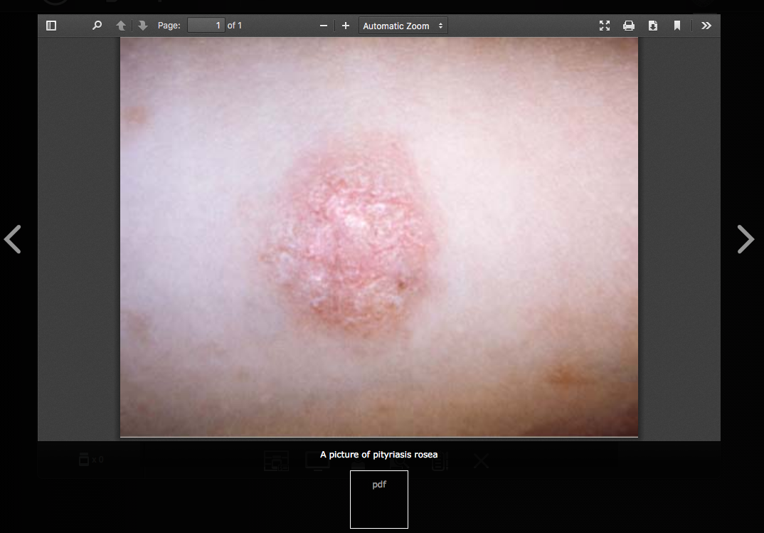
The gallery interface displays the description of the attachment and allows you to navigate between the other attachments (where applicable). To close the attachment gallery, click outside of the gallery area.

Dispense software
OTC exercises feature the dispense software running with patient search functionality only. If you are able to identify the patient you may search for them using the dispensing software to view any dispensing records or patient notes made about them.
If you are able to find this information it may assist you in recommending a medication. You may not be able to find some patients in the dispensing software. They may have never been to your dispensary before.

Selecting medications

Front of pharmacy
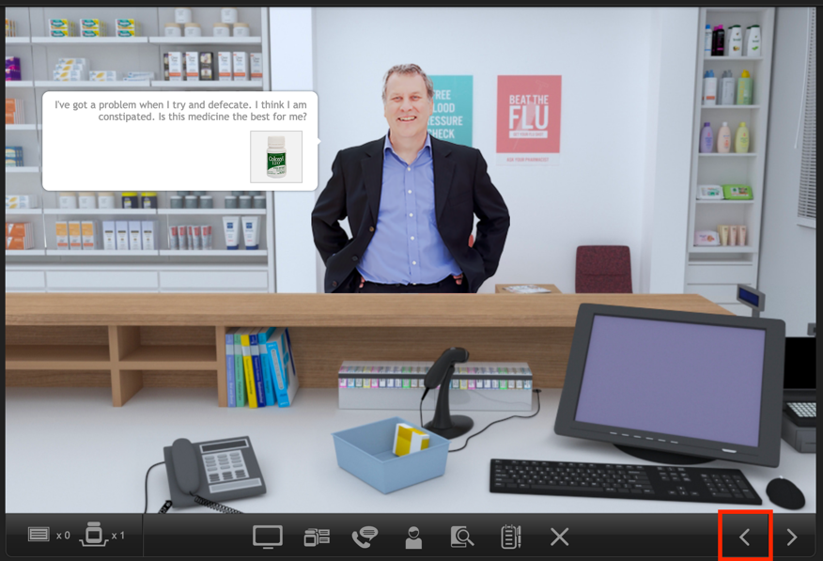
When you are ready to search for products to recommend to the patient you will need to move to the front of the pharmacy where the OTC products are located. To do so, click the left arrow on the bottom right corner of the screen.
OTC products are located in three areas. You can click the icons in the toolbar or on their locations in the 3d environment.
The 3d locations are outlined in different colours below.

The shelves, outlined in green.
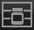
Under the counter, outlined in red.
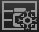
Under the counter fridge, outlined in blue.

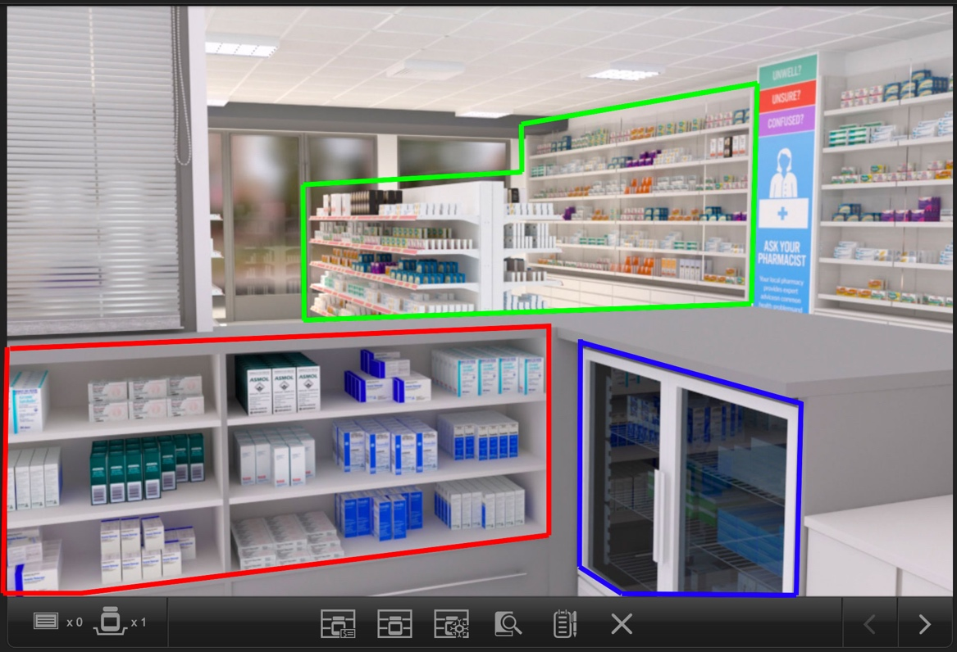

Category navigation
Clicking an OTC product location will open the category screen for that location. To view more categories, use the left and right navigation buttons along the bottom of the screen. Clicking a navigation button will move the shelves left or right by two shelves.
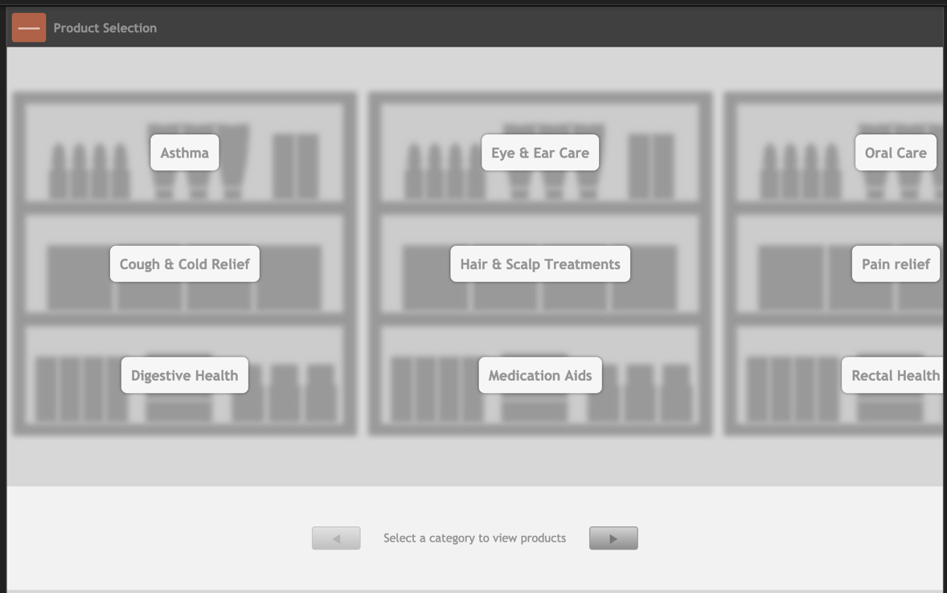
Navigation buttons
Category
Clicking a category will display the products in that category. Note that some locations will have different categories.

Category shelves
The product shelves in each category display up to 18 products per shelf. To return to the category screen, click the back button. To navigate the shelves, click the back and next buttons or the numbered navigation buttons on the right.
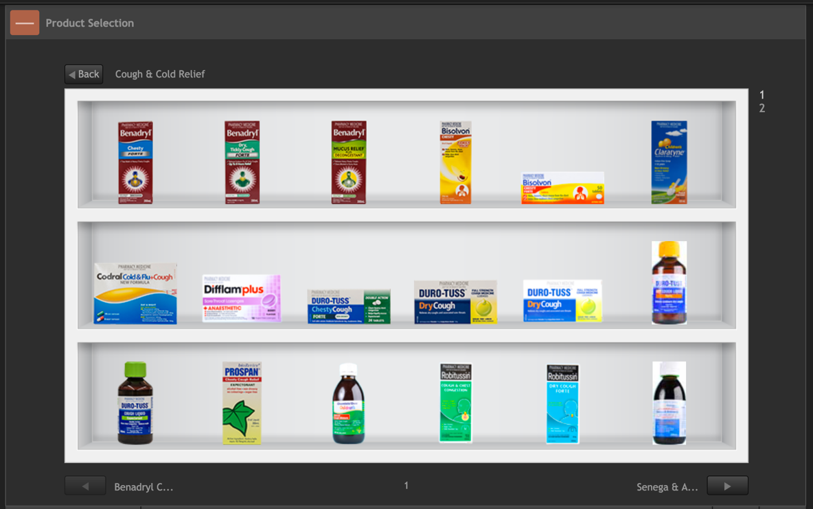
Shelf navigation
Back to categories
Category name
Shelf navigation
Medications

Product information window
To view information about a product, click it on the shelf and a product information window will be displayed. Product information windows are similar throughout OTC exercises, but they can change based on selection context, which will be explained later. The window can be moved by clicking on it and dragging.
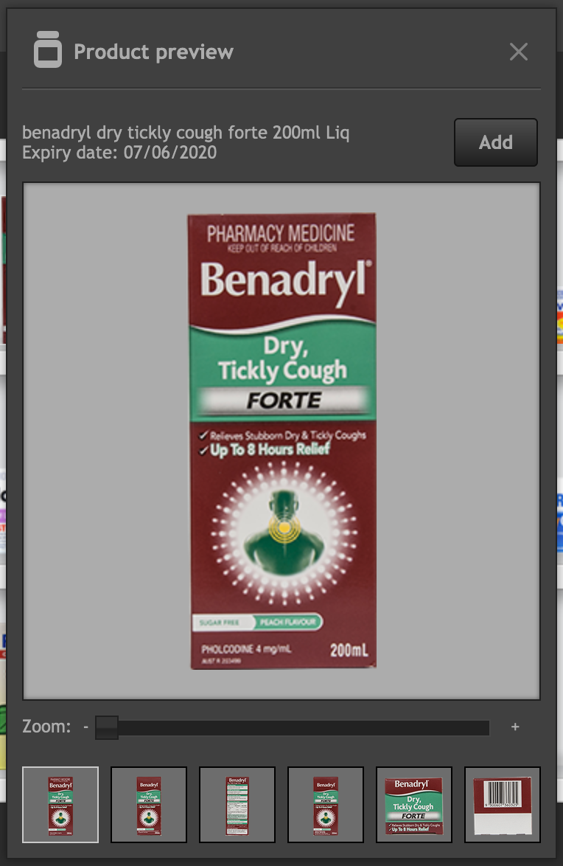
Add button

Product information
Close button

Zoom slider

Side gallery
Product preview
Selection information
The side gallery shows the different sides of the product. Clicking on a different side will display it in the product preview section. In some exercises, the side gallery will not appear.

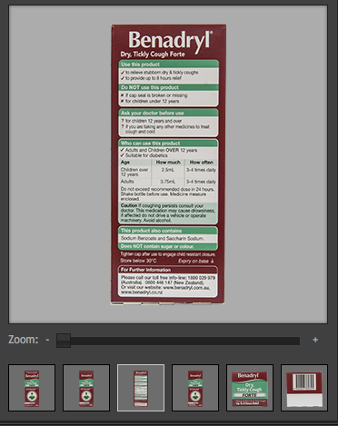
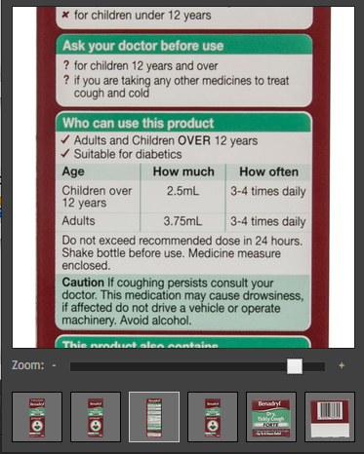
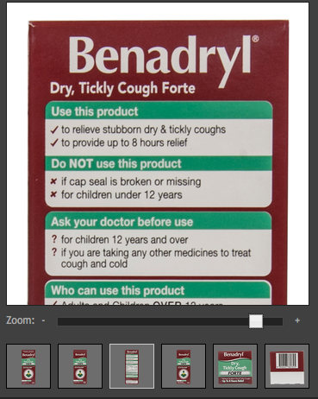
To view a side of the product in more detail, use the zoom slider to zoom in on that side. Once zoomed in, click and drag on the product preview to move the zoomed in image around to view the extra detail, as shown above.

Product selection and management
To add a product to your inventory, click the add button. The product window will disappear, and the product will be added to your inventory. If you click on the product again, the inventory will open again, appearing like it does in the image below.
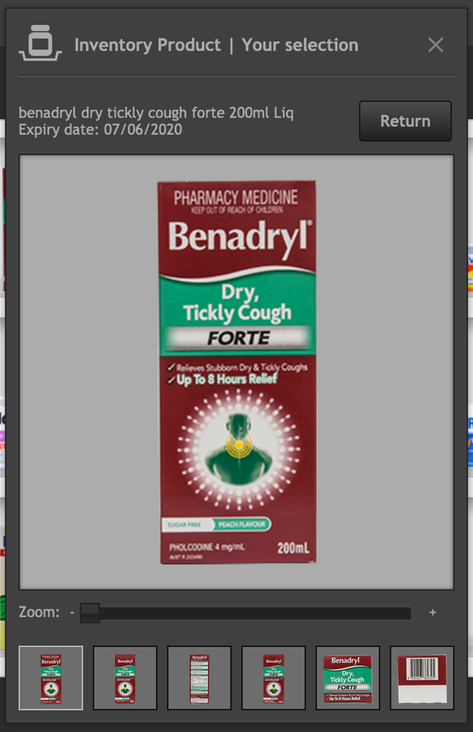
When a product is in your inventory, the selection information section of the product window is updated. The window now displays that the medication is one you selected and it is in your inventory.
The number of products in your inventory is displayed in the bottom left corner of the screen.
When a medication is in your inventory, a remove button appears. If you click that button, the medication will be removed from your inventory and placed back on the shelf.
If you close the product information window for a medication in your inventory, you can open it again by clicking the inventory button. Clicking on the inventory will list the medications in your inventory. To open the product information window, click on the name of the medication in the list.
In the Patient Action Pane (PAP) section of this guide, it was mentioned that patients could give you product(s) at the start of the exercise. When a patient gives you product(s), they are put into your inventory. You can open your inventory by clicking on the inventory button on the bottom left of the screen.
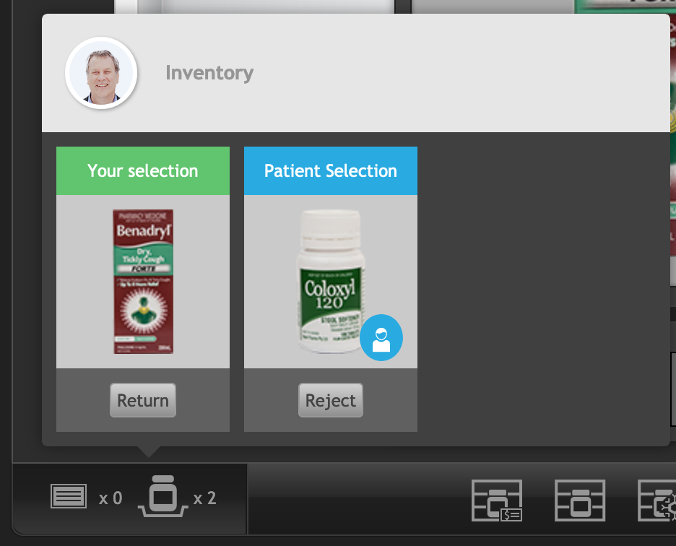
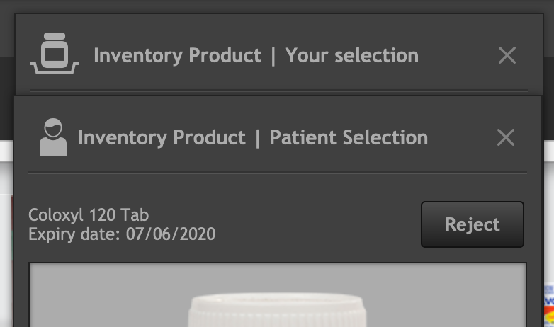
Patient products appear with a patient icon next to them in your inventory and a blue heading with the text Patient selection. Products that you have selected appear in green with ‘Your selection’. This is reflected when opening a product information window, note how the patient selected product appears with the patient icon in the heading.

You can remove Patient selected products, but they are not returned to the shelf. Instead, a prompt will appear telling you to counsel the patient about the rejected medication.
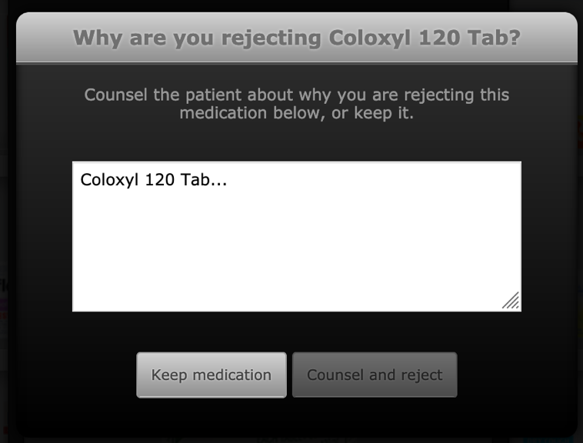
Type your reasons in the field provided or click the keep medication button to do nothing. When you have prepared your reason, click the counsel and reject button to continue.
When clicked, the patient action pane will be opened to the counselling section, where the counselling you entered will appear.
You can continue to edit your counselling point before clicking the counsel button to counsel the patient. Do not forget to do so.
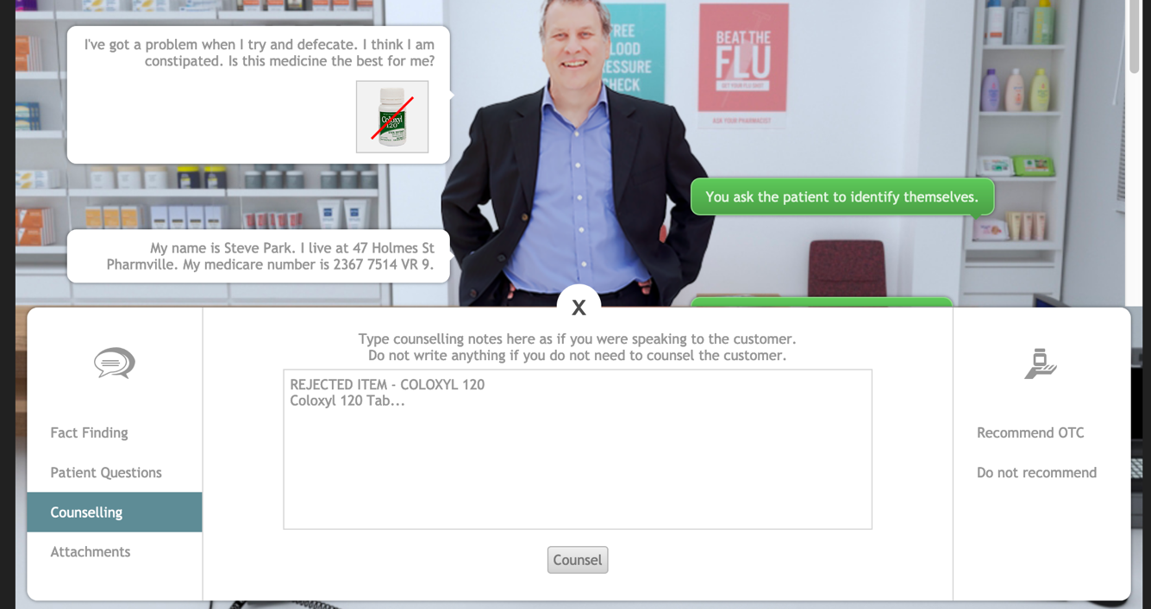
The product you rejected will now appear in your inventory as rejected and a red line will be put through the product where it appears in the patient speech bubble.

The medication will appear as rejected in your inventory and clicking it will open the product information window. You can re-instate a rejected medication by clicking on the add button on the inventory screen or the product information window. When you do so, you could consider re-visiting your patient counselling.
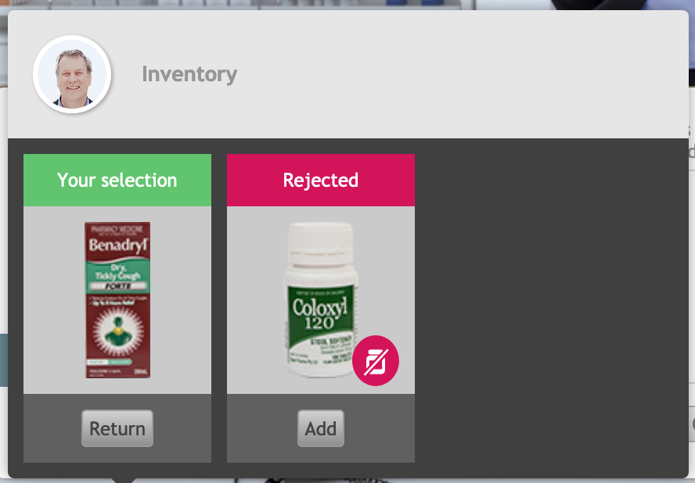
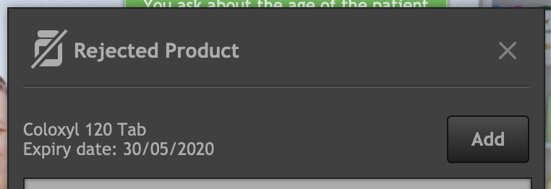

If you reject the medication again after re-instating it, the counselling prompt will not appear.

Finishing the exercise
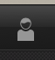
When you have reviewed all of the information you can gather about the patient, you must decide how you will complete the exercise. OTC exercises give you the choice of recommending OTC products to the patient or to not recommend any medication use and tell the patient why they should not self-medicate.
To finish the exercise, re-open the patient action pane by clicking the PAP icon. On the right hand side of the PAP are the exercise complete options.
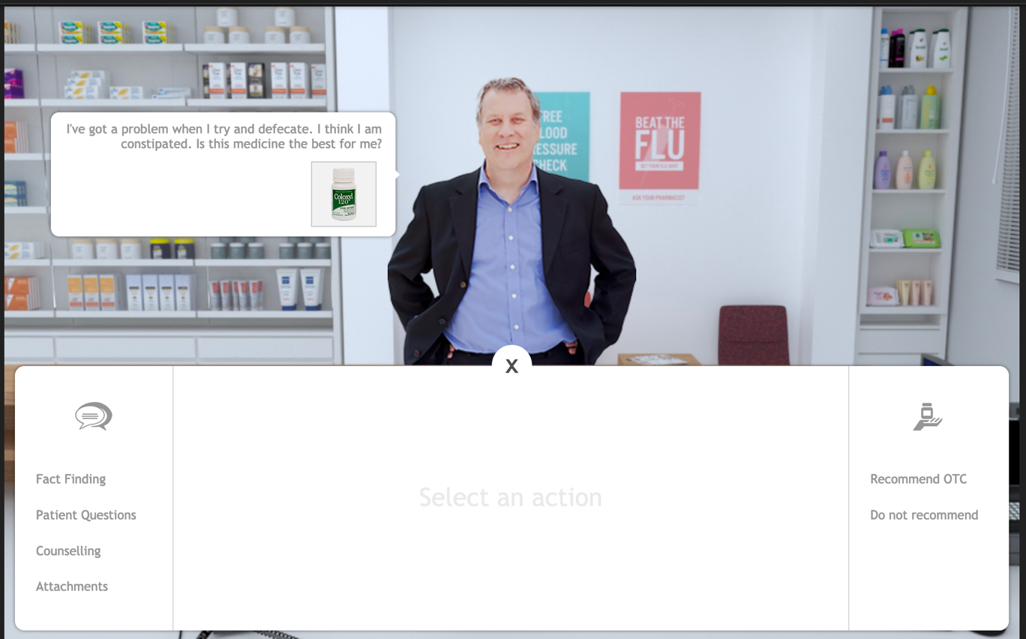
Exercise submit

Recommend OTC
If you are ready to recommended OTCs to the patient, click the recommend OTC button. The OTCs you have selected will be displayed on the screen. If you are ready to submit these OTCs, click the finish button to complete the exercise.
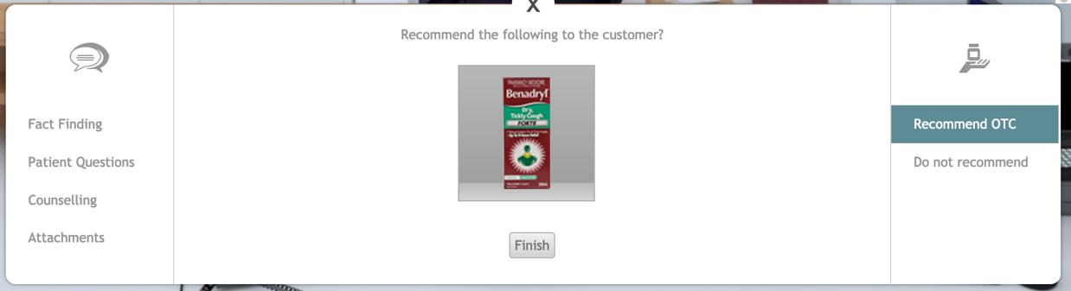

Do not recommend
If you do not recommend any OTCs to the patient, click on the do not recommend button. When you decide to not recommend an OTC, you need to give at least one reason why to the patient from the list on the left. You can choose as many reasons from the list as you want, but at least one is needed.
In addition to the selected reason(s), you need to describe your justification for not recommending any OTCs to the patient.
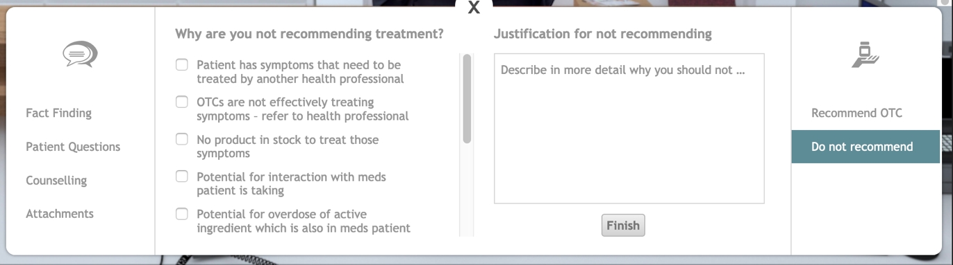
When you have selected your reasons and entered a justification, click the finish button to complete the exercise.

Getting feedback
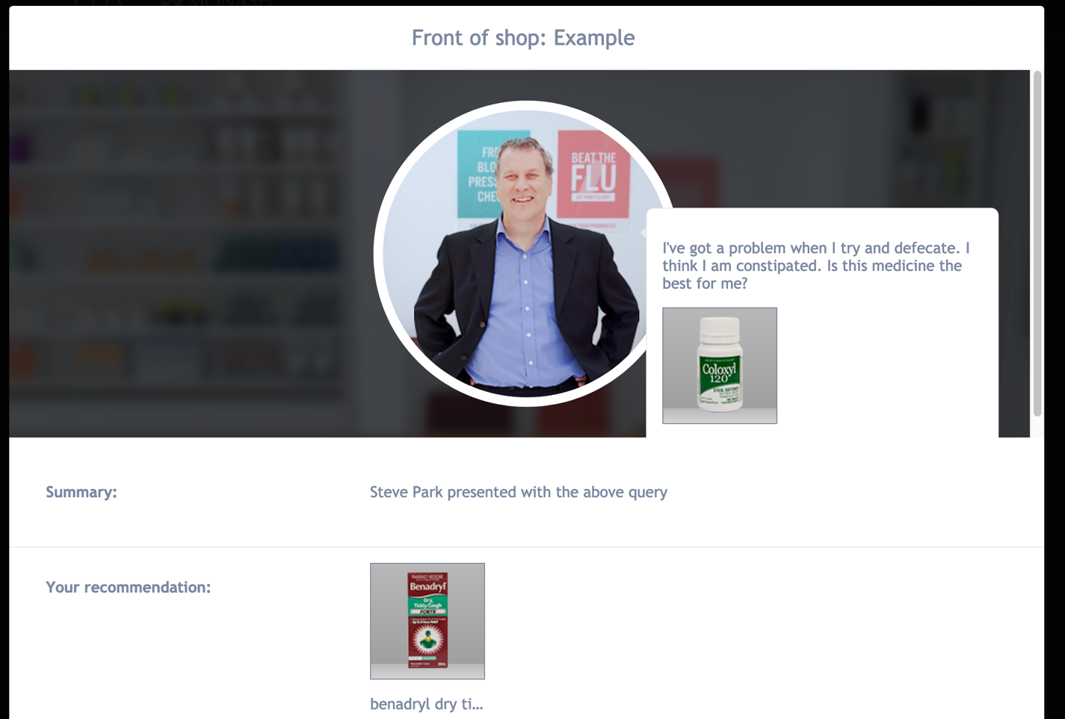
When you have completed an exercise and have returned to the dashboard, the icon for the exercise will have changed from the available icon to the feedback icon. Click on the feedback icon to see the feedback for the exercise.

You can reset the exercise and attempt it again by clicking on the Reset exercise button. Note that resetting an exercise will erase your exercise data.
When you have finished using MyDispense, remember to log out of the website and also close the browser to prevent anyone else from using your account.

