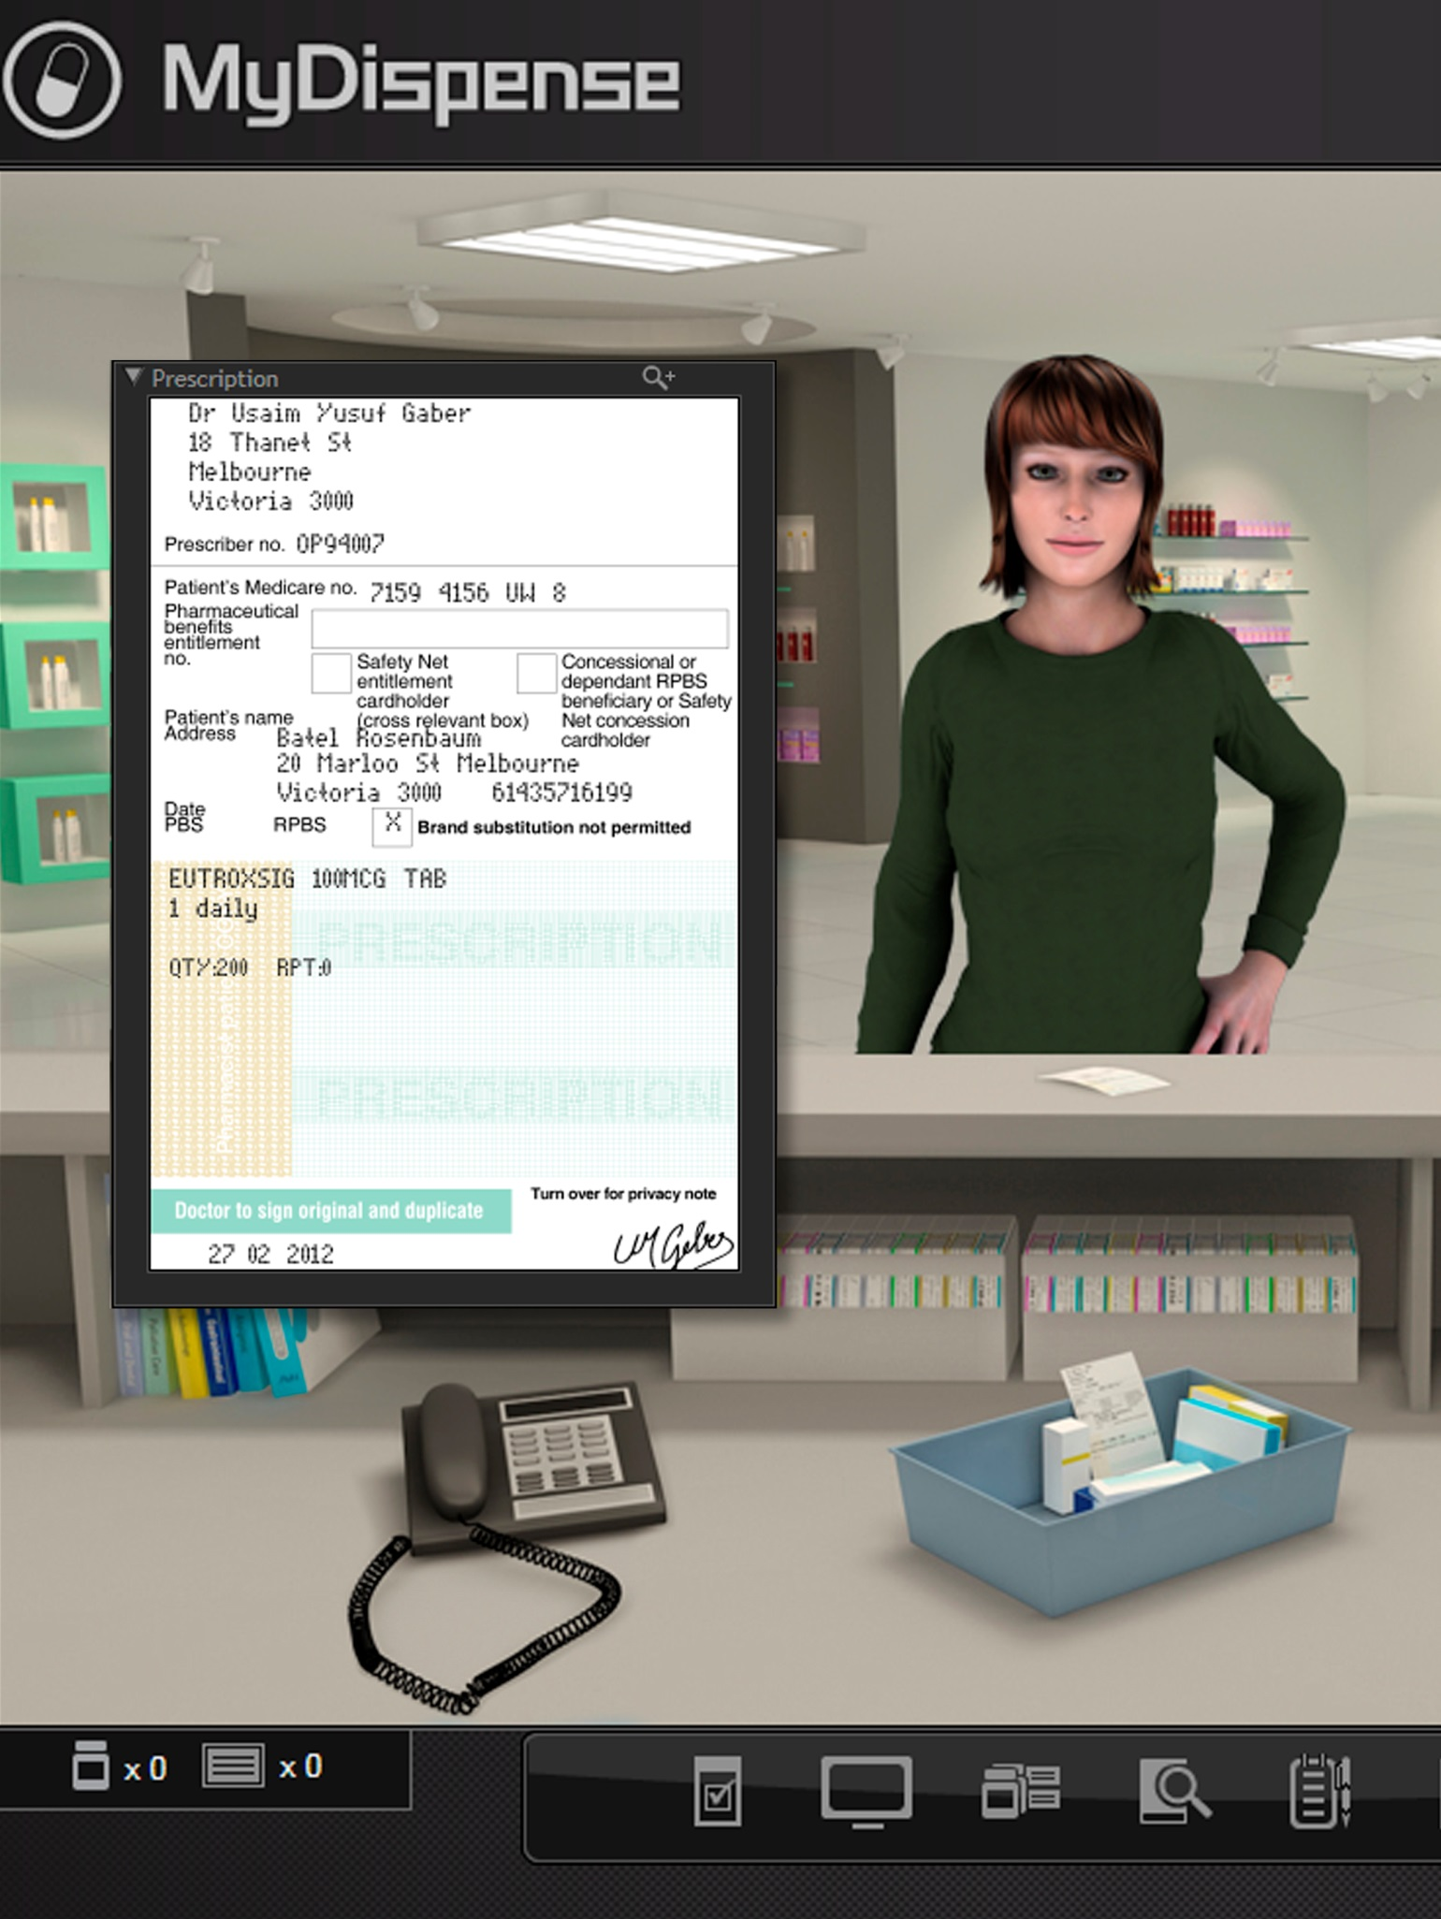
MyDispense
Assessment’s Guide

Version 5.2

Table of Contents
What is MyDispense? 5
Who is this guide for? 5
How should I use this guide? 5
MyDispense exams explained 5
Setting marks in the exercise designer 6
Marking features 6
Error marking 7
Fact finding marking 8
Penalties 8
Fact finding marking 9
Patient Questions marking 9
Labels 9
Cumulative marking 10
Label marking 11
Setting up an assessment tutorial 13
How to set a tutorial as an assessment 13
Setting up Studentgroups 14
Setting start and finish times for an exam 17
Exam manager 20
Accessing the exam manager 20
How to add markers to assessments 20
Assessment landing page 22
Checking if a student accessed or attempted an exam 23
Submitting a partially completed assessment 24
Assessment marking 25
Accessing exercise marks 25
Exercise marking interface 25
Marking 26
Critical criteria 27
Saving section marks 27
Resetting section marks 28
Marking sidebar 29
Navigating exercise marks 29
Saving question comment and mark 30
Resetting exercise marks 30
Exercise flagging 30
Assessment navigation 32
Exporting marks 32
Reviewed page export 32
All page export options 32

What is MyDispense?
MyDispense is a simulated learning and teaching environment that is designed to help students develop their skills and competency in dispensing medicinal products systematically, safely and accurately at a level of detail and difficulty corresponding to their knowledge and experience. It simulates the decision-making environment within which dispensing occurs, without reminders and prompts and with the opportunity for students to learn by making mistakes in a safe and secure learning environment. For an instructor, MyDispense is a framework allowing you to create a broad range of exercises and assessments from the simplest to the most demanding. The administrative interface is simple to use while giving you the control and flexibility to create challenging scenarios that best support your curriculum.

Who is this guide for?
This guide is a comprehensive guide on how to deliver assessments in MyDispense. This guide assumes that the exercises for the assessment have already been created and only marks need to be added to the exercise.

How should I use this guide?
You can either read the whole thing from beginning to end (but who does that with user guides?) or you can skim over the introductory sections to get a feel for how Assessments work, and then delve into the detail when you need it.
This guide has been designed to support the latter option.
You will find sections, titled in orange, which deal with specific and common tasks in MyDispense; hopefully these sections will get you where you need to be. If you need more detail, there will always be a more in depth description available.

MyDispense exams explained
An exam in MyDispense is a tutorial that has been setup as an exam and the exercises within that tutorial are separate marked activities that the student has to complete. For Students, an exam is similar to a regular MyDispense tutorial, except they must submit their assessment once they have completed it.
The administration side is more complex. As students submit their assessments, their submissions appear in the exam manager. The exam manager is where you can manage and mark the exercises that the students have completed. Eventually all of the students will be marked and you can export the marks to a file.

Setting marks in the exercise designer
Like other MyDispense features, assessment marking has its own section in the exercise designer. To activate exercise marking, expand the assessment section and check the enable assessment marking checkbox.
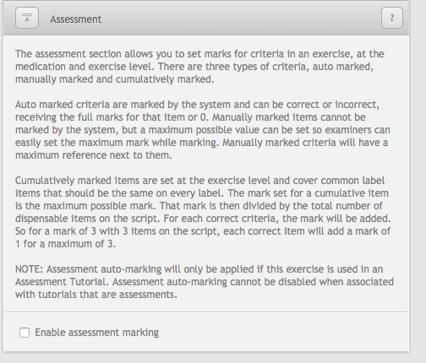

Marking features

Criteria marking types
Now is a good time to explain some of the marking features of MyDispense and what is to be expected when assigning marks. Criteria in MyDispense come in four varieties, auto-marked, manually marked, cumulative and custom.
Auto-marked criteria are simple enough that the system can mark them. This covers simple equation criteria, such as checking the dispense date matches the exercise date and so on.
Manually marked criteria require human oversight and are too complex for the system to mark them accurately. Counselling and directions on a medication label are examples of free text entry fields that can’t be marked easily by a computer. Manually marked criteria are prefixed by ‘maximum mark for’ as part of their criteria name.
Cumulative marks are a special set of marks designed to simplify the marking process for some label criteria. Criteria such as the label script date, doctor and patient are not re-selected during the label creation process, so they have been moved to a single location.
Cumulative marks are tallied using the number of medications in an exercise. If the mark is set at 3 and there are 3 medications in the exercise, then one correct label item is worth 1 mark, adding up each label the total mark awarded would be 3.
Custom marking is reserved for more complicated sections such as Fact Finding and Patient Questions. These have their own system for marking and will be explained in their respective sections.

Critical criteria
It is possible to flag almost any marking criteria in MyDispense as ‘critical’. Critical flagging is used to highlight a learning objective failure in an assessment, meaning that if a student gets 0 or negative marks for a flagged criteria, they should probably fail the exercise / assessment.
Flagging a criteria as critical is only used as a guideline. The system does not force the student to fail an exercise, only alerts markers to a critical failure in the marking interface. It is always up to the marker to make the final decision about a student’s marks, not MyDispense.

Customise exercise criteria
Marking criteria can be disabled to focus on learning outcomes. This includes disabling label marking completely, allowing an assessment to be about counselling or fact finding. Disabling criteria (outside of fact finding and patient questions), is done on a per item and criteria basis. Thus you could disable marks for initials on one label and have it enabled on another.

Error marking
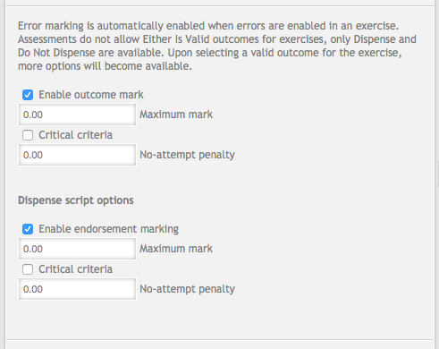
Error marking is automatic when errors are enabled in an exercise. The error section appears just below the enable assessment marking checkbox section, once assessment marking has been enabled. Error marking criteria is dependant on the error outcome selected for the exercise. The ‘Do Not Dispense’ and ‘Dispense’ outcomes have unique criteria available. The ‘Either is Valid’ outcome cannot be used for assessment exercises due to the difficulty of marking such an exercise.
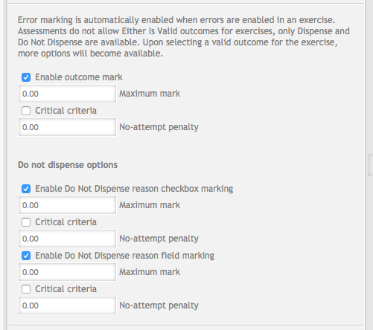
Shared between the two outcomes is the outcome criteria. The outcome awards marks for choosing the correct outcome (Dispense or Do Not Dispense) when completing an exercise. You can disable the outcome criteria, though this is not recommended as correctly selecting the outcome is a major component of errors.
Selecting the ‘Dispense’ outcome allows for label marking in the exercise and for marking of endorsements. Endorsement marking is a manually marked criteria that will display the student and exercise designer set endorsements side by side. The marker will examine the two prescriptions and assign a mark.
The ‘Do Not Dispense’ outcome has additional marking criteria based on the do not dispense reasons the student chooses when completing the exercise. A side effect of the Do Not Dispense outcome is that label marking will be automatically disabled. Label marking is disabled because the student will be expected to have no label data to mark as part of the exercise outcome and will be useless.

Fact finding marking
Patient and Prescriber fact finding assessment marking are identical in their implementation. Marking either is optional and must be enabled in the assessment section of the exercise designer. Note that the fact finding marking sections only appears if that type of fact finding is enabled in the exercise.
Thus if Patient fact finding isn’t enabled in the exercise it won’t appear in the assessment section, same with Prescriber fact finding marking. Once active, you must then activate marking for fact finding by checking the enable fact finding marking button.
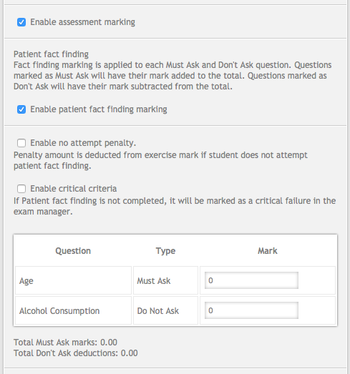

Penalties
Fact finding marking has the option of applying a mark penalty if the student does not ask the patient any questions. To enable the penalty, check the enable no attempt penalty checkbox. Doing so will display the penalty entry field, which is entered as a mark. The mark entered will be deducted from the exercise section mark if the student does not ask any questions for that fact finding type.
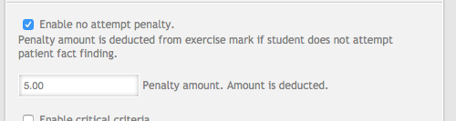
Fact finding marking can also be flagged as critical if the student does not attempt or gets a mark of 0 or less.

Fact finding marking
Setting up individual question marks for fact finding is a little different. Instead of displaying all the fact finding questions (patient or prescriber), it only lists questions set as Must Ask and Do Not Ask. Each question has field next to it where the mark can be set, which adds up to a total mark.
Must Ask questions will have their mark added to the total. Do Not Ask questions will have their mark subtracted from the total mark. Thus students are rewarded for asking correct questions and penalised for asking the wrong questions. Can Ask questions are ignored as they are considered neutral.
The total additions and deductions are displayed under the list of questions. It is recommended that the values match, so if a student asks all questions, they receive a 0. Otherwise a student may ask all questions and still get a positive mark.

Patient Questions marking
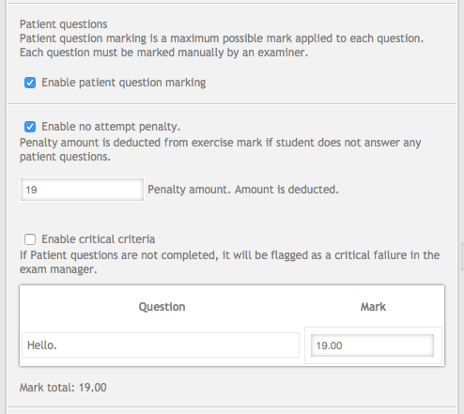
Patient question marking is similar to Fact Finding. Patient questions must be enabled in the exercise first before they will appear in the assessment section. Assessment marking for patient questions must be activated on top of that.
Patient questions feature a no attempt penalty options and critical flagging for non-complete / zero or negative marks. Below these options is the list of questions in the exercise.
Marks are assigned per question and are optional. Thus you can have three questions and only assign marks on the third question.
All patient questions are manually marked due to the free text of both the question and the answer. Marks assigned are a maximum mark for each question and only positive numbers can be set.

Labels
Label marking consists of two sections, cumulative marking and individual marking. Cumulative marking combines fields that are common to labels and will not change (data, prescriber, patient, etc.) and places them into one section. Individual marking sets marks for unique criteria per label, such as directions, correct medication and so on.
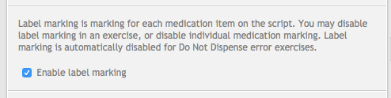
Label marking can be disabled completely. To disable label marking, uncheck the enable label marking checkbox. Note that in the case of exercises with a do not dispense outcome, label marking will be automatically disabled, as there won’t be labels to mark.

Cumulative marking
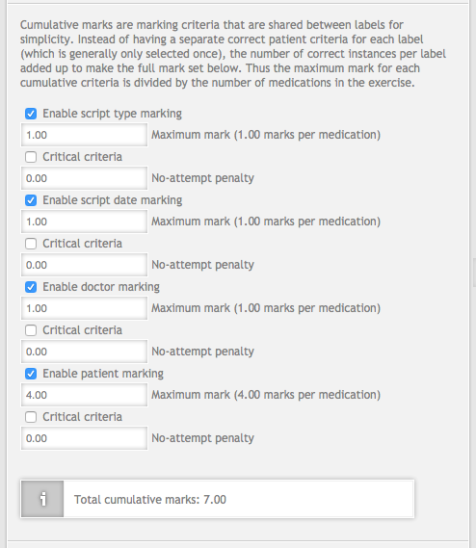
Adding up the number of labels that were correct for a criteria and dividing the mark by the total number of labels determine cumulative marks. If a mark of 4 were assigned in an exercise which had three labels (three medications on the script) and two out of three of the labels were correct, a mark of 2.4 would be awarded for that criteria. When entering a mark, this amount is automatically calculated and displayed next to the criteria.
There are four cumulative criteria in the Australian version. The US version has three criteria, as script type marking is not used. All cumulative criteria are auto-marked.
Each criteria can be disabled by unchecking the enable checkbox next to its name. Doing so will hide the mark field and additional options and the criteria will not be displayed in the assessment-marking interface. Disabling all of the cumulative criteria is possible.
Marking penalties for getting the criteria incorrect can also be applied. To apply a penalty, enter a penalty value in the no attempt penalty field. Penalties are entered as positive numbers which will be subtracted.

Label marking
To simplify the mark assignment process and add new management features, Label marking is completed on a single screen. To access the label marking pane, click on the set label marks button underneath the cumulative marking section.
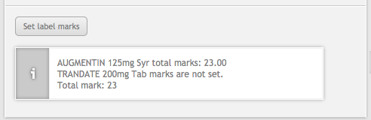
The label marks screen looks like the image below. Buttons and features have been outlined and are explained below.
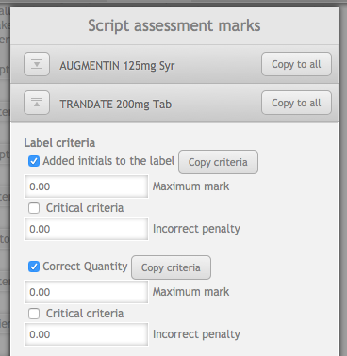
Medication name description
Expand/collapse medication section
Copy all criteria button

Enable checkbox

Copy criteria button

Mark field

Critical checkbox

Penalty field

The label marking pane separates each medication into it’s own collapsible section, similar to the exercise designer interface. Consolidating label marking in a single pane has allowed for criteria copy functionality to be added. In the diagram above, there are two buttons outlined, the copy criteria button and the copy all criteria buttons.
The copy criteria button is next to each criteria on a label. Clicking the button will copy the properties of that criteria to the same criteria on other medications. For example, if the added initials to the label criteria for Augmentin (medication 1) was enabled, had a mark of 5 and a penalty of 2 and the copy criteria button was clicked, the initials criteria for Trandate (medication 2), would be updated to match.
As another example, if you then disabled the initials criteria and clicked copy, then the initials would criteria would be disabled on all labels. Criteria copying will be applied to all labels currently in the exercise. There is no function to prevent it from overwriting a medication, so be careful!
Copy to all is an expanded version of the copy criteria button. It sits next to the medication name for the section because it will copy all of that label’s criteria settings and apply them to the other medications when clicked. The copy to all function is designed with the idea that one label’s criteria can be set up first and the settings for that label can be applied to the other labels.
This helps alleviate assessment setup time where label-marking criteria is identical or very similar across the labels. Once the copy function has been applied, settings can be changed individually without issue.
As with the cumulative marking section, criteria can be disabled by unchecking enable. If a label’s criteria are completely disabled, it will not appear in the assessment-marking interface. Marks and penalties are set in the same way as cumulative marking, with a positive value set in either field.

Setting up an assessment tutorial
Assessments in MyDispense are delivered using a tutorial set to be an assessment. If an assessment’s tutorial is not set up correctly it will not appear in the exam manager or display the submit button when students access the tutorial.
Assessments require that a studentgroup be attached to the tutorial. Studentgroups are a subset of students enrolled in the unit and can range from the whole unit to just one student based on need. Multiple studentgroups with different start and end times can be added to a tutorial, allowing for the same exam questions to be used with a ‘missed’ studentgroup at a later date.

How to set a tutorial as an assessment
To set a tutorial as an assessment, click on the edit tutorial button. The button is outlined in red in the screenshot below.
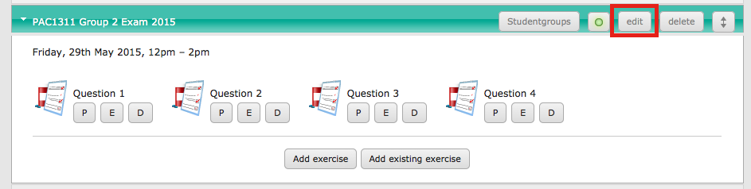
Doing so opens the edit tutorial screen and at the bottom of the screen are the assessment options. To set the tutorial as an assessment, check the tutorial is an assessment option highlighted in red. To save the new setting, click the update button.
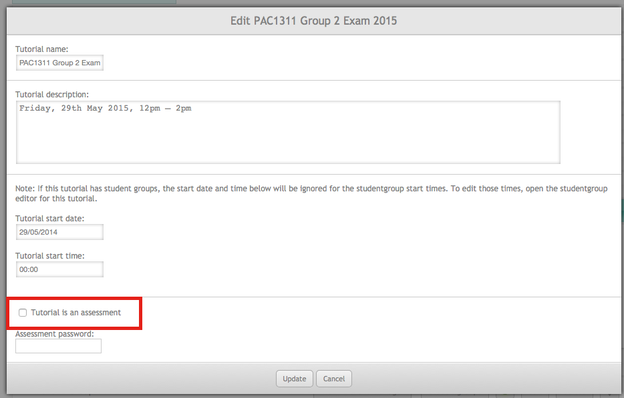
It is also possible to require a password to access the assessment by entering a password in the Assessment Password field. Note that the password would be required even during the start and end times for a studentgroup.
After clicking the update button, a red warning will flash if no studentgroups have been added to the assessment. The warning is a reminder that studentgroups are required for assessment and it may have deactivated the tutorial as a precaution.

Setting up Studentgroups
Once an assessment tutorial has been set up, a studentgroup needs to be created and populated. To access the studentgroups in a unit, click on the studentgroups button at the top of the tutorials screen.
Note that this guide assumes that there are students enrolled if the unit. If there aren’t students enrolled in the unit, do so now, otherwise you will not be able to create and manage studentgroups.
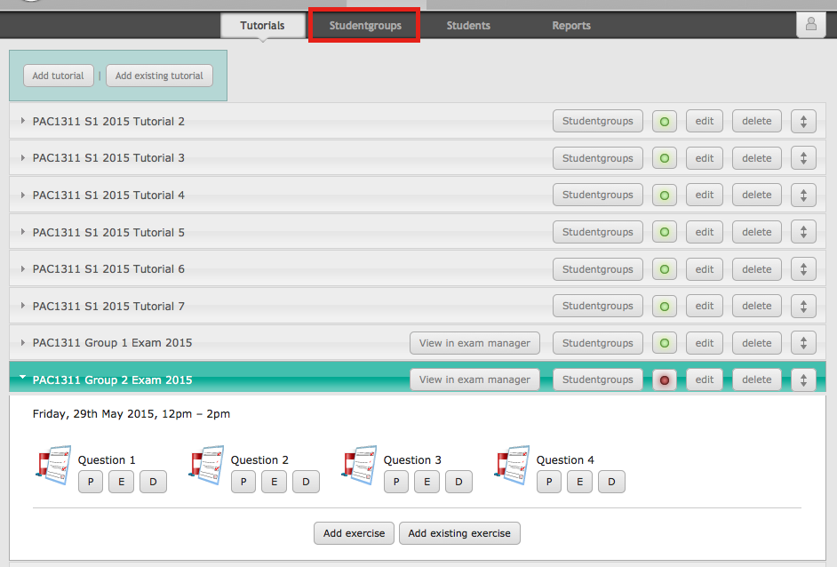
Once on the studentgroup page, create a studentgroup by clicking the add studentgroup button.
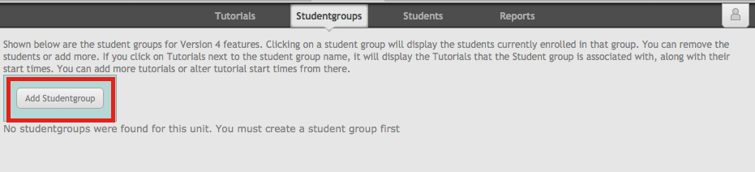
This opens the add studentgroup screen, which requires that you enter a name. Enter a name appropriate for your group (Exam Group 1, Unit group, etc.) and click the add button.
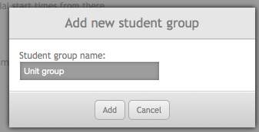
The studentgroup screen will look something like the screen below.
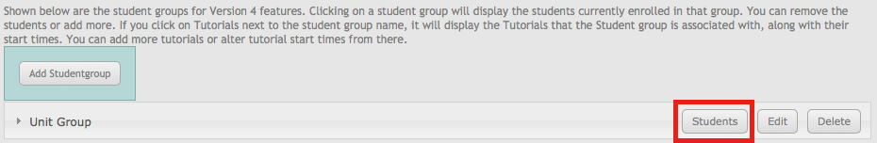
Now that there is a studentgroup for the unit, students must be enrolled. To do so click the students button in the group header, which opens the studentgroup student management screen.
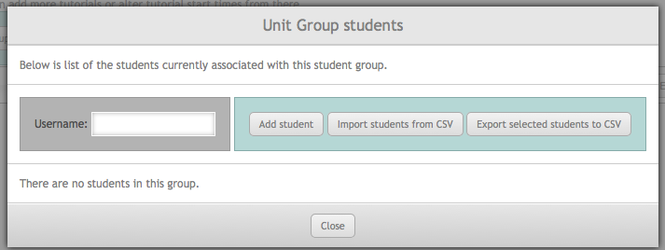
There are a two options for importing students into a studentgroup, using the list of students already enrolled in the exercise or by using a CSV file. The procedure for importing via CSV is the same as documented in the Version 4 instructor’s guide, so please consult that guide for instructions on how to import via CSV.
For the purposes of this document, click on the add student button. The add student screen displays all of the students enrolled in the unit.
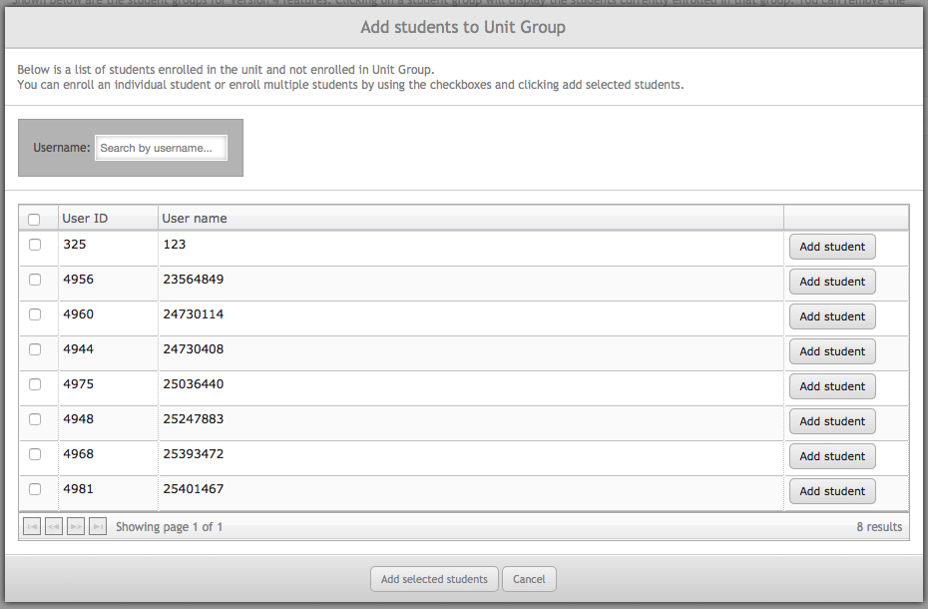
Username search
Add individual student button
Select student checkbox
Add selected students button
Cancel button
Select all

The username search box is used to find specific users enrolled in a unit. A single student can be added by clicking the add student button next to their username. Doing so will close the add student screen and return to the student management screen.
To add multiple students at a time, use the check boxes on the left of the table. Once the students have been selected (all students can be selected at once using the select all checkbox), add them using the add selected student button. This will enrol the students in the studentgroup and open the student management screen.
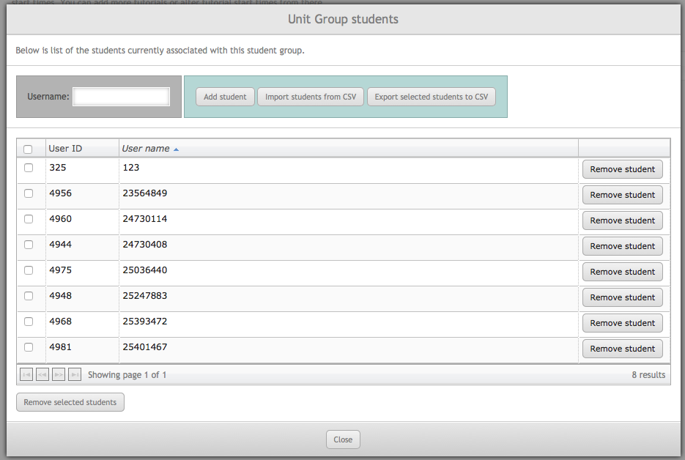
Once a studentgroup has students, they can be managed on the student management screen. Similar to the add screen, students can be removed one at a time by clicking the remove button (this does not cause the screen to be closed) or by using the checkboxes on the left and the remove selected students button.
Close the student management screen by clicking the close button.

Setting start and finish times for an exam
With the studentgroup setup and students enrolled, it must be associated with the assessment tutorial. To associate the studentgroup with a tutorial, click on the studentgroup name and it will slide open with more information.
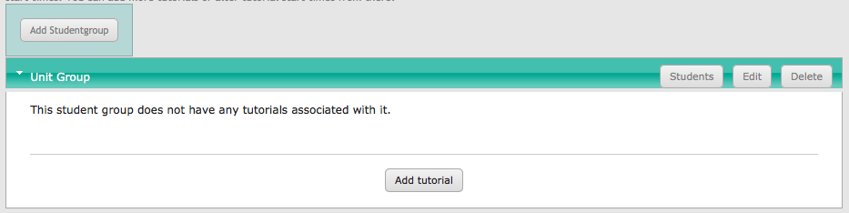
As seen in the screen shot, the studentgroup does not have a tutorial associated with it yet. Click add tutorial to add one.
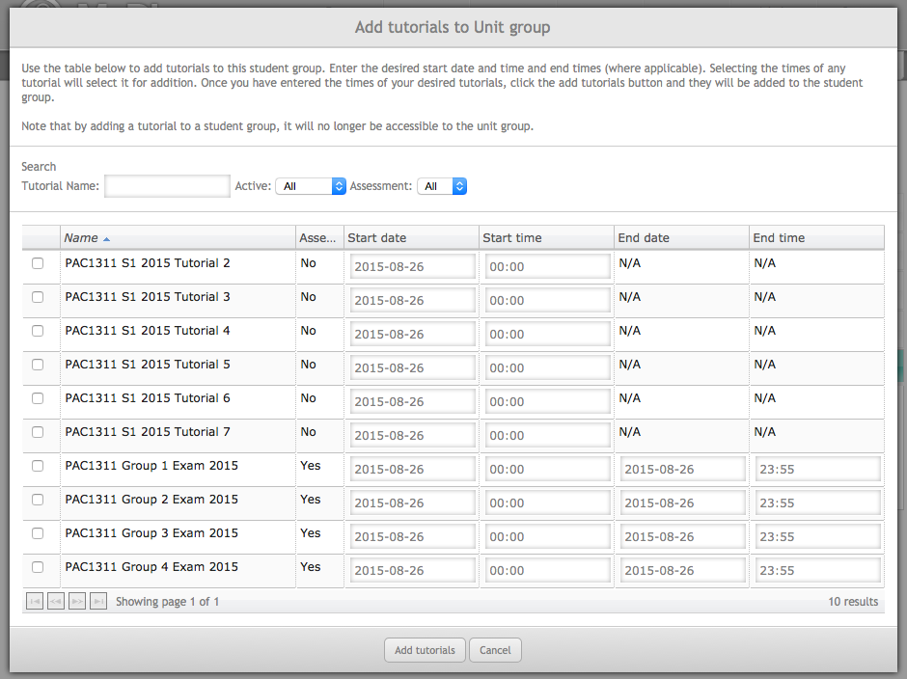
The add tutorial screen displays all tutorials in the unit inside a table. The search options along the top of the screen can be used to filter down to a subset of tutorials. Each row is a tutorial and displays whether it is an assessment and allows the start and end dates/times to be set. End date/time can only be set for assessments.
If an exercise is not associated with a student group, the start time for that tutorial is set in the tutorial settings (the same place the tutorial was set to be an assessment). Once a tutorial is associated with a studentgroup, the tutorials start time is ignored in favour of the studentgroup. Thus only students enrolled in the student group will be able to see that tutorial until it is removed, more students enrolled or more studentgroups are assigned to that tutorial.
The image below is a single row in the add tutorial table. The checkbox on the left is very important, if it is checked, then the studentgroup is going to be associated with that tutorial when the add tutorials button is clicked.
If the checkbox is not ticked, then the tutorial will not be associated with the studentgroup. Changing the start or end times for a tutorial will automatically check the box. To change the date / time, click on the field in the table and a widget will appear allowing you to select a date or a time based on the field clicked. Each MyDispense instance is set to the time zone of its institution, you do not need to calculate time zone offsets when setting date / time.
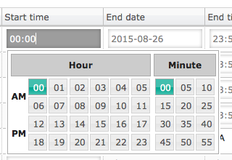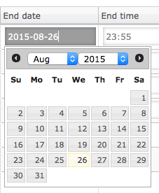
When setting start and end times for exams, the end time must always be after the start time. It is recommended that a buffer time be given before and after exams (15 minutes is a good benchmark) to ensure that the exam is displaying correctly for students and to give leeway in the event that extra time is given.
Once the end time has passed, students will not be able to access the tutorial. They can submit any exercise they are currently in, but will be unable to submit the exam. Students who have exercise data but were not able to submit (or forgot to), can have their exam manually submitted in the exam manager.
With the studentgroup associated with the assessment tutorial, remember to activate the assessment tutorial (which may have been automatically deactivated). If the tutorial is inactive come exam day, it will not appear to students.

To activate the tutorial, return to the tutorials management page and click on the activate button in the tutorial header. If the button appears red, the tutorial is inactive. If the button is green, the tutorial is active.
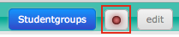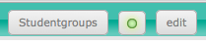

Exam manager
The exam manager is where the administration and marking of assessments are managed. In the exam manager you can view student marks, see which students have completed the assessment and which ones didn’t, mark individual students and export the marks for use in another application.

Accessing the exam manager
Clicking the exam manager button on the main menu accesses the exam manager.
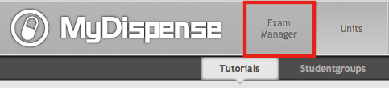
The landing page for the exam manager is the assessment list. The assessment list displays all assessment tutorials in MyDispense.
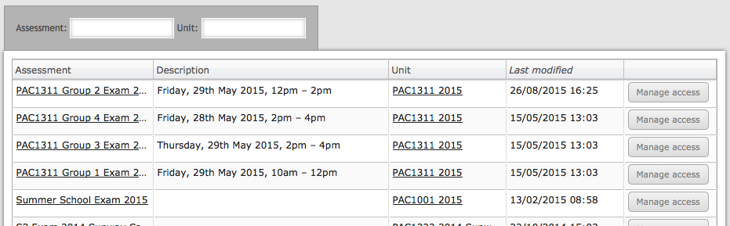

How to add markers to assessments
By default only administrators have access to all assessments. Instructors and Markers must be manually granted access to assessments. To add users, click the manage access button, which opens the marker access screen.
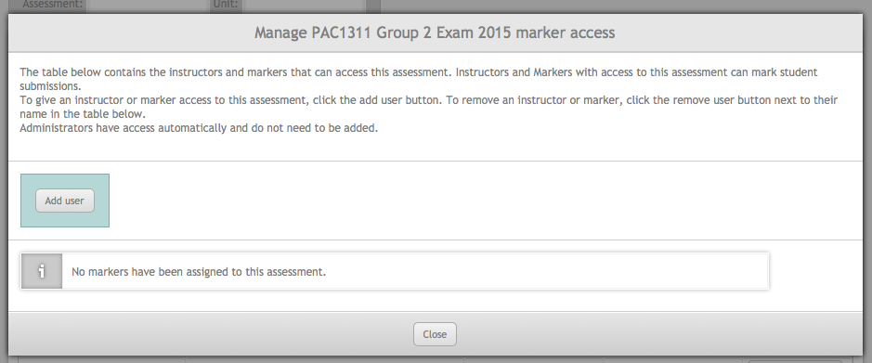
The marker access screen that appears is where users that have access are displayed. To grant access to a user, click the add user button. Doing so opens the add user screen and displays all instructors and markers in MyDispense.
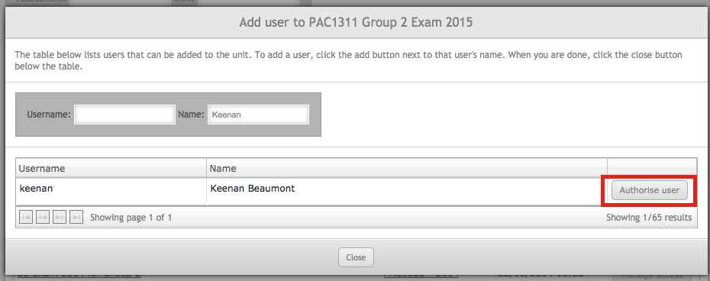
You can use the fields above the table to search by username and name (if it has been entered). To add a user, click authorise user, this adds the user to the assessment, but doesn’t close the dialog. You can search for another user and click authorize user again. Once you have added the users, click the close button to return to the marker access screen.
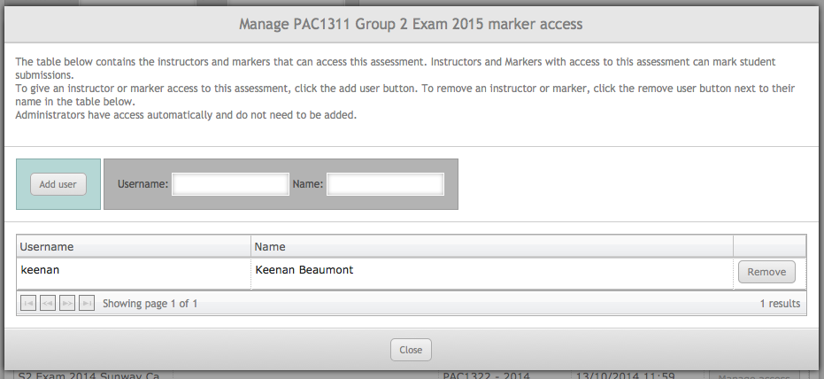
With a user authorised to access the assessment, you can remove them by clicking the remove button in the table. Note that there are no access levels for assessments, if a user have been authorised they have full access to the assessment contents. Any user authorised in this fashion cannot authorise other users. Only administrators can do so.

Assessment landing page
To access an assessment and start marking, click on the assessment’s name on the exam manager-landing page, which opens the assessment-landing page. The assessment landing page provides an overview of the assessment, displaying general statistics and marking progress for each question.
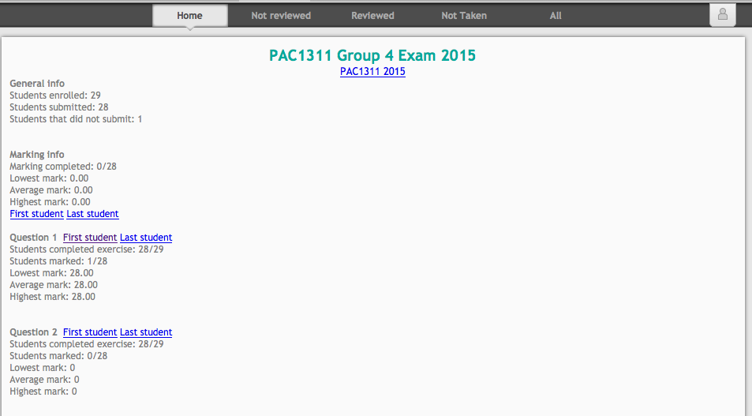
Along the top of the page is the assessment sub-menu, with links to the landing (home), Not Reviewed, Reviewed, Not Taken and All pages. The not reviewed page displays students that have not been marked completely and shows which questions have not been marked and marks for questions that have been marked.
The reviewed page displays the final mark for students and marks can be exported from the reviewed page. The All page displays all students currently enrolled in the assessment and their current status (Not taken, submitted, marked). The status of students can be exported from this page as a CSV file, along with detailed marks for each question (also in CSV).
The Not Taken page lists enrolled students that did not submit the exam. Simply because a student didn’t submit the exam does not mean that the student did not complete exercises in the exam. The list of not taken students can be downloaded in a CSV file.

Checking if a student accessed or attempted an exam
To check if a student that did not submit an exam accessed the exam while it was available, the Not Taken page provides access to the login times of each student enrolled in the exam. Checking if the student logged in at the time of the exam can be helpful if an exam dispute were to occur.
To view the logins for a student, open the not taken page, find the student and click the view logins button.
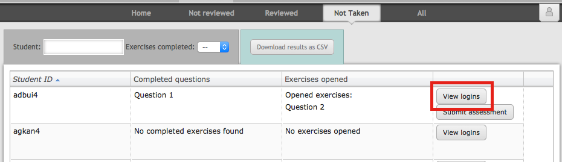
After clicking the button, the View logins screen opens and allows you to view all MyDispense login times for a student. The top of the screen displays when the assessment was available to the student and their last login time. At the bottom of the screen is a table of all of the student’s recorded login times.
By default the login time will be filtered to the date that the assessment was available, giving an overview of when the student should have logged in for the assessment.
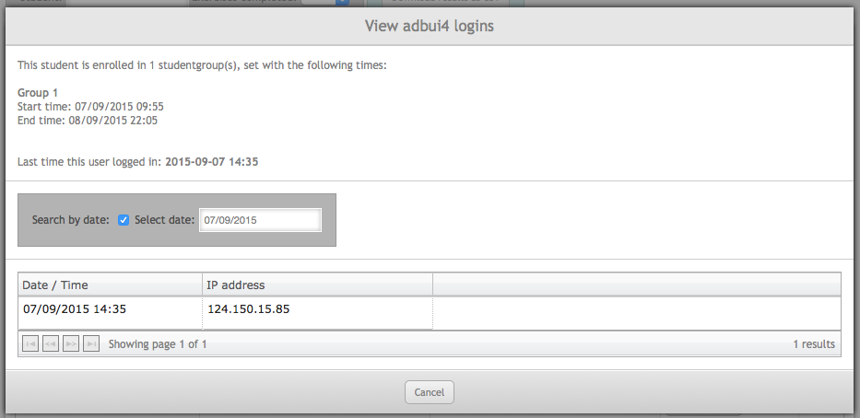
Unchecking the search by date checkbox can disable the date filtering. Doing so will display the login record for every time the student logged into MyDispense. Filtering is employed by default to keep the login record manageable.
Please note that logins can last up to 24 hours, so a login from the day before may still be valid.
In addition to logins, access to an assessment is also tracked by exercises opened. When a student opens an assessment exercise, it is logged and displayed on the not taken page.
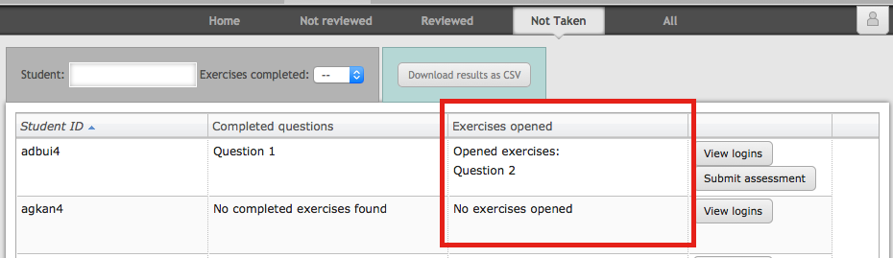
Exercise access logging is displayed in the table as exercises opened. If a student accessed an assessment exercise, the exercise name is displayed. When no exercises were accessed, No exercises opened is displayed and indicates that student did not open the assessment at all.

Submitting a partially completed assessment
Sometimes a student will forget to click the submit button and submit their assessment after completing some or all of the exercises. Completed exercises are listed by name in the completed questions column. If a student has completed exercises, you can submit the exam by clicking the submit assessment button.
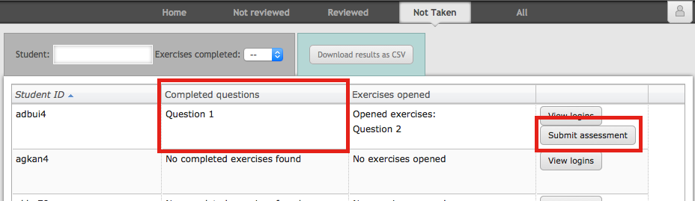
A confirmation screen will appear, with a list of exercises that can be marked once submitted. Click the submit assessment button to continue.
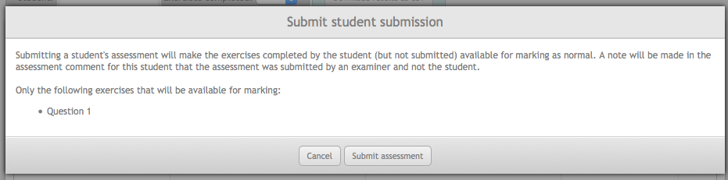
Now the student will appear on the Not Reviewed page as a student that requires marking and will no longer appear on the Not Taken page.

Assessment marking

Accessing exercise marks
The fastest and most efficient way to access marking for an exercise is through the assessment landing page. The landing page has links to mark the first and last students for each question, ensuring that marking starts from the beginning and students aren’t missed. Clicking the first student link for an exercise opens the marking interface.

Exercise marking interface
The marking interface is made up of different sections for each medication on the prescription (where applicable) and a section for exercise level criteria. Within each section there are two tables, one for auto-marked criteria in pink and another for manually marked criteria in blue. Each section has its own mark that is logged independently of the other sections.
On the right side of the screen is the final mark and navigation sidebar. The sidebar keeps track of the section marks, the final mark and comment.
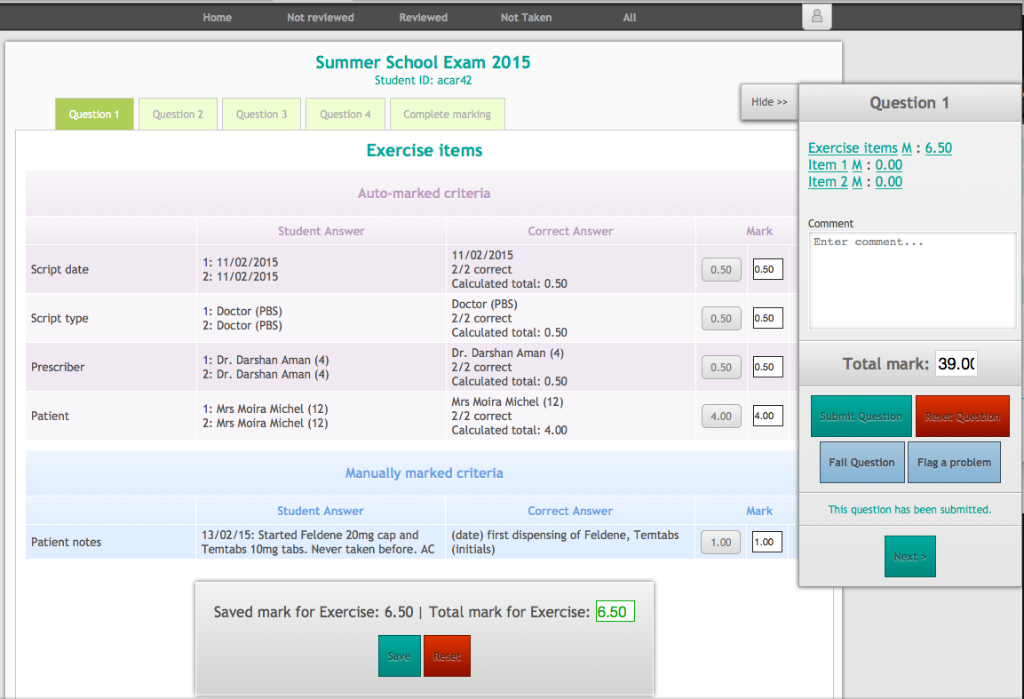
Exercise menu
Marking sidebar

Automark section

Manual mark section

Section mark

The exercise menu links to the marking page for other exercises in the assessment. Note that the link opens the marking page for the current student. Thus if you click on the Question 2 link while marking Question 1 for acar42, marking for question 2 will open for acar42 when the link is clicked.
The menu buttons are coloured with the current marking state for the question. Green indicates that marking has been completed for that question. White indicates that the question has not been marked yet. Black indicates that the question was not completed by the student and is unavailable for marking.
Clicking green and white buttons will open the marking page normally. Clicking when the button is black will open the marking page with a message that the student did not complete the exercise and no marks can be awarded for that exercise.

Marking
The marking interface is divided into two tables per marking section, the pink automark table and the blue manually marked table. Each table row is a marking criteria, where marks can be assigned.
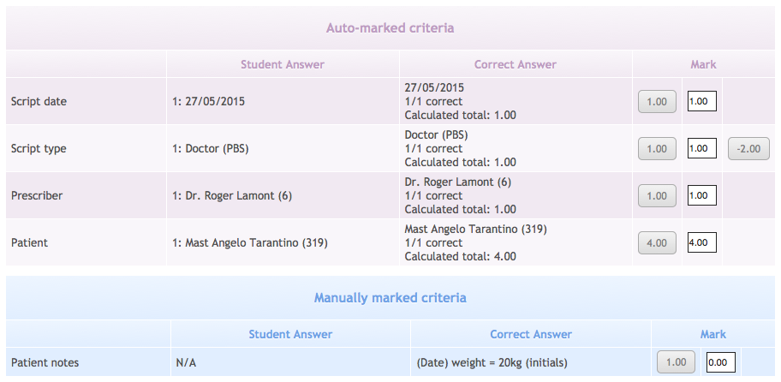
Criteria name
Student’s answer
Correct answer
Maximum mark
Penalty mark
Current
mark

Automarked criteria are simple criteria that compare the student answer and the correct answer. If the answers match, then the system will assign the maximum mark set for the criteria. The maximum mark for the criteria is displayed in the maximum mark field as a button. Clicking the button will assign the mark displayed as the mark for the criteria.
The mark field can be overwritten and custom marks assigned at any time. Marks must be a number up to two decimal places and can be negative. When a mark is entered, it is automatically formatted. If a non-number value is entered into the field, it will default to 0.00.
The column on the right of the mark contains the penalty mark button. If a penalty mark has been assigned to a criteria, then the button will appear as potential penalty for non-completing the criteria or getting it incorrect. Clicking the penalty mark button works the same way as the maximum mark button. Clicking it will assign the displayed value as the current mark. If the value displayed is -2.00, then the final value will be -2.00 marks.
Manually marked criteria default to a mark of 0 as they are considered too complex for automatic marking. The penalty and maximum mark buttons function the same, with the maximum mark button providing an easy method of marking criteria.

Critical criteria
Marking criteria can be set as critical in the exercise designer and act as normal marking criteria until they receive a mark of 0 or less. When a critical criteria goes under that mark, it is highlighted in the marking table and displayed as a direct link in the marking sidebar.
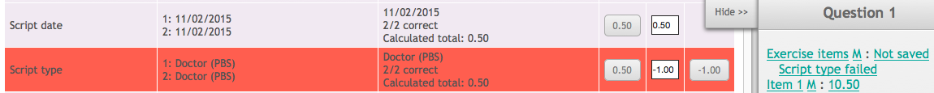
Note the script type failed underneath the Exercise items section in the sidebar. This indicates that a critical criteria has failed, along with the red highlighting of the criteria row. Note that the system only exposes critical criteria failures to the marker. The marker must decide whether to fail the question or award reduced marks.

Saving section marks
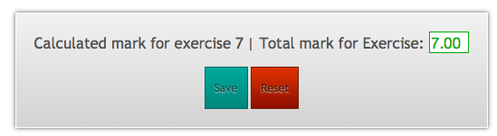
A marking section has a pair of Automarked and Manually tables and a section mark interface underneath them. The section mark interface has the final mark for that section, the current saved mark (or total automark calculation if no mark is saved), a save button and a reset marks button.
Current mark
Saved mark
Save marks button
Reset marks button

Criteria marks in a section are not saved until the section is saved. Section marks are saved by clicking the save marks button, which also saves the total mark for the section from the current section mark. The section mark is calculated by adding up the marks from each section criteria. The section mark can be overwritten at any time by entering a new mark in the current mark field. If you want to re-calculate the mark, click inside the mark field in an automarked/manually marked criteria and click out again. This will update the current section mark again.
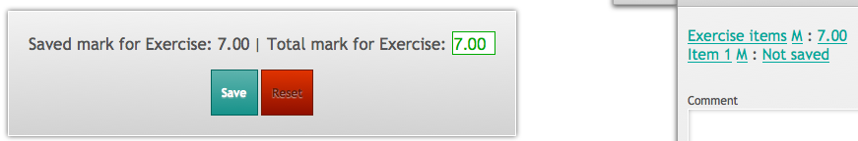
Once the section mark has been saved, the text on the left will change from ‘Calculated mark for…’ to ‘Saved mark for…’. This indicates that the mark has been saved and the current value of the mark. The marking sidebar will also display the current section mark next to the section (depicted on the far right). Sections that have not been saved will display Not Saved next to them in the marking sidebar.

Resetting section marks
To reset marks for a section, click the reset button in section mark area. Resetting marks for a section will set manually marked criteria back to 0, re-run the automarking system for Automarked criteria and remove the currently saved section mark.
Automarked criteria marks are calculated when the marking page is first opened, on a per student per exercise basis. Resetting section marks can be useful if the exercise mark values have been changed after the marking page has been opened as it triggers automark calculation.
Note that if marks for a section are reset, the exercise submission status will be set to unmarked.

Marking sidebar
The assessment marking interface includes the marking sidebar on the right hand side of the screen. The sidebar provides an overview of the assessment, the total mark for the exercise, exercise flagging options, exercise submission buttons and navigation options.
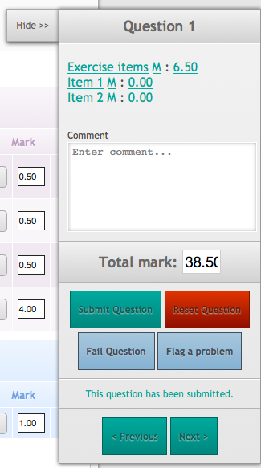

Hide/Show button
Marking section navigation
Question submission

Assessment navigation

Navigating exercise marks
The marking navigation section lists each marking section in the exercise and the current mark assigned to that section. It starts with the exercise items, which is the section used for exercise level marks such as Fact Finding, Errors and Cumulative marks and lists each medication on the script as Item #. Item 1 is the first item on the prescription, Item 2 the second and so on.
The marking section text can be clicked to navigate to that section. It may be difficult to see, but there are three navigation links per section.
The section name can be clicked to take you to the top of that section. For example, if you were to click the Exercise Items text, it would scroll the page to the start of the exercise items section. If you were to click the Item 1 link, it would take you to the first medication marking section.
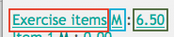
Section name link in red, Manual mark link in blue, Section mark link in green.
Next to the section name, there is an M. This stands for manual marking and clicking the M will scroll to the manually marked criteria for that section. Thus clicking the M next to Item 1 will display the manually marked items for the first medication on the script.
Finally, clicking the mark on the right of the section will scroll to the marking section for the section.

Saving question comment and mark
Exercise marks are saved using the assessment sidebar. As each section in the exercise is marked, the total is tallied as mark for the exercise. Once each marking subsection has been completed, the final exercise mark and comment can be submitted.
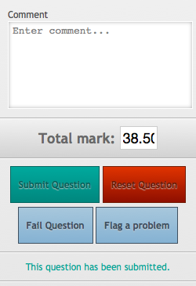
The comment box is used to write an optional comment about the student’s performance or can be used for internal messages / reminders to other markers.
By default, the total mark for the exercise is calculated by adding up individual marks for each section. However, the mark can be overridden by entering a new value in the field.
To submit the mark for the exercise, click the Submit Question button. This will save the mark, along with the comment and set the question as marked. With the question marked, the assessment navigation tab for the exercise at the top of the screen will turn green, signifying that the question has been marked.

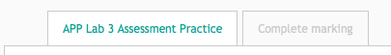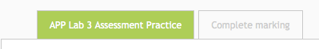
In addition to regular question saving, there is the option to fail an exercise. Failing an exercise will submit each section with its current mark and the exercise with a mark of 0. To fail a question, click the fail question button. If a comment has not been entered, the comment ‘Question failed’ will be entered and saved.

Resetting exercise marks
To reset the marks for an entire exercise, instead of a just a section, click the reset question button in the marking sidebar. Doing so will reset the marks for each section and reset the marking status to unmarked. Resetting the exercise will also re-run the automarking system for all criteria in the exercise.

Exercise flagging
When a problem occurs when marking an exercise and the marker is unable to resolve it, the exercise can be flagged. Exercise flagging allows a marker to flag the exercise as having a technical problem or a academic / peer review problem. A description of the problem can be entered in a problem field and the problem flagged.
Exercises that have been flagged then appear on the assessment landing page as separate links for easy access. When a flag is set, it is set for the current page only, covering a single student’s marks for an exercise.
To flag an exercise, click the Flag a problem button on the marking sidebar. When the flag a problem button is clicked, the question submission disappears and is replaced with the flag a problem interface.
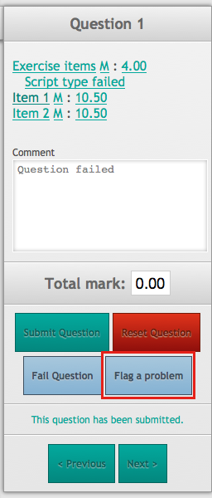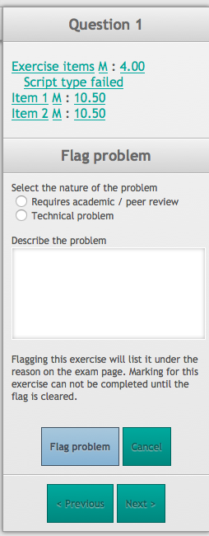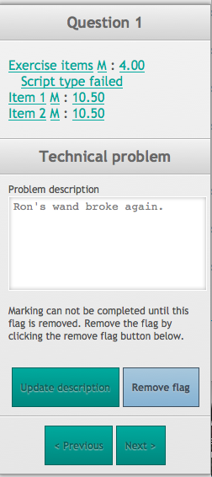
Left to right: Regular marking sidebar, Flag a problem interface, Flagged exercise interface
On the flag a problem interface, the type of problem can be selected along with a description of the problem. The flag can be cancelled by clicking the cancel button, which will return to the regular marking sidebar. To confirm the flag, click the flag a problem button.
Once a flag has been confirmed, marking can not be completed for the exercise until it has been removed. The marking sidebar interface will display the flagged exercise interface (3rd image above), until the flag is removed. The flag can be removed by clicking the blue remove flag, or the description updated by changing the text and clicking the update description button.
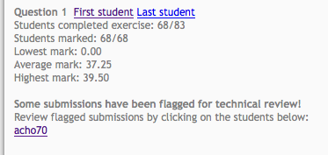
On the assessment landing page, the flagged exercise appears underneath the reason for the flag. Clicking the student username link will display the marking page for the student and the flagged exercise interface in the sidebar.

Flagging makes problems easier to find than sending links and usernames through email. Removing the flag from the exercise will make the normal sidebar interface appear and remove the exercise from the assessment landing page.

Assessment navigation
Along the bottom of the marking sidebar, there are next and previous navigation buttons. When clicked, these buttons will load the marking page for the next (or previous) student enrolled in the assessment. Note that the navigation button will load marking for the same exercise, only for a different student. Once the last student has been reached, the next button will disappear and the previous button will disappear if the first student is reached.
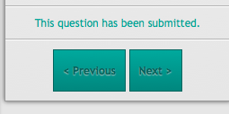

Exporting marks
Assessment marks can be exported and downloaded from the Reviewed or All page in an assessment. These pages can be accessed from the landing page assessment submenu. Marks are provided in a CSV format for import into other systems.

Reviewed page export
The reviewed page download provides the final mark, username and comment for the completed assessment. To download the exported marks, click the download results as csv button. Your browser will be prompted to download the CSV file.
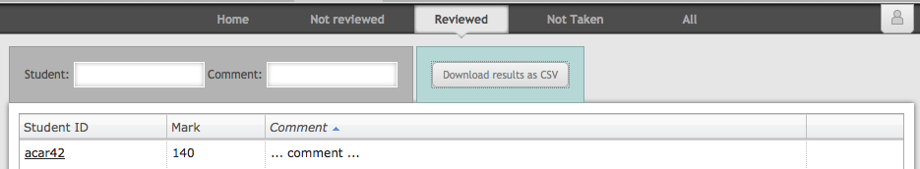

All page export options
The All page provides two download buttons. Download results as CSV and Download Question Results as CSV. The download results as CSV button exports the status of all students, including the student username, whether they submitted the assessment, whether they have been marked, the final mark (if applicable), comment and the IP address of the submission.
Download Question results as CSV exports the username, the total mark, final comment and the mark for each question. Each export option has its uses and downloads in CSV format. To download either, click the download button.

