MyDispense Validation Exercise

User Guide

About MyDispense
MyDispense is an online pharmacy simulation that allows you to develop and to practise your dispensing skills. It provides a safe environment in which you may make mistakes without experiencing the serious consequences of practicing in the real world. For your maximum benefit use MyDispense as seriously as you would when dispensing medicines in real practice.
You will access a number of exercises, grouped into tutorials, each designed to support specific learning outcomes. At the end of each exercise you will receive feedback to indicate how well you did and to outline any mistakes you might have made. You may also undertake marked assessment exercises in MyDispense.

An important note about Web browsers
MyDispense will run very well in all of the mainstream web browsers, however, we recommend that you use the Firefox browser for the best experience. If you use Microsoft Internet Explorer at home you will need to ensure you have version 9 installed, which requires Microsoft Windows 7 to run. If you do not have Windows 7 we recommend that you install another browser such as Firefox or Chrome - both of which are free to download and install.

The introduction Screen
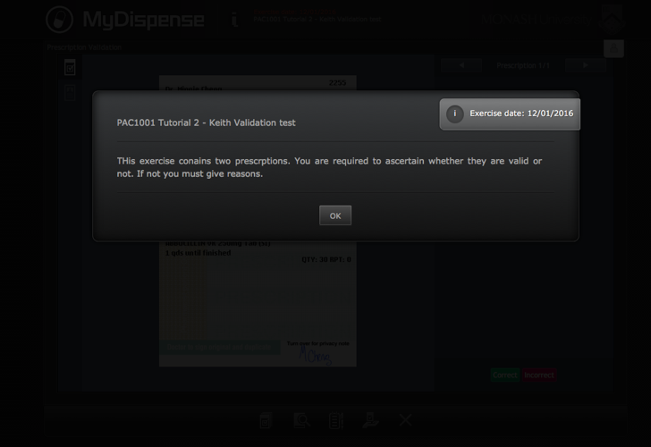
Once you have selected an exercise you will see the Introduction screen. This screen gives some background information and provides context for the exercise.
Click on the OK button to continue.
If you want to see the Introduction screen again click on the exercise name next to the Monash University logo. 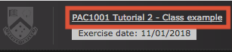

Exercise screen
The main exercise screen displays the prescription under review and its current status.

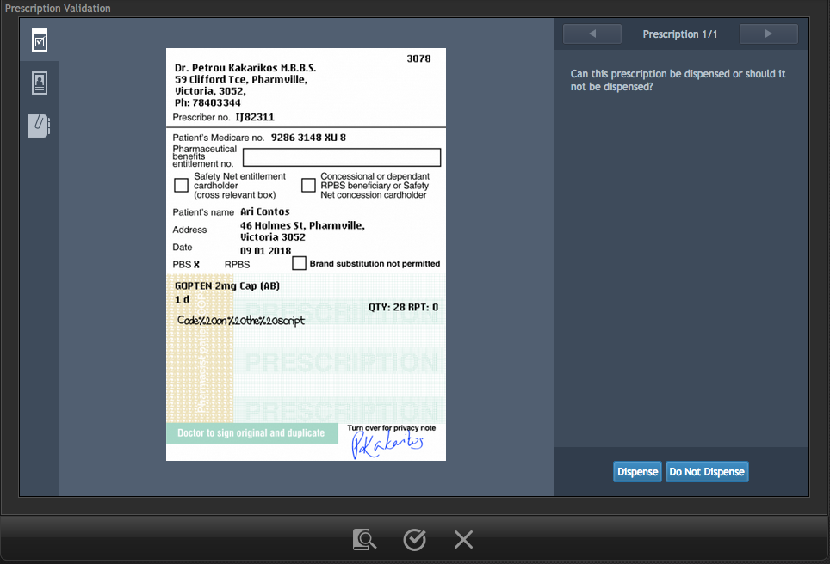
Attachments
Patient information
Review area
Prescription
Toolbar
You are working at a dispensary and have been asked to review prescriptions that are about to be dispensed. You will review each prescription you have been given and decide if the prescription is correct or if there is a problem with it.

Toolbar tools

Accessing information sources
During an exercise you will need to gather information to safely dispense the prescription. There are a number of online resources available within MyDispense which are accessed by clicking on the references icon in the toolbar.
This will show you the references panel.
Click on the relevant link to go to the appropriate online resource.
You may need to enter your Authcate ID and password when accessing resources within Monash University, for example MUSO, Micromedex and Martindale.
You can toggle the references panel visibility by clicking its icon in the toolbar.

Saving and exiting
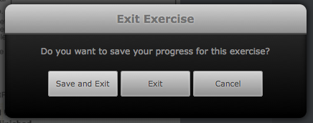
Clicking on the exit exercise icon will open the exit exercise dialog box.

The dialog has three options, save and exit, exit and cancel. Save and Exit will save your current exit progress and return you to the Unit tutorial screen. The next time you open the exercise you will be asked if you want to continue from where you left off.
Exit will return you to the unit tutorial screen without saving your progress. Cancel will close the dialog.

Navigating prescriptions
A validation exercise may have more than one prescription for you to review. To navigate through the prescriptions, use the left and right arrow buttons on top of the review area. The number of prescriptions is displayed between the arrows, along with the prescription # currently displayed.
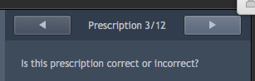

Viewing patient details
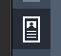
As you navigate the prescriptions in the exercise, you may need to know some more background information about the patient on the prescription. To view the patient and prescriber details on a prescription, click the patient details icon.

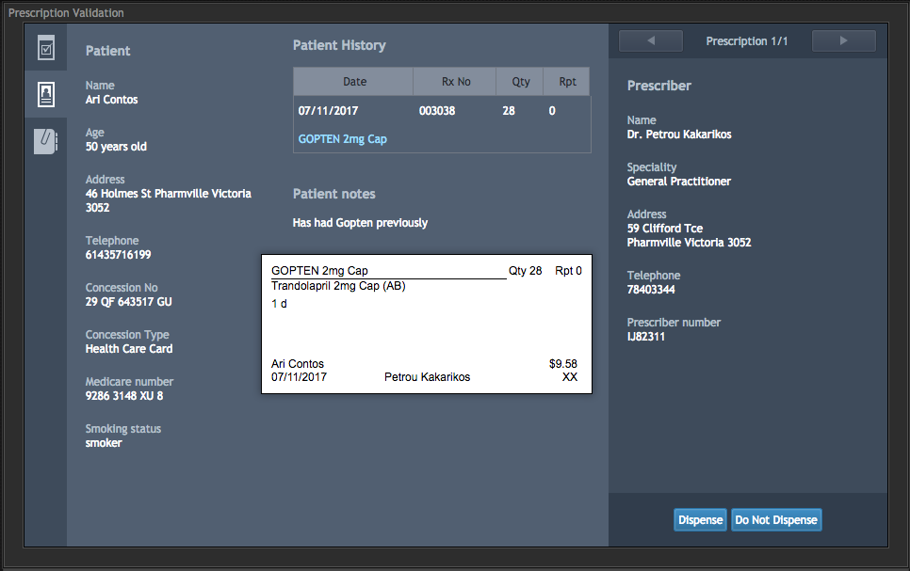
Prescriber details
Patient details
Sometimes the patient may have some patient notes and dispensing records. To view a dispensing record in detail, click on the blue medication name; doing so will display the label from the dispensary.

Viewing attachments
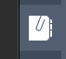
As you navigate the prescriptions in the exercise, some may have additional information available in the form of attachments. To view the attachments for a prescription, click the attachments icon.

Reviewing a prescription
Reviewing prescriptions is done in stages. First you must decide if there is something wrong with the prescription. To do so you must select whether the prescription is correct or incorrect by clicking the correct or incorrect buttons on the bottom of the prescription review area.
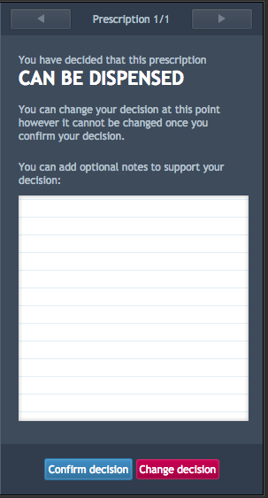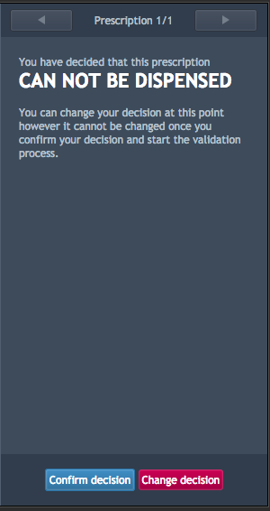
At this point you may still change your decision. If you click the change decision button it will return you the first decision screen, where you select if the prescription is correct or incorrect. If you confirm your decision you will not be able to change your decision on whether prescription is correct or not, so choose wisely.
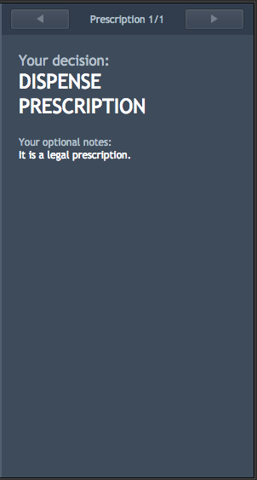
On the Can be Dispensed decision screen, you may enter notes that refer to your decision making for the prescription.

Correct confirmation
When you confirm that a prescription is correct the decision area will turn green to confirm your decision. Once your decision has been confirmed you can not edit the prescription again, it is locked to your decision.
Once a decision has been made for a prescription, it is considered complete. You may finish the exercise when all the prescriptions you need to check have been completed.

Incorrect confirmation
When you confirm that a script is incorrect, you must select reasons why it is incorrect.
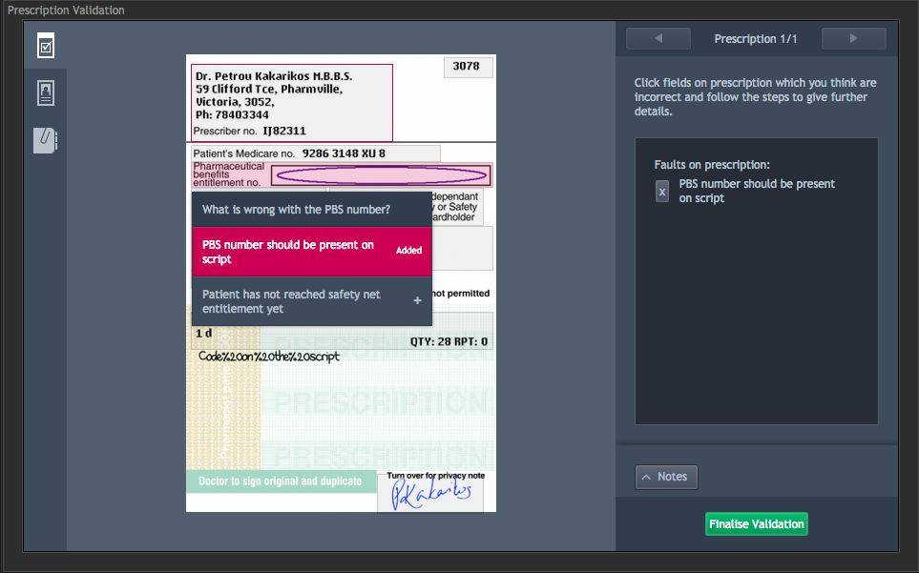
To select the reasons why, you must select areas on the script where you believe the problem exists and select a problem from the box that appears. In the above image, you can see that clicking on the script displays a menu with options. If a problem in the list has an arrow next to it, clicking it will reveal more problems that can be selected. If a problem has a + next to it, it will be added to the list of problems with the prescription and will circle the problem on the prescription (where applicable).
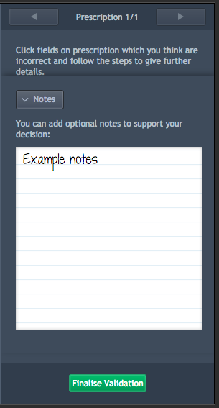
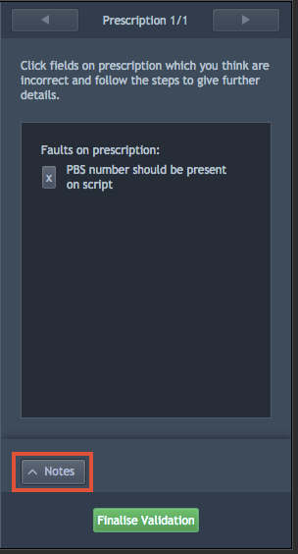
You may also add notes about your decision making by clicking the notes button on the right hand side of the screen, under the list of problems. This will display the notes section where you can enter your notes.

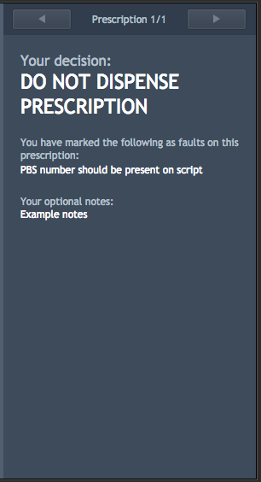
If you have selected a problem and you want to remove it, click on the X button next to the problem to remove it.

When you have identified all of the problems, click on the finalise validation button to finish reviewing the prescription. You must have selected at least one problem to finalise the prescription. When the script has been finalized the review area will have be filled in red.

Finishing the exercise
When you have reviewed all of the prescriptions, you will need to hand the prescriptions back to your work colleague. You can do this by clicking on the handover icon on the task bar.
Clicking on the button will display a confirmation window. Click finish to complete the exercise and display feedback. If you have not reviewed all of the prescriptions, you will be unable to complete the exercise.

Getting feedback
When you have completed an exercise and return to the dashboard the icon for that exercise will change from the available icon to the feedback icon. Click on the feedback icon to see the feedback screen.
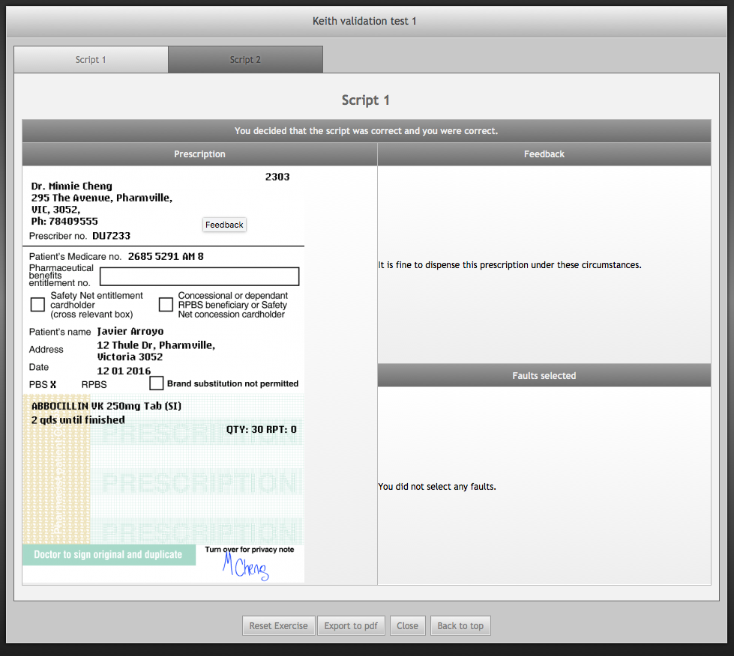
On the feedback screen, each prescription in the exercise is displayed as a tab on the top of the screen.
Clicking on the prescriptions will swap to feedback for that prescription.
Underneath the script number is the outcome for the exercise. The outcome tells you if you selected whether the script was correct or not correctly.
Underneath the outcome feedback is the prescription.

The prescription displays any problems with the prescription. Problems that you matched correctly are displayed in green. Problems you missed are displayed in red and problems that you selected but were not matched are displayed in purple.
On the right side from the prescription image is the problem section. The problem section lists each problem you got correct, the ones you missed and the ones you selected without a match.
You can reset the exercise and attempt it again by clicking on the Reset exercise button. Note that resetting an exercise will erase the existing exercise data.
When you have finished using MyDispense, remember to log out of the website and also close the browser to prevent anyone else from using your account.

