MyDispense User Guide

About MyDispense
MyDispense is an online pharmacy simulation that allows you to develop and to practise your dispensing skills. It provides a safe environment in which you may make mistakes without experiencing the serious consequences of practicing in the real world. For your maximum benefit use MyDispense as seriously as you would when dispensing medicines in real practice.
You will access a number of exercises, grouped into tutorials, each designed to support specific learning outcomes. At the end of each exercise you will receive feedback to indicate how well you did and to outline any mistakes you might have made. You may also undertake marked assessment exercises in MyDispense.

An important note about Web browsers
MyDispense will run very well in all of the mainstream web browsers, however, we recommend that you use the Firefox browser for the best experience. If you use Microsoft Internet Explorer at home you will need to ensure you have version 9 installed, which requires Microsoft Windows 7 to run. If you do not have Windows 7 we recommend that you install another browser such as Firefox or Chrome - both of which are free to download and install.

The MyDispense Dashboard
You will now see your MyDispense Dashboard screen. You will see a list of Units that you have access to. Click on the View tutorials button to see the tutorials within the unit.
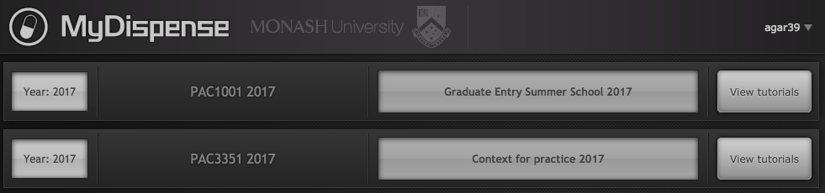
Click on a button to open the unit.

You will see a list of tutorials. Clicking on a tutorial title bar opens it so you can see the exercises within.
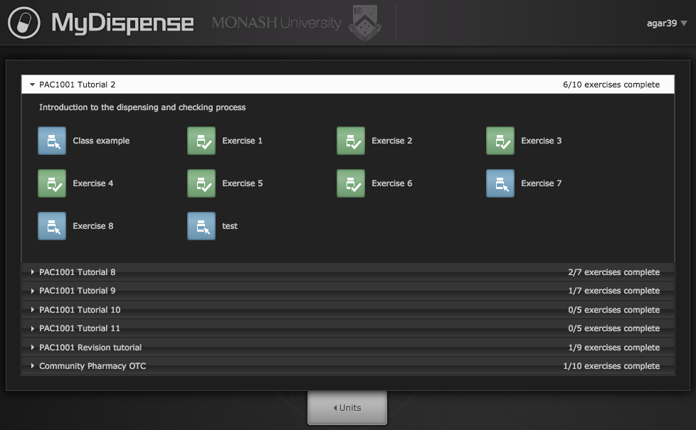
Click on the tutorial title bar to see the exercises.
exercise.

Click on an icon to go to that exercise.

The introduction Screen
Once you have selected an exercise you will see the Introduction screen. This screen gives some background information and provides context for the exercise.
Click on the OK button to continue.
If you want to see the Introduction screen again click on the exercise name next to the Monash University logo. 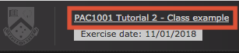
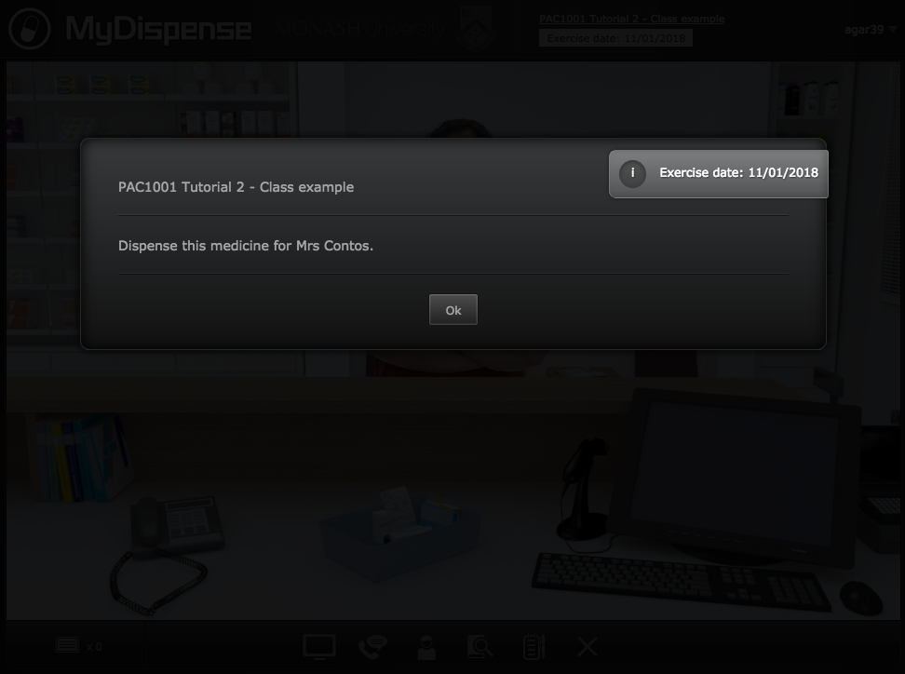

The dispensary screen
This screen gives you access to the tools and resources you need to complete an exercise.

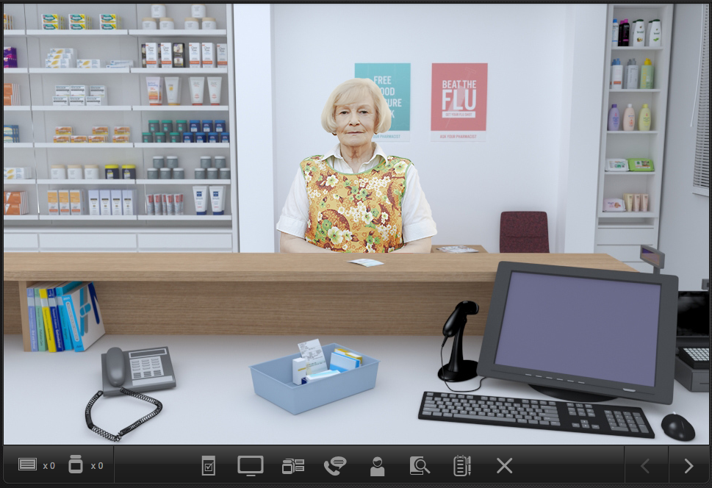
Dispensing software
Toolbar
References
Patient
You are the community pharmacist standing behind the counter of this busy dispensary. A patient will be standing at the counter waiting for you to dispense their prescription appropriately.

Viewing the prescription
The first thing you will want to do is examine the patient’s prescription. To do this, click on the prescription button in the toolbar or on the prescription on the shop counter.
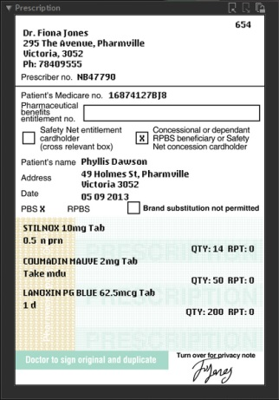
The prescription button shows you the prescription panel.
You can drag the prescription around the screen to position it so that it does not obscure information underneath.
You can also toggle the prescription visibility by clicking on the prescription icon on the toolbar.
You can change the size of the prescription by clicking on the magnify buttons and lock it to the top layer by using the lock button.

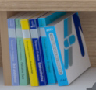
Accessing information sources
During an exercise you will need to gather information to safely dispense the prescription. There are a number of online resources available within MyDispense which are accessed by clicking on either the references icon or the reference books on the counter.
This will show you the references panel.
Click on the relevant link to go to the appropriate online resource.
You may need to enter your Authcate ID and password when accessing resources within Monash University, for example MUSO, Micromedex and Martindale.
You can toggle the references panel visibility by clicking its icon in the toolbar.

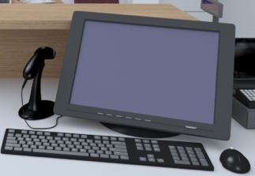
The dispensing application software
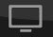
Nearly all modern Australian pharmacies use software to help manage the dispensing process. MyDispense has a simulated dispensing package built into it that you can access either by clicking on the dispensing app icon on the toolbar or the computer screen on the counter. You can toggle the visibility of this screen by clicking on the dispensing app icon.

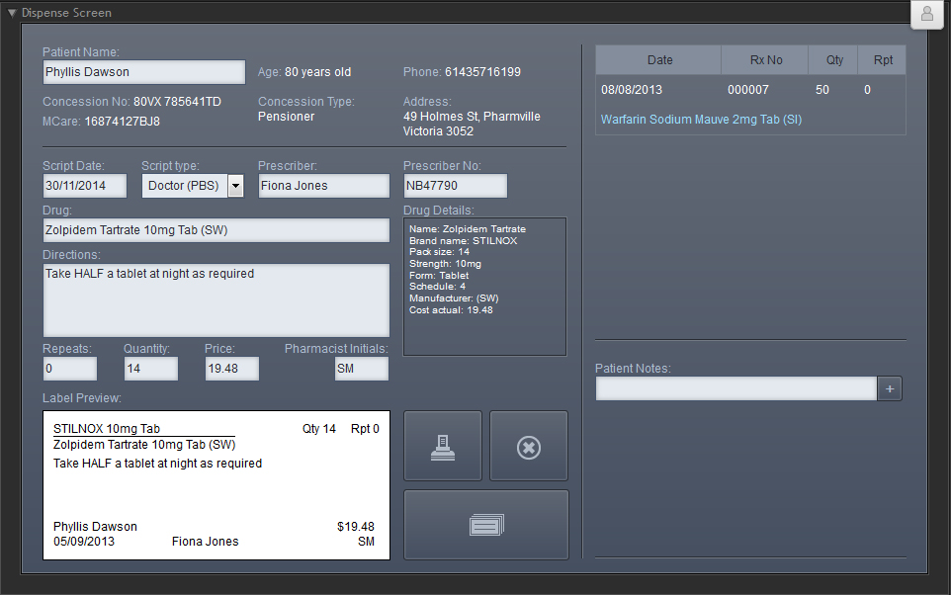
You will need to select a patient from the patient database. To do this type the first few letters of the last name of the patient on the prescription into the Patient Name box, then hit the Enter key. Select the correct patient from the list that appears.
You need to select a prescription date and prescription type from the drop-down lists that appear when the appropriate field is clicked. | 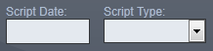
You will also need to select a prescriber and drug from the appropriate fields by typing the first few letters of the appropriate name into the box and pressing Enter. The software shows you a list of items or people whose names begin with those letters. | 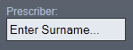
In the Directions box, enter the directions that you want to appear on the label.
Make sure that the Quantity and Repeats values are correct. You should also enter your initials in the Pharmacists Initials box. The Price field shows an indicative price for the medicine, and requires no input. | 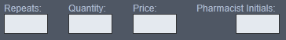
The space near the bottom right of the screen allows you to enter patient notes.  Existing notes appear in grey; your notes will appear in blue.  To add a note, begin typing in the white space, then click on the + button to save your note. You can edit a note by clicking on it and delete a note by clicking on the X button. | 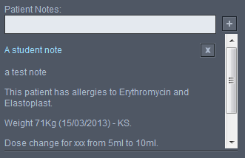
Click on the print button to create a virtual label. Click on the clear button if you want to clear the screen of data and start again. | 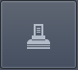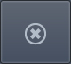
Once you have printed a label the Label Management panel will appear. The label management panel is where you select the medication on the prescription that your label is intended for.
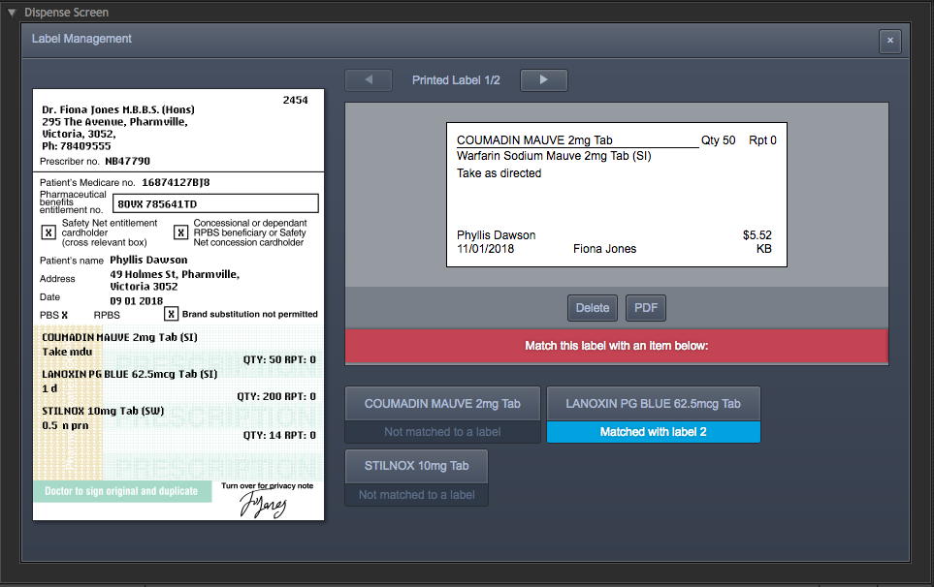
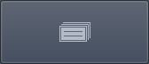
On the left is the prescription and the labels you have created are on the top right. Below the label are buttons that correspond to each medication on the prescription. When you click a medication button, that will tell MyDispense that you want to use that label for that medication on the prescription. You must select a medication for each label you create. If you try to submit the exercise without selecting medications for all of your labels, you will be taken back to the label management panel.
If you need to see the label management panel again, click on the Label Management button

If you need to change the label, click on the Delete button underneath the label and edit the details in the dispensing app.
Click on the button to close the Label Management panel.

The Pharmacy Back Room
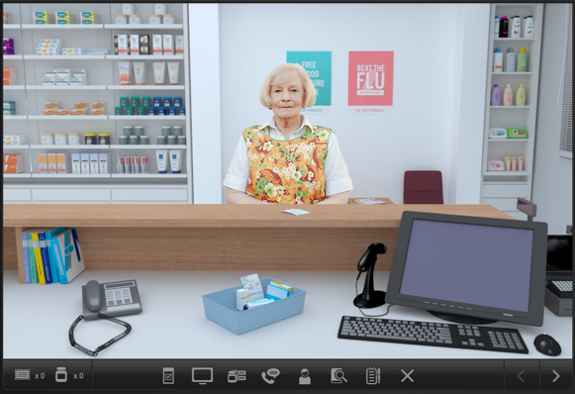
The Pharmacy Back Room allows you to access the medicines and other products that you will need to dispense to patients.
To get to the back room click on the right arrow button at the bottom right corner of the task bar:
You will see the backroom appear. You can click on the Shelves, the Fridge and the Safe to select products from any of those locations.
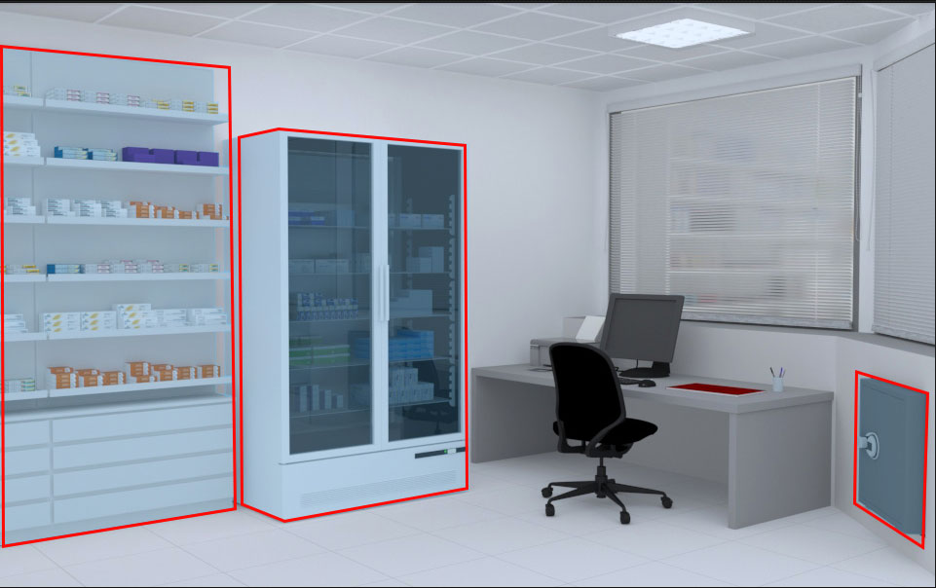
Safe
Shelves
Fridge

Product Selection
From the Back Room screen, click on either the safe, shelves or fridge to open the Product Selection screen.
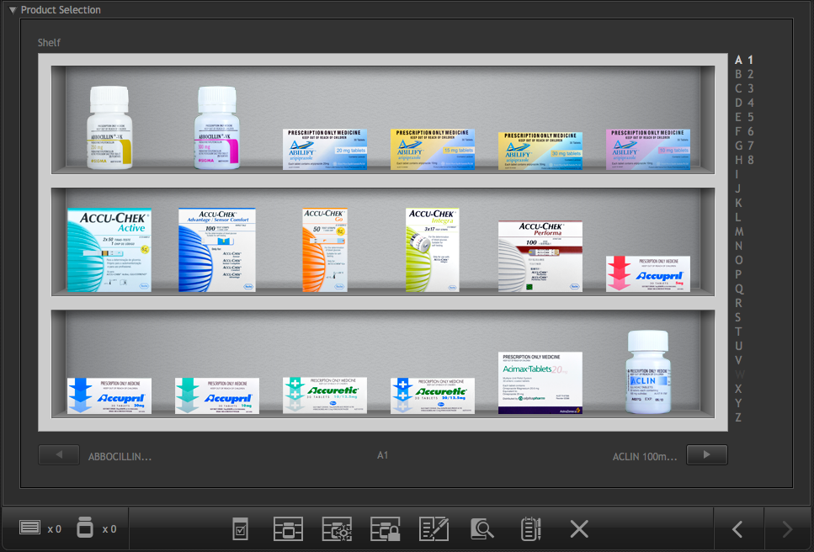
Safe
Shelves
Fridge

You can quickly swap between locations by clicking on the icons on the back room taskbar.
Instructions for selecting products:
Use the alphabetical list to go to the shelves containing drugs that begin with that letter. Products may be arranged in alphabetical order either by brand name or generic name; the ordering will be made clear in the exercise instructions. Click on the sub-list to the right of the alphabetical list to move between screens of items beginning with the same letter, or use the arrow icons under the shelves.
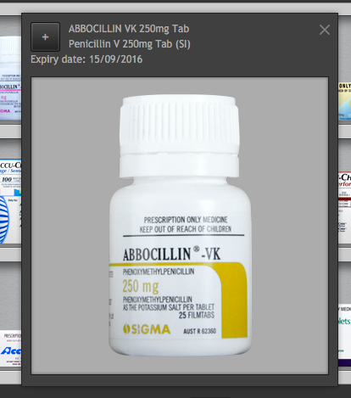
Click on an item on a shelf to open the medication information window. The information window can be moved by clicking on the borders of the window and dragging.
To add the medication to your inventory, click on the + button.

The Schedule 8 Register
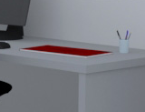
If you are required to dispense items from the safe, you may need to complete an entry in the Schedule 8 register. This is located in the Back Room on the desk below the safe.
You will see the Index page:
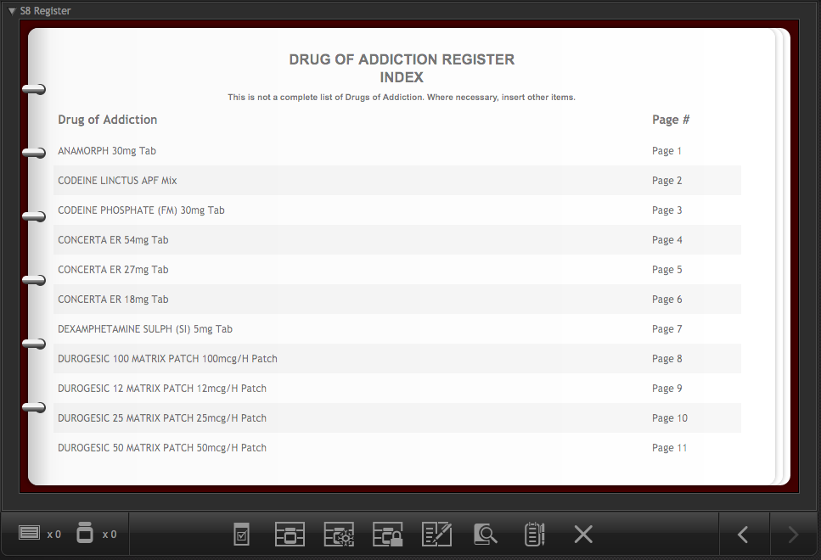
Click on an item on the Index page to go to the appropriate page in the register.
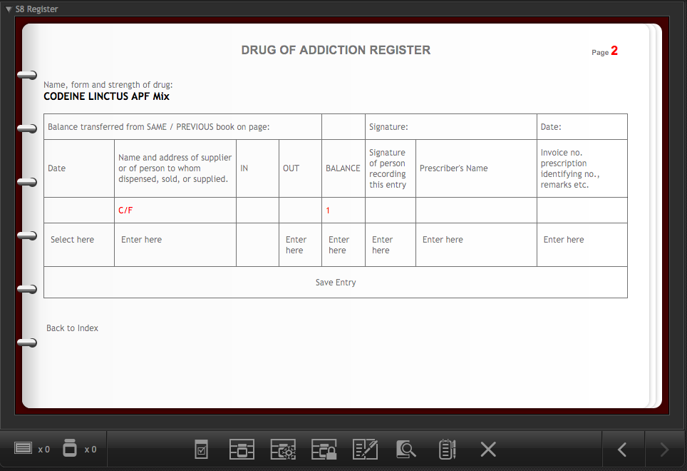
Once you have entered the appropriate information, click on the Save button to complete the entry and close the register.

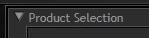
Returning to the Shop front
When you have picked your products you should return to the Shop front screen. To do this you should minimise the product selection screen…
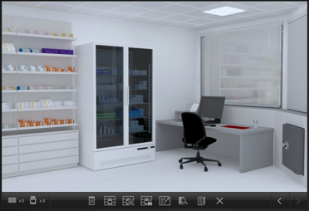
…then click on the left arrow button at the bottom right of the task bar.

Putting it all together
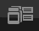
Once you have printed your labels and selected the appropriate products you will need to put these items together ready for handing over the patient. You will also need to check that your product selection is correct by scanning the products with a barcode scanner, and to select any ancillary labels that need to be added to the medicine. All of these things are done on the dispensary Benchtop screen.
To access the Benchtop screen you can either click on the icon on the task bar or the basket on the counter.
On the Benchtop screen, imagine that you have turned out the contents of your pharmacy basket (prescription, labels and product items) onto the counter top in order to assemble the medicines.
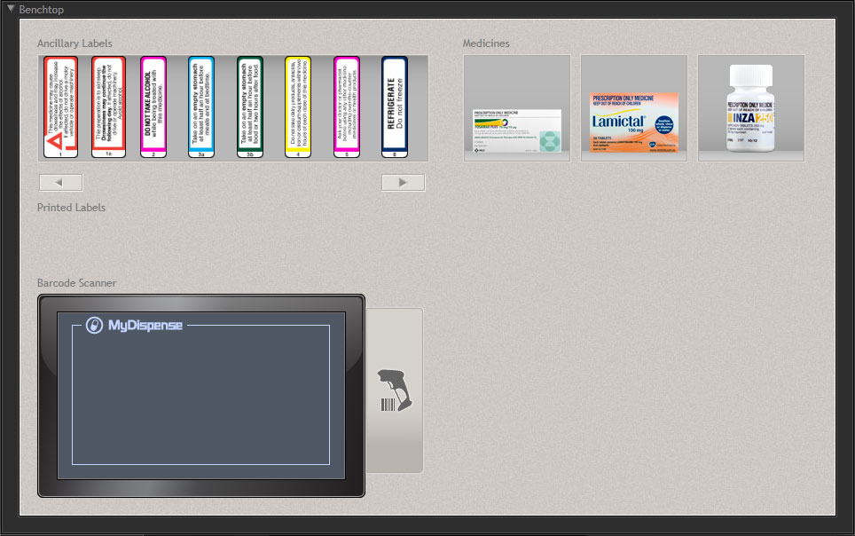
3 - Product area
2 – Scanner area
1 - Label area
The Benchtop screen has three main areas:
- a Label area where your dispensing and ancillary labels can be accessed
- a Scanner area where you can access the barcode scanner
- a Product area where you put the items together

Attaching labels
To attach your dispensary label to the appropriate product, click on the label (the cursor will change to a label ) then click on the product to which you want to attach the label. This will open the Label Placement screen. The Label Placement screen shows a ‘flattened’ view of the product along with the label. You need to drag the label to an appropriate place on the product.

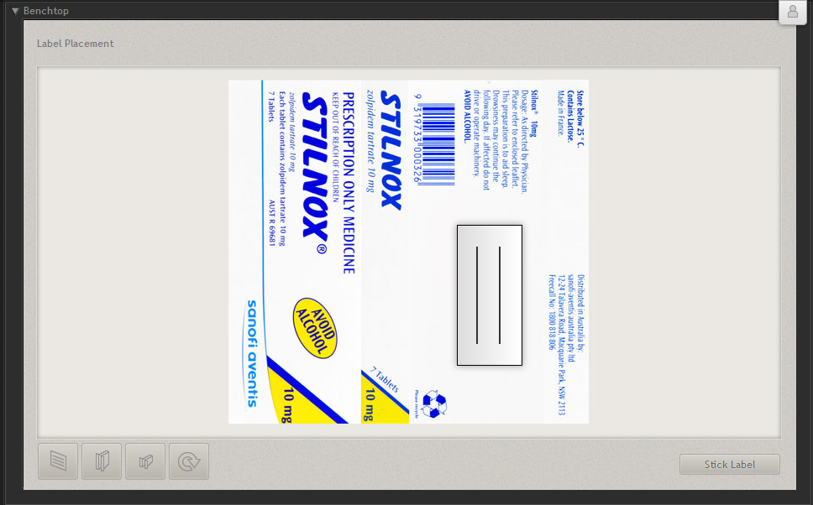
rotate label
half-flag label
full label
flag label

You can select from several label types:
- A full label is a normal dispensing label,
- A Flag Label has smaller adhesive area to make it easier to stick the label on products without covering information
- A Half-flag Label has an even smaller sticky area for use on very small items such as eye drop bottles.
You can also rotate your label to get the best possible fit on the product.
When you are satisfied that the label is in the correct place, click the Stick Label button. You will be returned to the Benchtop screen.
If you make a mistake, you can remove the label from under the product by clicking on the ‘X’.

Ancillary labels
If you need to add ancillary labels to the product, select a label from the horizontally scrolling list in the top left corner, and then click on the appropriate label (the cursor will change to a coloured label ). Click on the product that you want to stick that label on. The label will appear under the product.
Repeat the above process for any other products on your bench top.

Using the barcode scanner
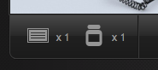
You can verify that you have selected the appropriate product for the label that you printed, by using the barcode scanner. The scanner screen will show up to three product names depending on how many items you made labels for. Click the round button on the scanner screen next to the item you wish to scan (the cursor will change to a scanner ) then click on the product in the top right corner that matches the item on the screen. You will see a message telling you whether the product and item are correctly matched.

Managing labels and medicines
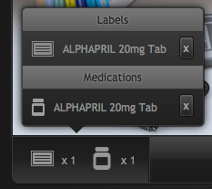
You will notice a small panel at the bottom of the MyDispense interface with medicine bottle and label icons. This panel represents the labels that you have printed and the medicines that you have selected during the current exercise.
Clicking on this panel will show you a list of medicines and labels. If you click on a medicine or label you will see a pop up screen showing the details of that item. Clicking on the ‘x’ next to an item will remove that item from your inventory.

Patient Action Pane
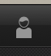
Clicking on the patient or the patient action pane icon on the toolbar will open the Patient Action Pane (PAP). The PAP is where you will interact with the patient and gain as much information about them as possible and where you will submit the exercise.
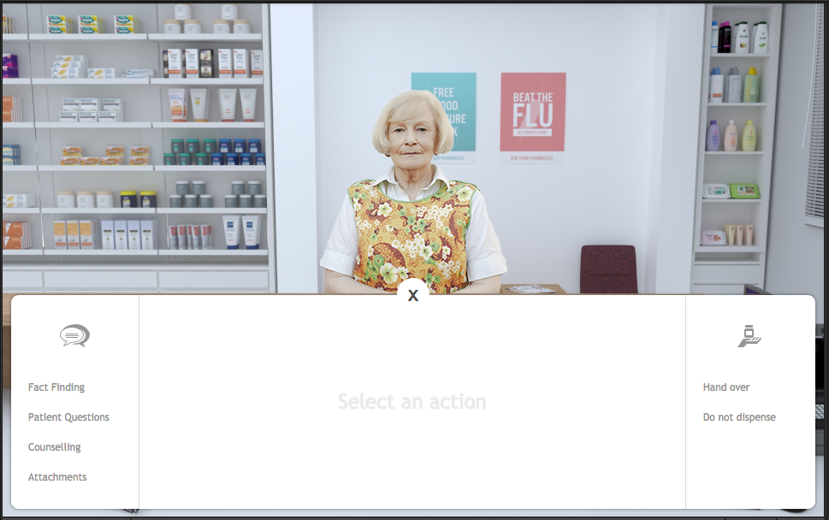
Patient interaction area
Exercise submit
Communications actions
Close button
The patient interaction area is where all interactions with the patient occur. Interactions appear like a conversation. Your questions, replies and question appear on the right hand side of the patient and the patient’s replies and questions appear on the left hand side of the patient.
If the exercise starts with a speech bubble with a binder inside it, it means that the patient has extra documentation in the form of attachments to show you. Clicking on the binder icon will open the attachments screen, which will be covered later.

Communication actions
Clicking on a communications action will display that communication action in the middle of the PAP. For instance, clicking Fact Finding will display the Fact Finding screen, Patient questions, the patient questions and so on.

Fact finding
Fact finding is where you may ask the patient some questions about themselves to discover as much as possible about their condition. To ask a question, click on the ask button next to a question in the list.
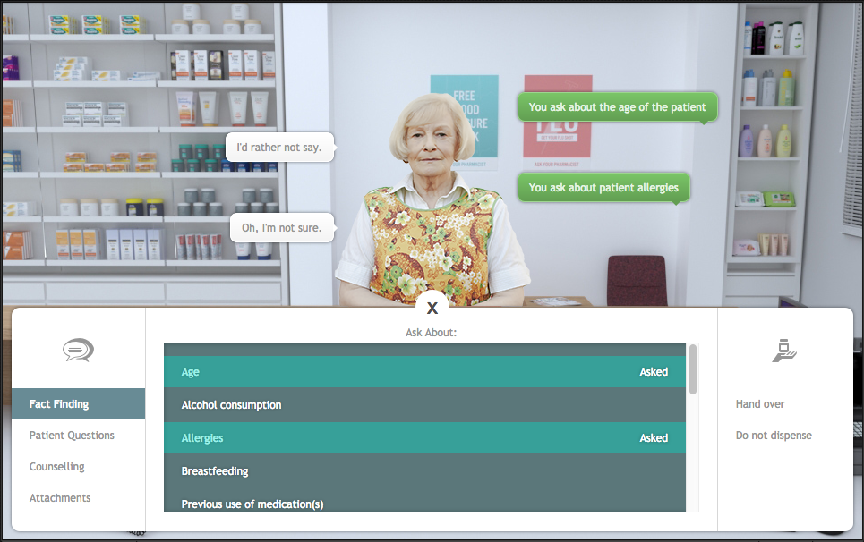
Sometimes it is better to not ask certain questions as it is inappropriate, but not asking certain questions may result in you missing important information about the patient. Sometimes you may be able to ask the patient about their personal information and they might tell you their name and some other details.
You may only ask the questions found in the list.

Patient questions
Sometimes the patient may have questions they want to ask you, but they won’t ask without you prompting. When you first open the patient questions section, it will look similar to this:
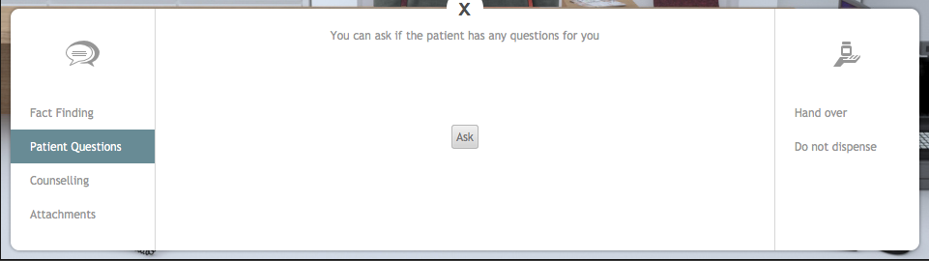

Clicking the Ask button will have you ask the patient if they have any questions. The patient may reply with their question or they will tell you that they have no questions.
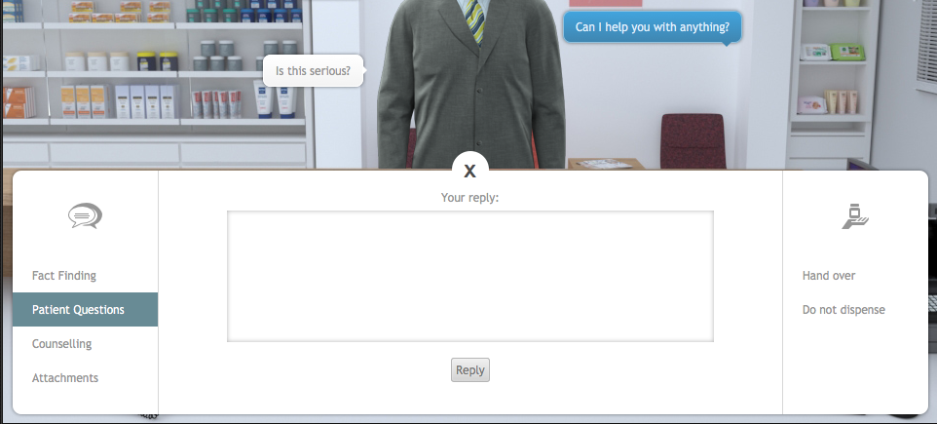
If the patient does have a question, the reply interface appears. In the field provided, enter your response to the patient and click the reply button. You will communicate your reply to the patient and will be able to prompt for another question.
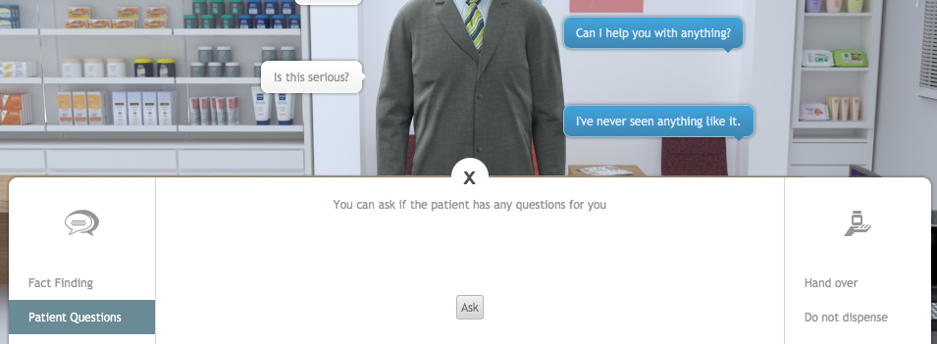
When the patient has no more questions, they will reply that is the case. Please note that a patient may have different questions before you select a medication and after you select a medication, even if they told you that they had no more questions.

Counselling
Using the counseling interface, you may counsel the patient in the use of the medication and about any other details about the dose. Type your counseling advice into the field provided and click the counsel button.
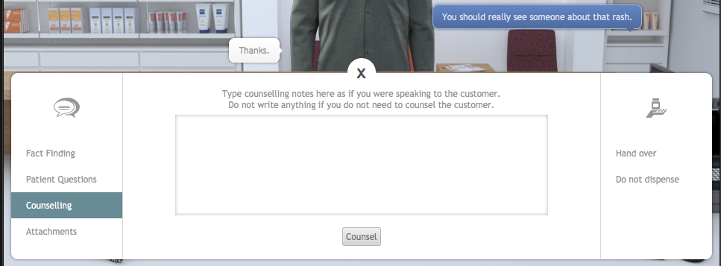
Clicking the counsel button will add what you have entered into your interaction with the patient. Each time you enter something and click the counsel button, it will be added as a new patient interaction. Your previous counselling notes will not be removed, only added upon. So if you need to clarify your counselling, do so by communicating with the patient.

Attachments
Attachments feature any additional documentation the patient may have about their condition. This can range from pictures of their problem to supporting documentation or test results. Clicking the attachments action will display a list of attachments in the exercise and a description of the attachment.
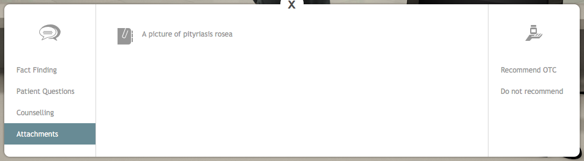
Clicking an attachment in the list will open the attachment in a gallery for you to view.
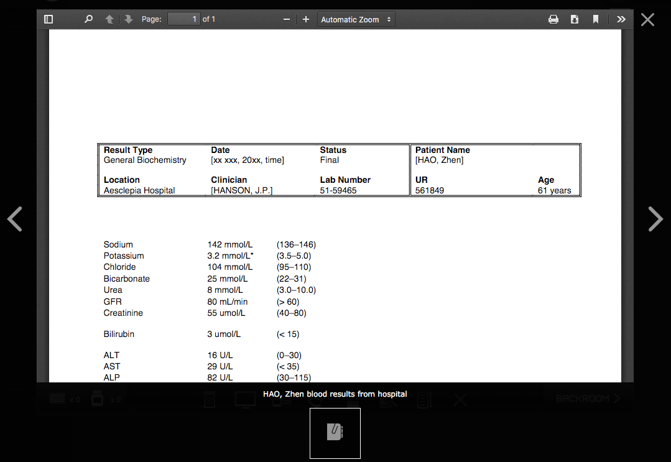
The gallery interface displays the description of the attachment and allows you to navigate between the other attachments (where applicable). To close the attachment gallery, click outside of the gallery area.

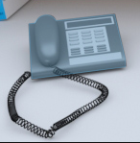
Fact Finding from the Prescriber
In certain circumstances, you need to obtain information from the prescriber to complete an exercise accurately. If prescriber fact finding is available a telephone will appear on the Benchtop.
If you click on the telephone a larger telephone screen will appear. Use this screen to select the correct prescriber from the contacts list.

Click on the Call button to call that prescriber.
Click on a topic in the left hand column to discuss it with the prescriber. As with the patient fact finding, you should only discuss relevant topics. Clicking on every topic to gain more information, without considering what you really need to know, will be regarded as wasting the prescriber’s time and you may be penalised.
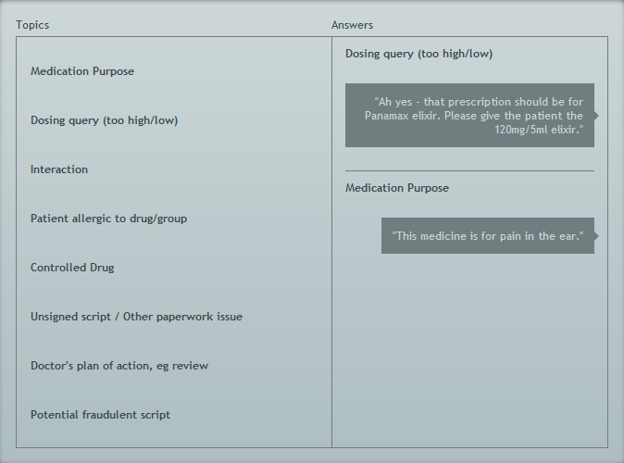
When you have finished with this screen, click on the End Call button.
- Taking notes
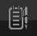
Clicking on the notes icon will open the Notes panel.

Make notes here about the dispensing decisions and choices you make. For example, why you chose to use a particular ancillary label.
In an exam situation, the examiner will review the logic of your decisions.

Completing an exercise
When you have completed all of the dispensing activities, you will need to hand over the items to the patient. You can do this by clicking on the patient action pane icon in the taskbar.
Clicking on this will display the patient action pane:
Use the buttons on the right hand side to decide whether you should hand over the medications or not dispense the medications.

Hand over
If you want to hand the medications over to the patient, click the handover button. The products you have selected will be displayed on the screen. If you are ready to submit the selection, click the finish button to complete the exercise.
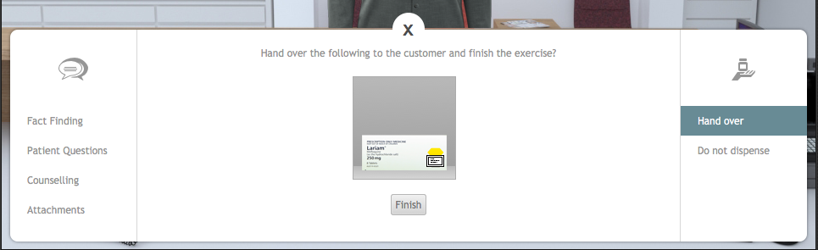

Do not dispense
If you think there is a problem that prevents you from dispensing the prescribed medicines to the patient, click the do not dispense option. You will be required to explain why you are not able to dispense the medicines. Once you have entered your explanation, click the finish button to complete the exercise.
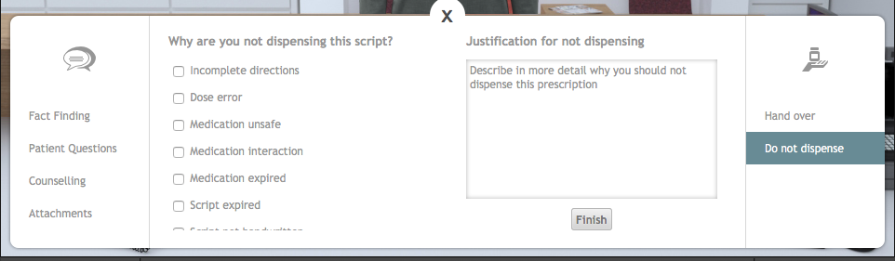

Getting feedback
When you have completed an exercise and return to the dashboard the icon for that exercise will change from the available icon to the feedback icon. Click on the feedback icon to see the feedback screen.
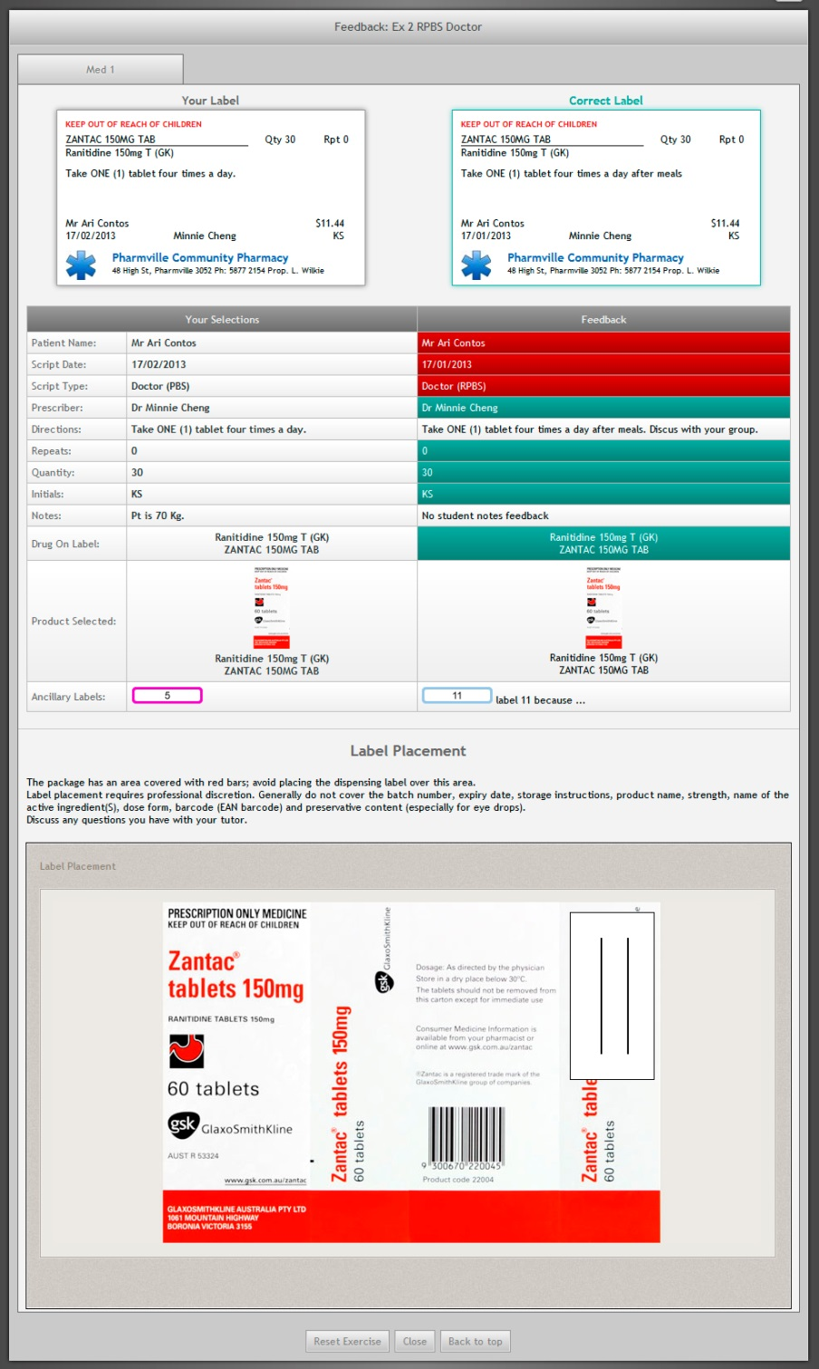
On the feedback screen your data is shown on the left side of the screen and the instructor’s feedback is shown on the right.
The top section shows your label against the feedback label. Your label can still be correct while not being exactly the same as the feedback label.
The next section shows the individual items in the exercise. A red row in the feedback indicates that you got something wrong, green means that item is correct.
Some rows are neither green nor red, such as in the directions row. This is because there are many ways to write correct directions.
At the bottom of the screen will be the label placement feedback and also any optional elements, such as, patient counseling or fact finding.
You can reset the exercise and attempt it again by clicking on the Reset exercise button. Note that resetting an exercise will erase the existing exercise data.

When you have finished using MyDispense, remember to log out of the website and also close the browser to prevent anyone else from using your account.

