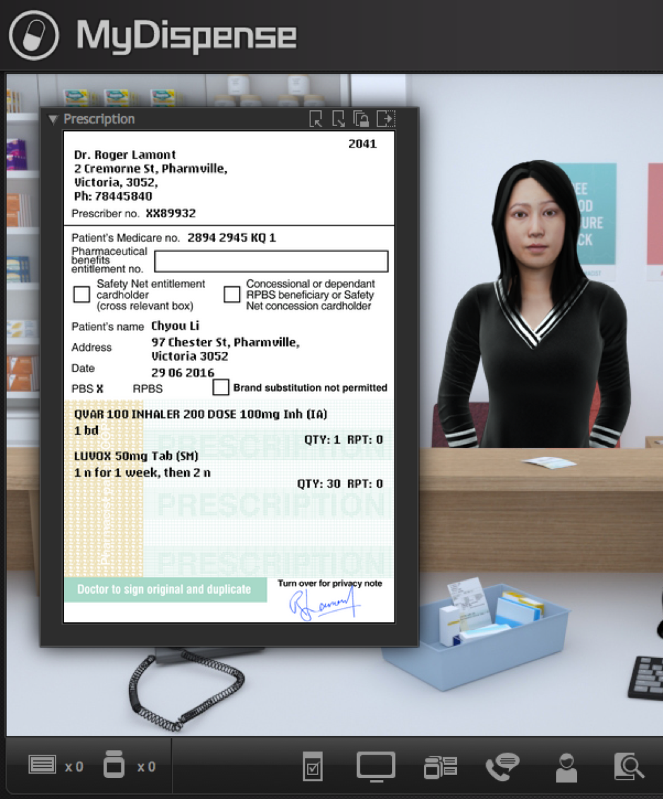
MyDispense
Validation exercise Guide

Version 5.2

Table of Contents
What is MyDispense? 4
Who is this guide for? 4
How should I use this guide? 4
Validation exercises explained 4
Validation exercise designer 5
Create a new validation exercise 5
Validation exercise designer overview 5
Creating a prescription 6
Managing exercise prescriptions 12
Saving the exercise 13

What is MyDispense?
MyDispense is a simulated learning and teaching environment that is designed to help students develop their skills and competency in dispensing medicinal products systematically, safely and accurately at a level of detail and difficulty corresponding to their knowledge and experience. It simulates the decision-making environment within which dispensing occurs, without reminders and prompts and with the opportunity for students to learn by making mistakes in a safe and secure learning environment. For an instructor, MyDispense is a framework allowing you to create a broad range of exercises and assessments from the simplest to the most demanding. The administrative interface is simple to use while giving you the control and flexibility to create challenging scenarios that best support your curriculum.

Who is this guide for?
This guide is a comprehensive guide on how to create validation exercises in My Dispense. This guide assumes that the reader has previous experience in creating Exercises in MyDispense. Validation Exercises are available in MyDispense version 5+.

How should I use this guide?
You can either read the whole thing from beginning to end (but who does that with user guides?) or you can skim over the introductory sections to get a feel for how Validation exercises work, and then delve into the detail when you need it.
This guide has been designed to support the latter option.
You will find sections, titled in orange, which deal with specific and common tasks in MyDispense; hopefully these sections will get you where you need to be. If you need more detail, there will always be a more in depth description available.

Validation exercises explained
A validation exercise is a new type of exercise introduced in MyDispense version 5 and is based on the scenario of checking another pharmacist’s work. Students are presented with a number of Rx’s to go through and will decide if there is a problem with the Rx or if it is correct.

Validation exercise designer

Create a new validation exercise
Creating a validation exercise is similar to creating a Dispense exercise in MyDispense. From the unit tutorial screen, click on the Create validation exercise button at the button of the tutorial list.
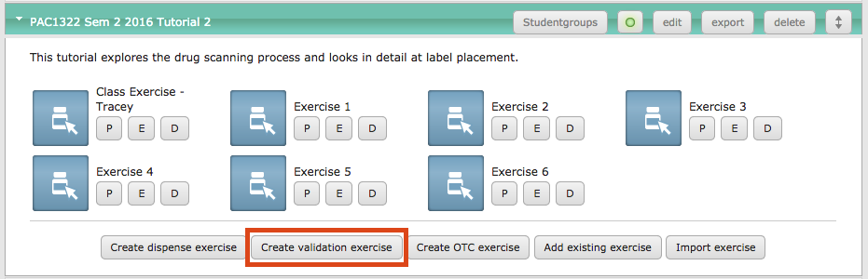
This opens the validation exercise designer.

Validation exercise designer overview
The validation exercise designer is very similar to the dispense exercise designer. The left side of the screen has the review panel, the centre of the screen is where the exercise is edited and the right side of the screen has the prescription preview panel.
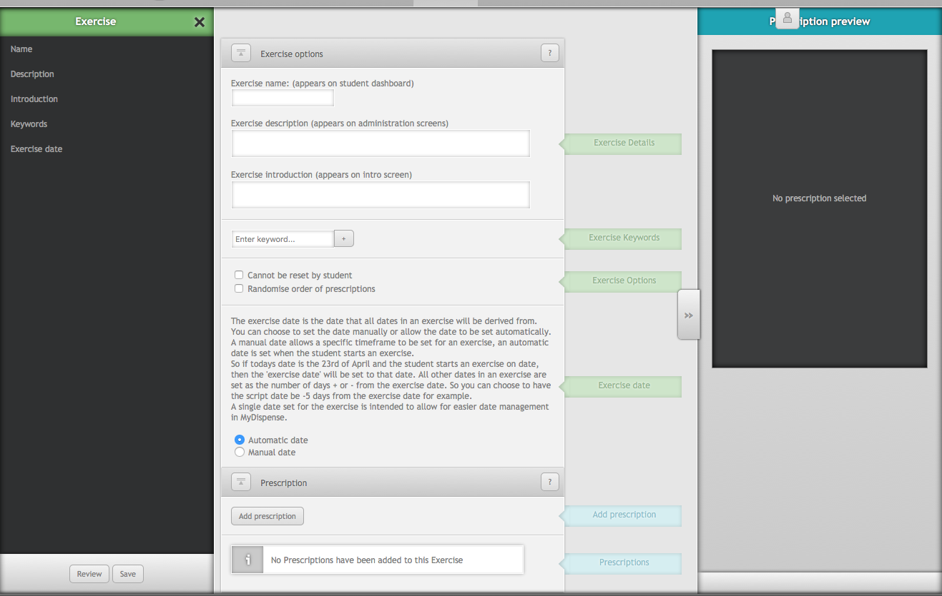
Validation exercises have the same basic exercise details as Dispense exercises. Requiring that a name, introduction, description and date be set.

Creating a prescription
Prescriptions are at the heart of the validation exercise type. To add a new prescription, click the add prescription button in the prescription section, which opens the prescription pane.
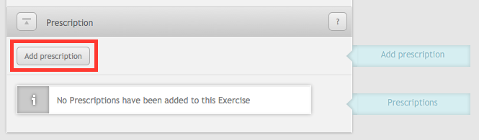
The prescription pane is divided into tabs, which are used to manage different aspects of the prescription. While a tab is open, the button to display it does not appear. The tabs are:
- Prescription – Base prescription information. The prescription tab is open by default
- Medication tabs – A tab is displayed for each medication that has been added to the prescription.
- Add medication tab – Used to select a new medication to add to the script, which then opens the tab for that new medication
- Extras – Contains supplementary data such as patient notes and dispensing records
- Outcome – Used to select the outcome of the script, whether the script is correct or if there is a problem with the script.
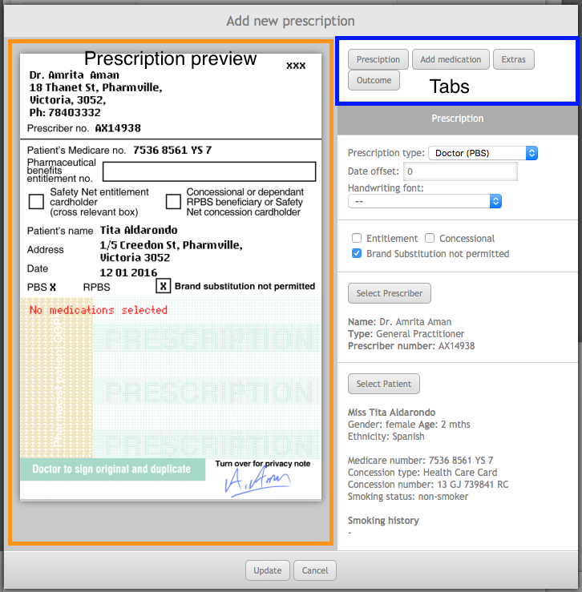
The prescription pane

Prescription tab
The prescription tab is displayed by default when the prescription pane is first opened and contains the basic items required for the prescription. To begin, a prescription type must be selected from the drop down box. Selecting a prescription type will display a preview for the script on the left hand side of the pane.
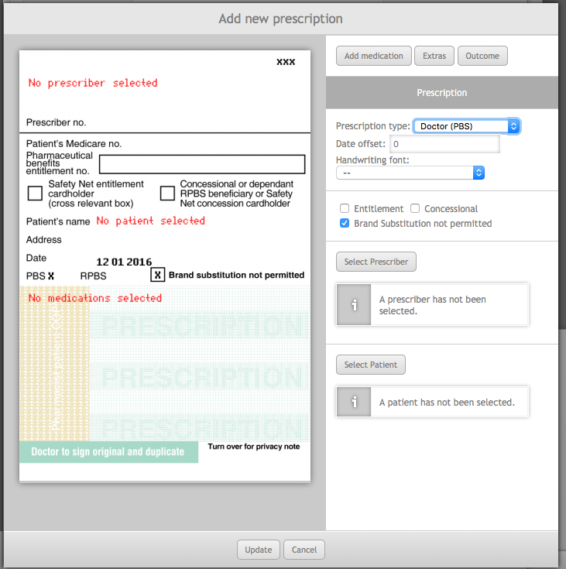
The date offset sets the date of the script as a # of days before or after the current exercise date. For example -3 would set the date for the script as 3 days before the exercise date.
Please note that positive values are allowed, so that date errors can be introduced. If you do not want to set a date error, please ensure that a negative offset is entered.
A handwriting font may also be selected from the drop down box. If a handwriting font is selected, all text will be displayed in that font on the script.

Underneath the handwriting font section are the script specific options. Some prescription types have additional options or fields that must be entered (such as an authority number or a hospital ward). Changing the script type will cause the script options to reset. When changing the script type, always make sure that the script options are set correctly.
The next two items to be set are the prescriber and patient. Selecting either is done by clicking the respective select button. Doing so will display a table where they can be selected for use on the script. There are no additional options beyond selecting the two.

Add medication
Once a prescription type has been selected, the add medication button will appear in the tab area. The add medication button is displayed based on the maximum number of medications a prescription can hold. It will disappear if the maximum number of medications on a prescription have been reached or there are too many medications on the prescription.
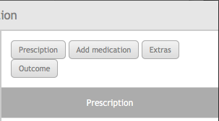
Clicking the add medication will display the medication selection screen. Once a medication has been selected, a medication tab for that medication will be created and opened.

Medication tab
Each medication on the prescription will have its own tab. Clicking the tab will display the medication tab for that medication. Medication tabs are displayed with the name of the medication on the tab.
In the image below there are three medications on the prescription: Abbocillin VK 250mg Tab, Accucheck Performa 100 Strip and Accupril 5mg Tab. Accucheck Performa is open on the pane and the other two medications appear as tabs in the tab bar.
Inside the medication tab, the directions, qty and repeats can be set for the medication and the prescription preview will update to reflect the changes. The medication can be changed for another one by clicking the select medication button, which opens the medication select pane.
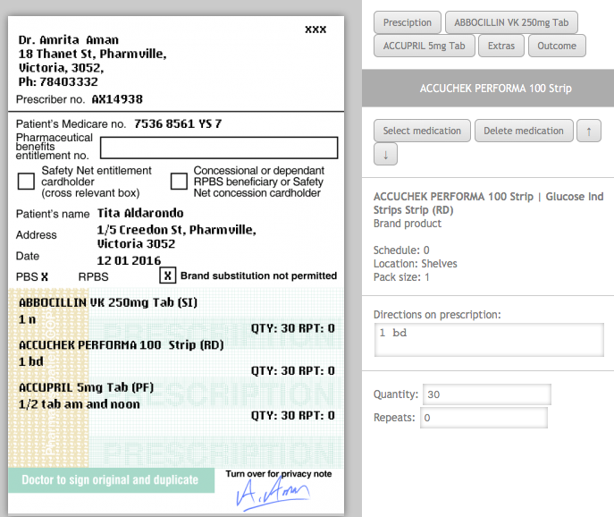
Medication tab example
The medication can be removed from the prescription by clicking clicking the delete medication button. Deleting a medication will move any medications below it up a slot on the script. For example, deleting Accucheck Performa 100 on the script above would make Accupril 5mg the second medication on the script.
The order of medications can be changed by clicking the arrows next to the delete medication button. Clicking the up arrow will move the medication up the script and clicking the down arrow will move the medication down.

Extras tab
The extras tab is where additional patient background information can be added to the script using patient notes and dispensing records. Each prescription in the exercise is treated separately, so notes and dispensing records are not shared between prescriptions even if the scripts have the same patient.
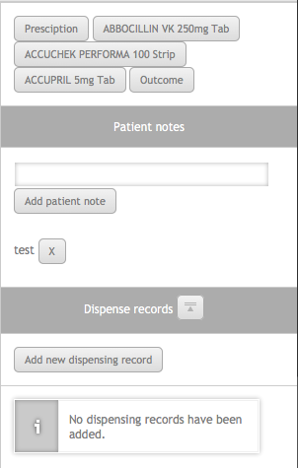
During the exercise, students will be able to view the patient notes and dispensing records set on the extras tab using the patient information screen. The additional notes can be used as supplementary information to determine how they should treat a prescription.

Extras tab

Prescription outcome tab
The prescription outcome tab is where the overall outcome for the prescription is selected and options filled out. There are two outcomes for a prescription: Dispense script and There is a problem with the script. The there is a problem with the script has been named so because the problem may not necessarily prevent dispensing the prescription.
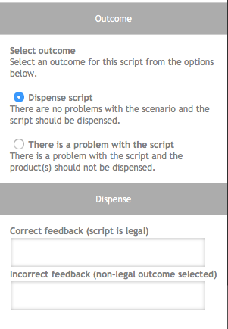
Dispense script indicates that there is nothing seriously wrong with the prescription and it should be dispensed normally. All that is required for a dispense outcome is to complete the dispense outcome feedback fields.

Outcome tab with dispense script selected
Selecting there is a problem with the script displays a list of all the potential problems with the prescription. Some options hide fields on the prescription, making the field incomplete or missing. Other options require background data on the patient provided in the extras tab, such as subtheraputic doses or overdoses on medications.
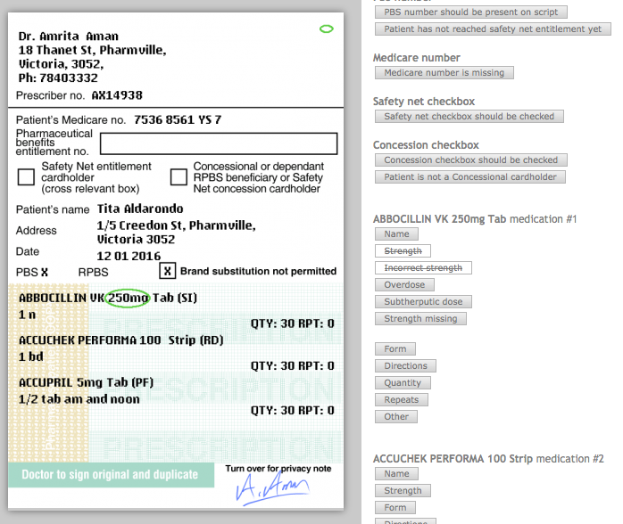
Incorrect strength medication options
Selecting an error will draw an ellipse around the corresponding field on the prescription. These ellipses are later used in feedback and compared to the student selections through colour coding (green is a match, purple is a mismatch and red is missed by the student). A basic list of all the script problems is below.
Script ID missing | Date incomplete | Date missing
Script expired | Script incorrect date | Prescriber name missing/incomplete
Address missing / incomplete | Prescriber phone number missing | Prescriber not permitted to use this type of prescription
Prescriber signature missing | Patient name missing / incomplete | Patient address missing / incomplete
Medication name missing / incomplete | Medication strength incorrect (overdose or subtheraputic) | Medication strength missing
Medication form missing | Medication form inappropriate | Medication form not available
Medication directions problem (subtheraputic dose or overdose) | Medication directions missing | Medication Qty missing
Medication qty is more than can be supplied | Medication repeats missing | Medication repeats, too many repeats
Medication potential interaction | Medication suspicion of abuse | Medication not allowed on this type of Rx
Contraindication with patient’s existing medication | Patient has allergy to medication

Based on the type of prescription, additional options will appear. At least one problem must be selected for the outcome to be valid, along with the wrong outcome feedback fields.

Save prescription
When the prescription is ready, click the update button to finish working with it. Clicking the update button will close the prescription pane and add the new prescription to the list of prescriptions in the exercise.
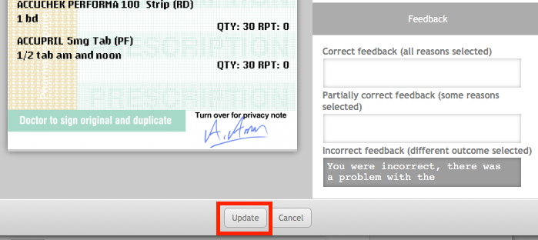

Managing exercise prescriptions
Beneath the Add prescription button in the prescriptions section is the list of prescriptions currently in the exercise. Each prescription appears as an item in the list and is displayed with it’s type and the number of medications on the prescription. For example: Doctor (PBS) #M 3, is a Doctor (PBS) script with three medications (#M 3).
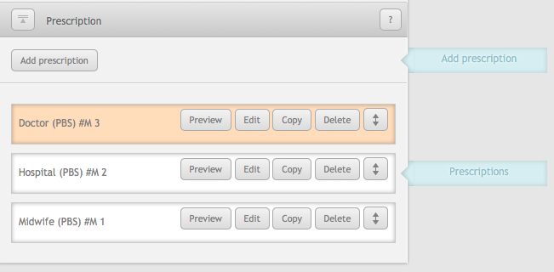
Prescriptions list
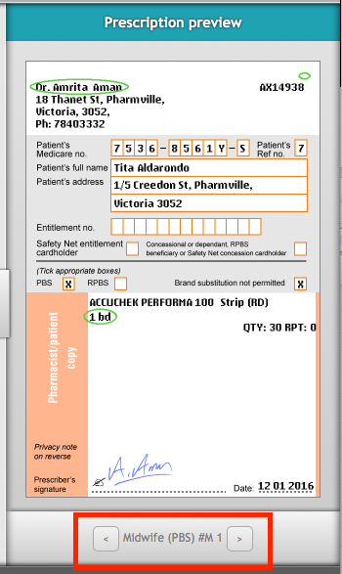
The prescription in the list that is highlighted orange is the prescription currently on display in the prescription preview pane. To look at another prescription in the preview pane, click on the Preview button for that prescription. It will turn that prescription item orange and display the script in the preview pane.
At the bottom of the prescription preview pane are arrow buttons next to the name of the prescription name. Clicking the left and right arrows will navigate between the prescriptions in the exercise and display them in the prescription preview pane.
Clicking the edit button on the prescription item will open the prescription pane again with that prescription loaded where it can be edited.
The copy button will add a copy of that prescription onto the end of the prescription. It copies all aspects of the prescription including the outcome.
Prescription preview pane
The delete button will immediately delete the prescription from the list and the exercise. There is no confirmation window so make sure that you are sure about the prescription being deleted.
On the far right there is an arrow button. Clicking and dragging this up or down will change the order of the prescriptions as they appear in feedback. Normally prescriptions will be displayed in the order that they appear in the list, however the order can be randomised by checking the ‘Randomise order of prescriptions’ exercise option.
Randomising the order of prescriptions in the exercise will display them in a random order for the student to complete. The prescriptions will appear in the correct order during feedback, no matter the order they appeared in for the student.

Saving the exercise
You may save your exercise at any time by clicking the save button underneath the checklist. The checklist does not need to pass for you to save your exercise this way, but it will not be available to students until you publish it.
To publish your exercise (so students can see it), click the publish button. Doing so will run the checklist, which must pass before you can publish the exercise. Fix the issues outlined in the checklist and click publish again.

