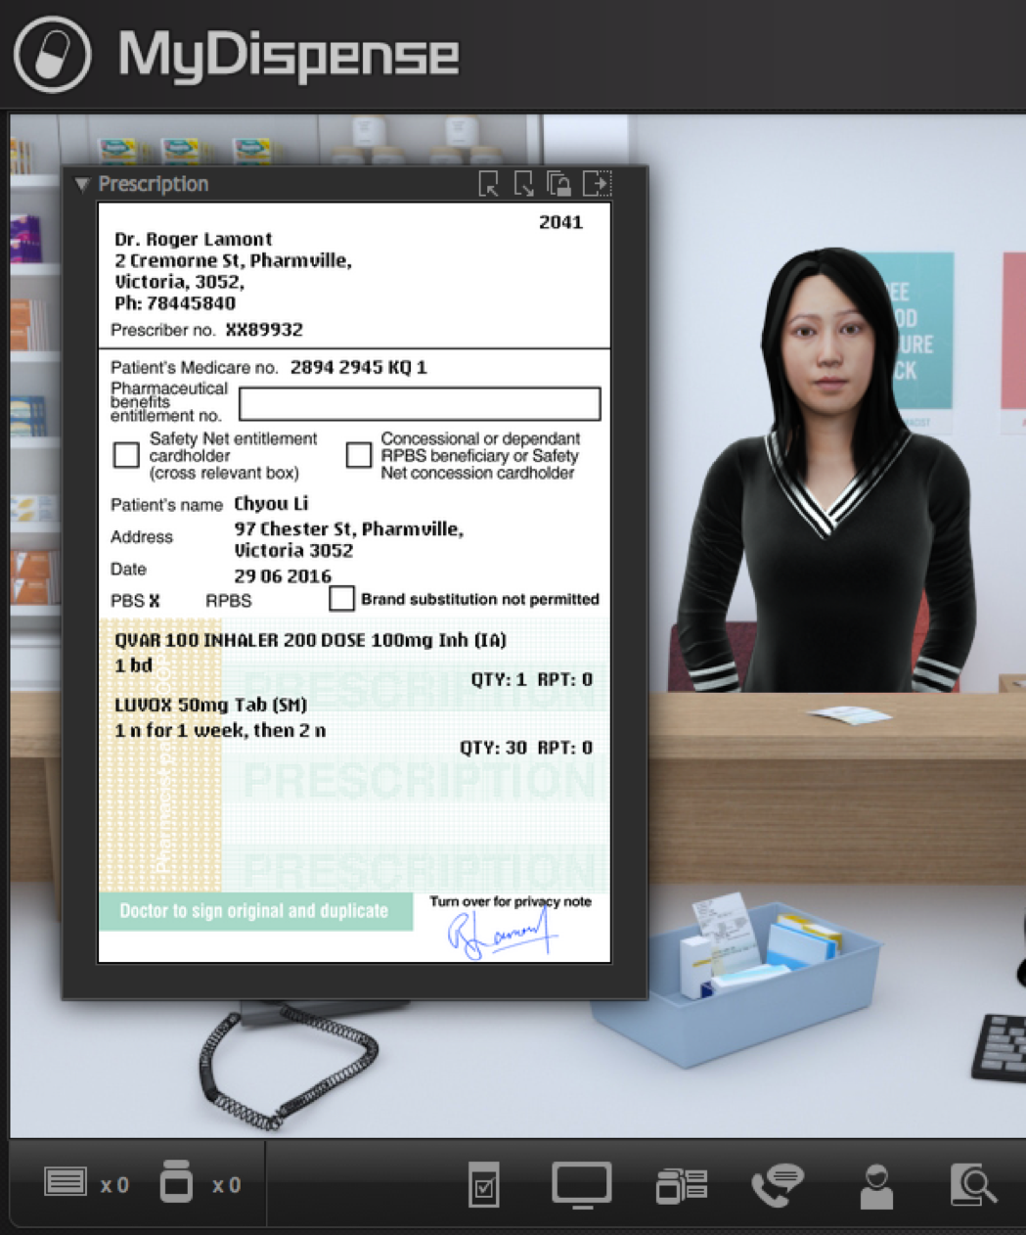
MyDispense
OTC exercise Guide

Version 5.2

Table of Contents
What is MyDispense? 4
Who is this guide for? 4
How should I use this guide? 4
OTC exercises explained 4
OTC exercise designer 5
Create a new OTC exercise 5
OTC exercise designer overview 5
OTC exercise options 6
Patient details 8
Patient selected medications 9
Patient communication 11
Exercise outcome 15

What is MyDispense?
MyDispense is a simulated learning and teaching environment that is designed to help students develop their skills and competency in dispensing medicinal products systematically, safely and accurately at a level of detail and difficulty corresponding to their knowledge and experience. It simulates the decision-making environment within which dispensing occurs, without reminders and prompts and with the opportunity for students to learn by making mistakes in a safe and secure learning environment. For an instructor, MyDispense is a framework allowing you to create a broad range of exercises and assessments from the simplest to the most demanding. The administrative interface is simple to use while giving you the control and flexibility to create challenging scenarios that best support your curriculum.

Who is this guide for?
This guide is a comprehensive guide on how to create OTC exercises in MyDispense. This guide assumes that the reader has previous experience in creating Exercises in MyDispense. OTC Exercises are available in MyDispense version 5+.

How should I use this guide?
You can either read the whole thing from beginning to end (but who does that with user guides?) or you can skim over the introductory sections to get a feel for how OTC exercises work, and then delve into the detail when you need it.
This guide has been designed to support the latter option.
You will find sections, titled in orange, which deal with specific and common tasks in MyDispense; hopefully these sections will get you where you need to be. If you need more detail, there will always be a more in depth description available.

OTC exercises explained
OTC exercises are a new type of exercise introduced in MyDispense version 5. A customer will appear in the dispensary and the student must decide whether to recommend a medication for their symptoms.

OTC exercise designer

Create a new OTC exercise
Creating a OTC exercise is similar to creating a Dispense exercise in MyDispense. From the unit tutorial screen, click on the Create OTC exercise button at the button of the tutorial list.
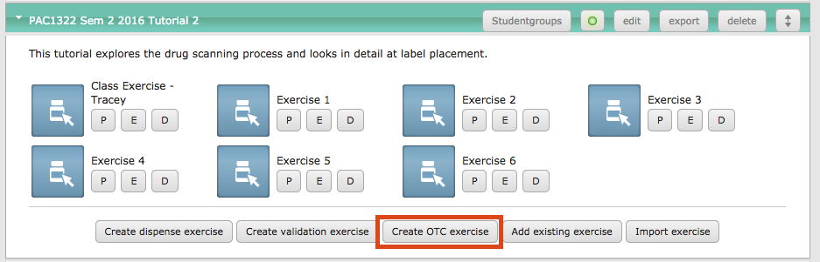
This opens the OTC exercise designer.

OTC exercise designer overview
The OTC exercise designer is similar to the dispense exercise designer. The left side of the screen has the review panel and the centre of the screen is where the exercise is created.
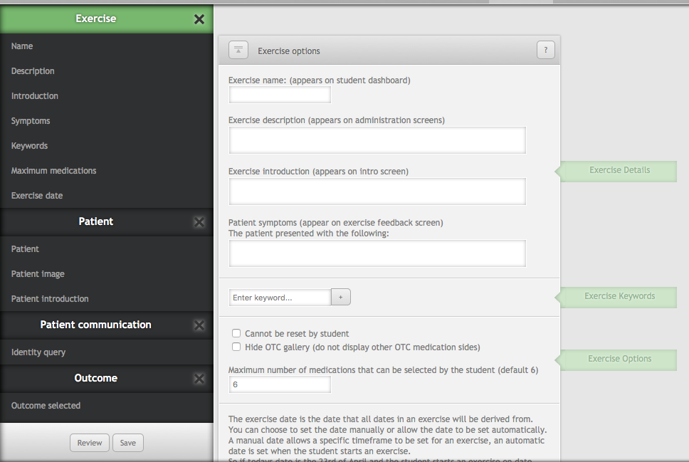

OTC exercise options
OTC exercises are similar to dispense exercises, requiring that a name, introduction, description and date be set. In addition to these is the Patient Symptoms field, Hide OTC gallery option and maximum number of medications option.
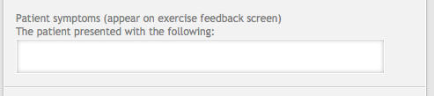
The patient symptoms field is used to give a general overview of the patient’s symptoms. Any symptoms entered should be written in the context of “The patient presented with the following:” because the symptoms field is displayed like the image below in feedback:
Thus the symptoms field provides general context about what the student should be trying to treat in the exercise.
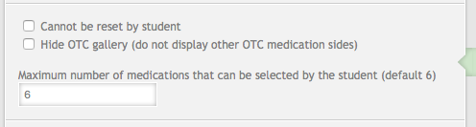
OTC exercise options include limiting the number of medications that can be selected by the student at one time. The restriction is designed to stop students from selecting extreme numbers of medications off the shelf to suggest to patients.
When a student has reached their medication limit, a message will appear to tell them that their inventory is full and that they must put a medication back before selecting new one. Restricting the number of medications students can select forces them to think about their choices.
By default, the maximum number of medications that the student may select is set to 6. This can be set to any number above 0.

Another OTC exercise option is hiding the OTC gallery during medication selection. The OTC gallery allows students to view the other sides of the OTC medications, zoom on the side and move the side around to read more information.
Hiding the OTC gallery has the effect shown in the images below. The first image has the OTC gallery enabled and the second has the gallery disabled. Students are now unable to click through and view the other sides of the medications.
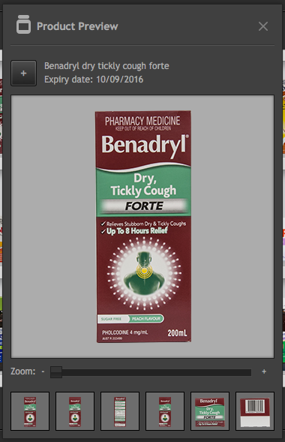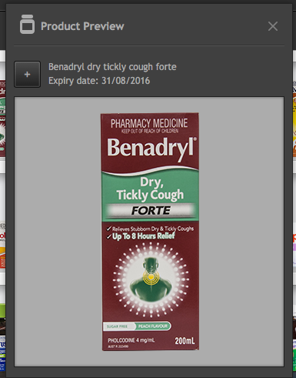
Disabling the gallery can be useful when you want students to have limited information or during introductory exercises.

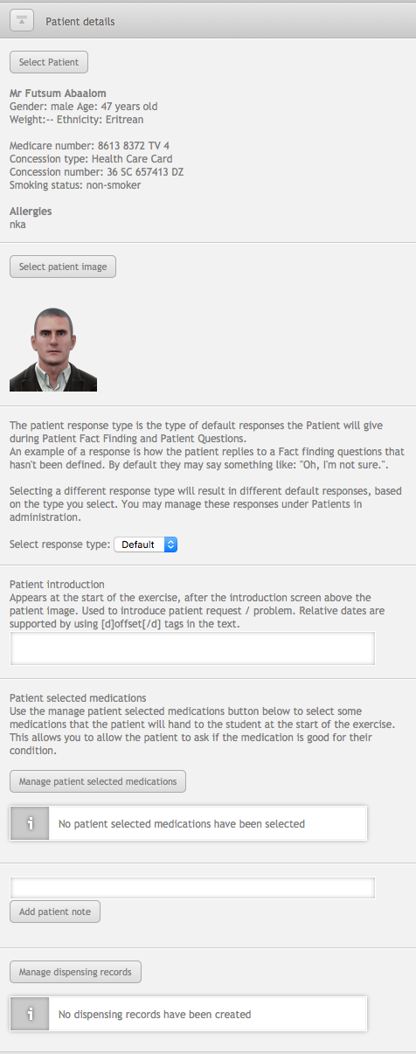
Patient details
In OTC exercises there is no prescription, instead a patient appears in the dispensary and describes their problem. The patient details section is where the patient is selected and basic details filled out.
The process for filling out the patient details is similar to the dispense exercise. The patient must be selected along with a patient image. If a patient has a locked patient image, the patient image will be selected automatically.
Underneath the patient image section area is the patient introduction. The patient introduction is displayed after the exercise introduction screen inside a speech bubble. The patient introduction is the initial interaction with the student and could describe a pain or a symptom.
The patient introduction field can have dates embedded in it by using date offset tags. For example, if [d]-5[/d] is entered, during the exercise it will be replaced with a date 5 days before the exercise date. Such as 8/1/16. If a positive number is entered, it will X days after the exercise date.
The context of the patient introduction should be considered if there are starting medications or if the patient has attachments. If the patient has either of these, consider referencing them.
Additional patient information can be supplied using patient notes and dispensing records. These will appear during the exercise.

Patient selected medications
Patient selected medications (PSM’s) are medications that the patient will present to the student at the start of the exercise. The student will need to decide whether to keep the medications or select different medications from the shelf. You will find the PSM section under Patient Details.
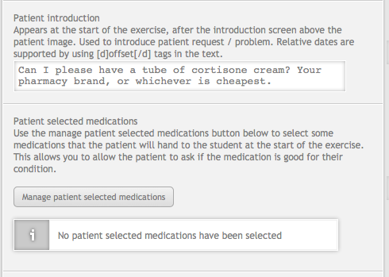
To select PSM’s, click the manage patient selected medications button. The management screen allows you to search for and select medications by clicking on that medication row. If a medication row is highlighted, it means that it selected and will be displayed as a starting medication.
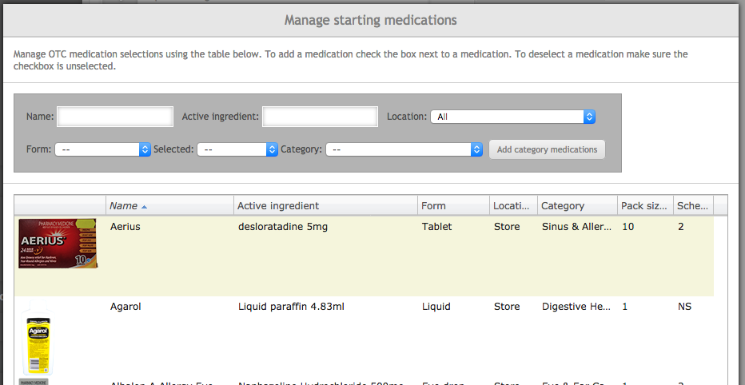
You may add a whole category of medications to your selection by selecting a category from the drop down list and clicking the Add category medications button. To view medications you have selected, select ‘selected’ from the selected drop down search box.
After medications have been selected, click the update medications button on the bottom of the screen to finalise the selection. The PSM’s are displayed in a list under the manage button, with the option to remove single medications.
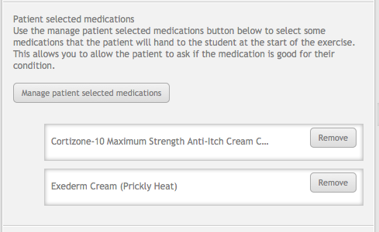
After adding starting medications, the context of the patient introduction should be revisited. Does the introduction reference the starting medications? If it does not, consider changing the patient introduction text to suit the change in context.
For example, a patient introduction could change from:
“Can I please have a tube of cortisone cream? Your pharmacy brand, or whichever is cheapest.”
To:
“Which of these cortisone creams is the cheapest?”

Patient communication
Communication with the patient during the exercise is important to gain facts about the patient, their symptoms and circumstances. Patient communication is achieved using a combination of an identity query, patient fact finding and patient questions.

Identity query
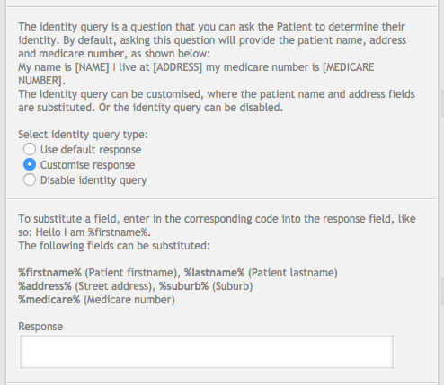
During the exercise it may become necessary to identify the patient. Determining the identity of the patient may be important to find additional patient information in the computer, but there is no prescription to provide an easy method of discovering who the patient is.
The identity query allows the student to ask the patient to identify themselves as a question in fact finding. There are three ways to use the identity query; use a predefined patient response, customise the patient response and disable the query.
Using the default response will always display the same response: My name is [NAME]. I live at [ADDRESS]. My Medicare number is [MEDICARE NUMBER] (or region equivalent patient id number, where applicable).

Customising the response allows full control over how the patient responds to the identity query. Instead of a polite patient, you could write a response that fits in with the character of the patient. Data fields are inserted using codes written in the response and are replaced with the correct data during the exercise.
For example, if the patient’s name is Sarah, entering: “I’m %firstname%” will result in “I’m Sarah” during the exercise. The fields for the patient name and address have been separated into their components so information can be omitted or be presented out of order if desired.
The identity query can be disabled completely, hiding the question from the list completely. Hiding the identity query is dependent on the exercise scenario, but can be done.

Patient fact finding
OTC exercise patient fact finding consists of two lists of questions, predefined patient fact finding questions and custom patient fact finding questions. Feedback for patient fact finding has two options, basic and advanced.
Basic fact finding feedback requires that feedback for the predefined and custom questions be entered in a single text field underneath all of the questions. Advanced feedback uses a separate field for each question, which is accessible when editing the question. Note that when using advanced feedback, Can Ask questions do not require feedback.
The feedback options allow exercise designers to manage the feedback for questions how they see fit. If basic feedback is selected, individual feedback cannot be set per question.
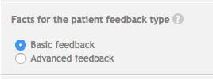
Completing predefined patient fact finding questions is optional, nor do all questions need to be defined. If a question is not defined, it will still appear in the list of questions that the student can ask, but a random response (for example: “Huh?”, “I don’t know”) will be given instead. Thus only questions that an educator want students to ask need to be defined.
After a predefined question has been defined, it can be cleared by clicking the clear response button in the predefined question table. Clicking the button will clear the question and leave it blank.
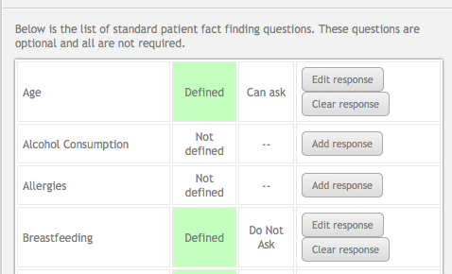
Underneath the predefined fact finding questions list is the custom questions area. Custom questions are fact finding questions that are defined completely by the instructor. Due to the custom nature of the questions, the question must be defined and there is no default response or ability to search for existing responses or feedback.
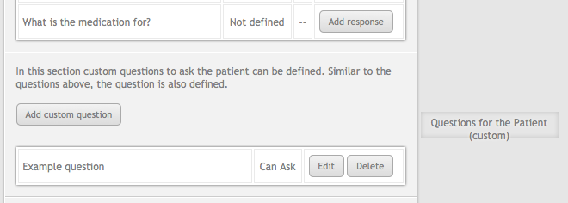
To create a custom question, click the add custom question button, which opens a dialog similar to the one below.
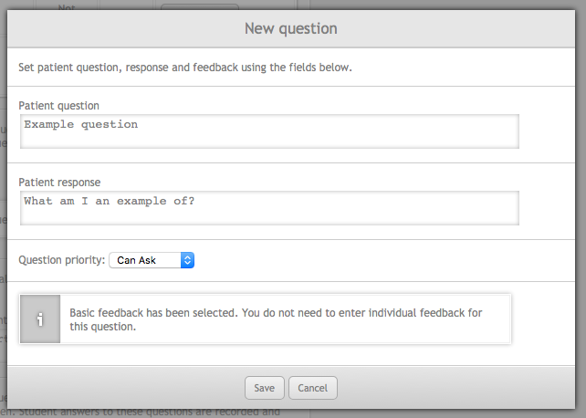
The patient question field is what is asked to the patient and what appears for the student to select in the fact finding interface. The patient response is how the patient responds to the question. Feedback is what is displayed for the question during feedback. The question priority defines whether the student should ask this question, like predefined fact finding questions.
If advanced feedback is enabled, feedback will have to be entered per question just like pre-defined questions (except for Can Ask questions, which do not need feedback). If basic feedback is enabled, the feedback field will not appear either.
If basic feedback is enabled, the basic feedback field appears underneath the custom question list. Enter all of the feedback for the questions you have defined (the important ones) in this field.

Patient questions
Patient questions in OTC exercises are the same as dispensing exercises.
Patient questions can be set to be asked before / after patient intervention or any time during an exericse. If a question is set to only be available before the patient intervention then that question will not be displayed after the student selects medications or counsels the patient. Counselling the patient / selecting medications is taken as interacting with the patient, so the questions will change.
In the image below, the A, B and E next to the edit button indicates whether a question is asked After, Before or Either.
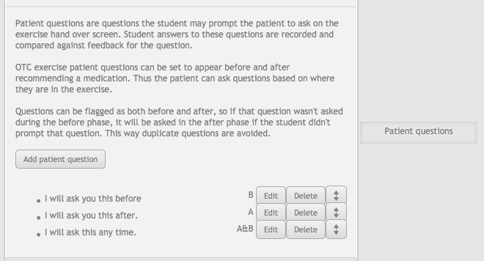

Exercise outcome
The exercise outcome determines how the exercise should end and the feedback options for the exercise. OTC exercises have two outcomes: Do not recommend and Recommend medications. However, there are two feedback options for Recommend medications, Basic and Advanced.
Basic feedback is intended to give a broad overview of the medications that the student should have recommend and does not perform any checks against the medications that the student has selected at all.
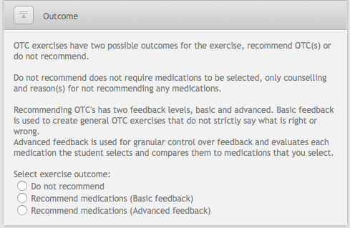
Advanced feedback checks the student’s selected medications against groups of medications created in the exercise designer. These groups allow for medications to be evaluated and students are told if they were correct or incorrect.

Do Not Recommend
The do not recommend outcome and feedback is nearly identical to Dispense Exercises Do Not Dispense option. Once do not recommend has been selected, a list of reasons why the student should not recommend a medication will appear, along with feedback fields.
The patient counselling feedback field is shown next to any counselling the student did during the exercise. The correct outcome feedback is shown when the student chooses not to recommend medications. This feedback field is shown whether the student selects the correct reasons not to recommend or not and should tell the student why they should not have recommended, including specifics beyond the selected reasons where applicable.
The wrong outcome feedback is shown when the student recommends medications instead of not recommending medications. Use this field to tell the student why they should not have recommended medications in this scenario.

Do Not Recommend feedback example
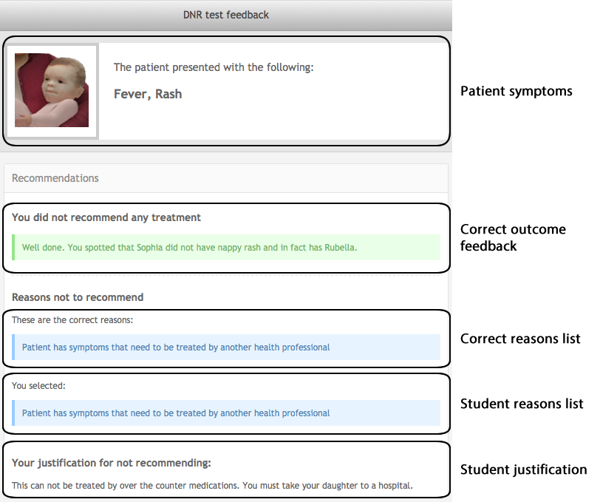

Recommend medications basic feedback
Basic recommend medication feedback is designed to give the student a broad overview of how they could have treated the patient. Medications are not marked and no indication is shown to students about whether their selection was correct or incorrect. Instead, feedback is provided using counselling and a correct feedback field, making basic recommendations similar to Do Not Recommend.
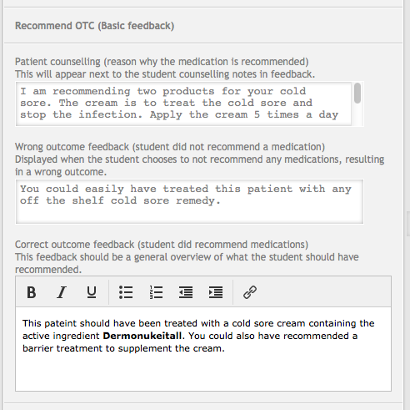
Patient counselling feedback is displayed next to any counselling notes that student entered during the exercise. Wrong outcome feedback is displayed when the student chooses to not recommend any medications. The correct outcome feedback is displayed underneath the medications the student recommended to the patient.
In addition to the above fields, there is an option to display some recommended medications to the student. To enable recommended medications, check the recommended medications box. Medications are selected by clicking the manage recommended medications button, which opens a selection screen identical to the starting medication screen.

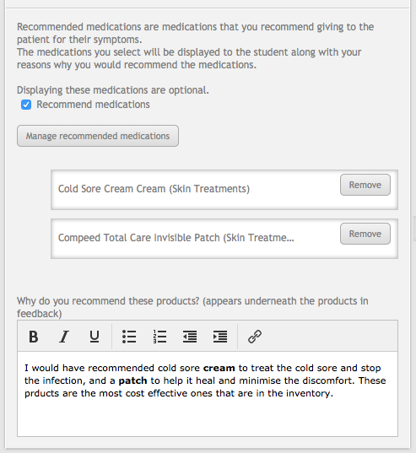
Once the medications are selected, they appear in a list underneath manage button.
Underneath the list, there is another feedback field that is used to explain why these medications would be recommended to the patient.
The feedback field appears above the recommended medications on the feedback screen.

Recommend medication basic feedback example

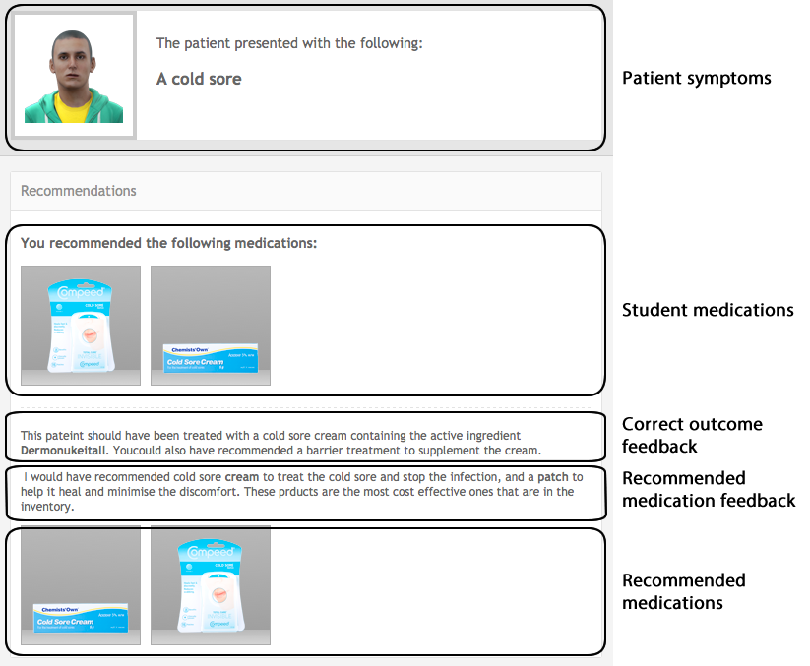

Recommend medications advanced feedback
Medication recommendation is delivered through treatment groups. Treatment groups, group together medications that you could recommend to treat a symptom of a patient. If the student selects a medication from a treatment group, they will be given positive feedback for that treatment group.
Treatment groups have their own set of feedback and may have a group of harmful medications. If the student recommends a medication that is harmful, negative harmful feedback will be displayed for that group.
At least one required treatment group must exist with recommend medications selected. Any number of treatment groups may exist in an exercise. To add a treatment group, click the add treatment group button.
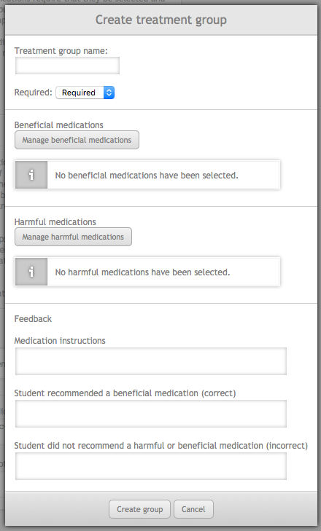
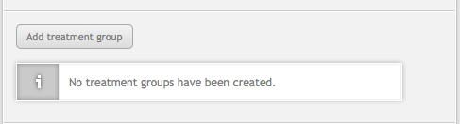
On the left is the treatment group screen. At the top are the options for the treatment group, followed by the beneficial medications for the group, the harmful medications and the feedback fields for the group.
The treatment group name is never displayed to students. The name is used to allow exercise designers to identify what the treatment group is supposed to treat.
Treatment groups can be set as optional. An optional treatment group should contain treatments that supplement the main ailment of the patient. Optional groups can be used to show students how further medications could be recommended to manage a condition and so on.
Beneficial medications are medications that the student should recommend to the patient. Harmful medications should not be recommended to the patient. Each set of medications is managed by clicking the manage harmful or beneficial medications button.

Clicking the manage button displays the OTC management screen.
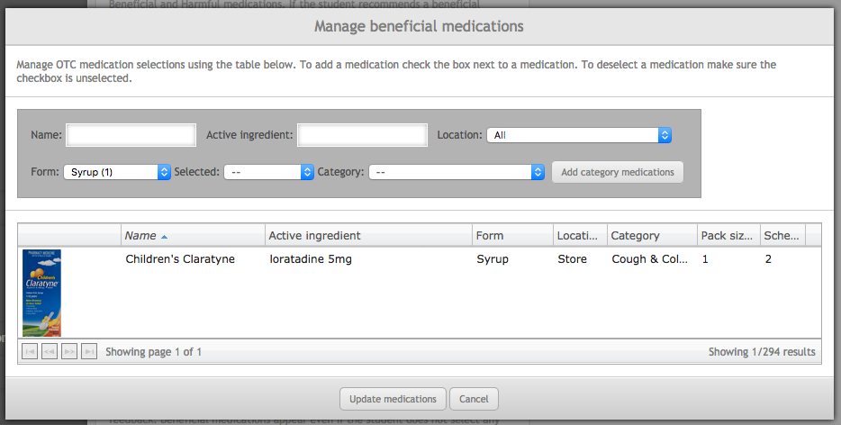
Unlike other medication selection screens in MyDispense, the OTC management screen allows multiple medications to be selected at once. To select a medication, click on the medication row in the table. Any medication you select will persist through searches and appears with a yellow highlight on the row. If you want to see the contents of your current selection, use the ‘selected’ search option.
Note that if you have any other search options selected, they will still be matched even with the selection search option enabled. Remember to clear your other search options first.
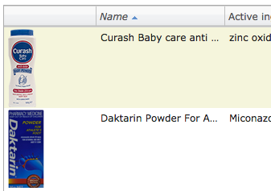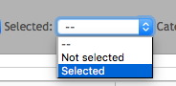
If you want to add medications in bulk from a category, select the desired category from the category search drop down menu. Once selected click the add category medications button.
Clicking the button will add medications in that category to the medication selection by highlighting all medications in that category. A notice will appear at the top of the screen with the number of medications added to the selection.
Once a category of medications has been added to the selection, they can be de-selected by clicking the rows of the undesired medications. To more easily facilitate this, use the selected search filter.
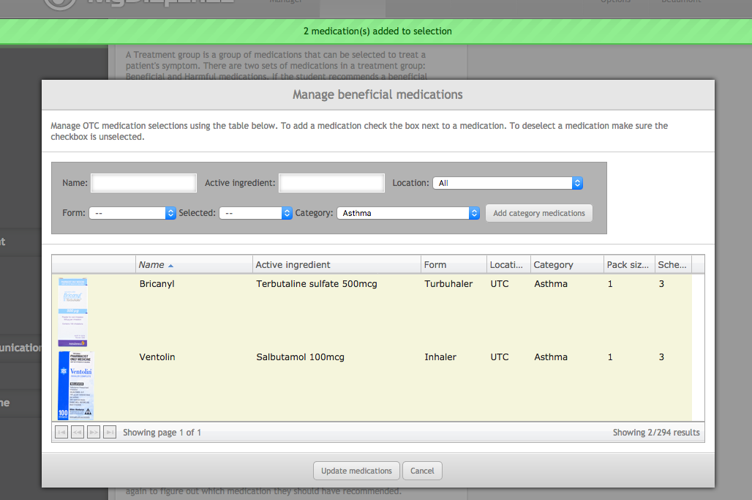
When selecting medications, there are a few rules. A medication that has been selected as beneficial in one treatment group cannot be added as harmful in another and vice versa. Medications be selected in other groups but they must match the selection in the other group. For example, a beneficial medication selected in one group can be selected as a beneficial medication in another group.
Medications that break these rules will not appear in medication selection screen where the rule is broken. They cannot be selected by the category add button either.
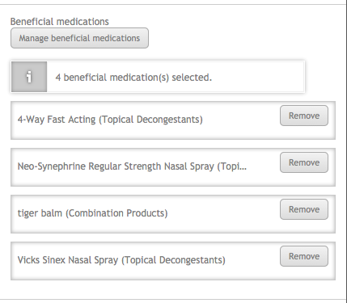
Once the desired medications have been selected, click the update medications button at the bottom of the management screen. The treatment group screen will be updated with the selected medications.

The selected medications are listed similar to the picture on the left. Selected medications can be removed from the group by clicking on the remove button next to the medication.

Each treatment group has its own set of feedback fields. They are: medication instructions, beneficial feedback, harmful feedback (if harmful medications have been set) and did not select any medications feedback.
When a student has completed an exercise, the medications instructions feedback is displayed underneath the counselling feedback, which is outside of the treatment group screens. Medication instructions are only displayed if a beneficial medication from the group has been selected. Thus if the student does not select a correct medication, they will not see this feedback.
The medication instructions have been split to make it easier to manage medication specific instructions per treatment group. Trying to maintain all of the medication instructions outside of the treatment groups would be more difficult.
The beneficial feedback field is displayed if the student selects a beneficial medication from the group. If the student selects a harmful medication, the harmful feedback will be displayed. Note that if the student selects a beneficial and harmful medication from the same treatment group, the harmful feedback will be displayed.
If the student does not select any medications selected for the treatment group, the did not select medications feedback will be displayed. The context of this feedback changes based on whether the treatment group is required or optional.
If the treatment group is optional, the feedback should suggest that the student could have treated the student further with some of the medications in the group. If the treatment group is required, the student has failed provide beneficial treatment for the patient and the feedback should reflect that.
Note that in the feedback, the beneficial medications for the group will be displayed to the student as medications they could / should have recommended.
Once the feedback has been set, create the treatment group by clicking the create group button at the bottom of the screen.

The new treatment group will appear underneath the add treatment group button. The group display is in the following format: <name> <Number of beneficial medications> B <number of harmful medications> H (<group required or optional>.
The picture below is an example of what a defined treatment group looks like.
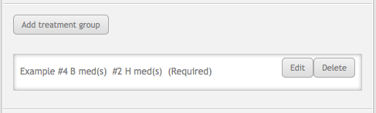
Clicking the edit button will open the treatment group screen where you can edit everything in the treatment group. Clicking delete will immediately delete the treatment group from the exercise.
Underneath the treatment group section there are two feedback fields, patient counselling and wrong outcome feedback. The patient counselling field should cover the general reasons for why the patient should take the medication. Anything specific to the medications in each treatment group should be set in the medications instructions field inside the treatment group.
Wrong outcome feedback is displayed when the student decides to not recommend any medications instead of recommending medications. The field should be used to explain that the student should have recommended treatment. The feedback screen for an incorrect outcome will not display any medications that they should have recommended.

