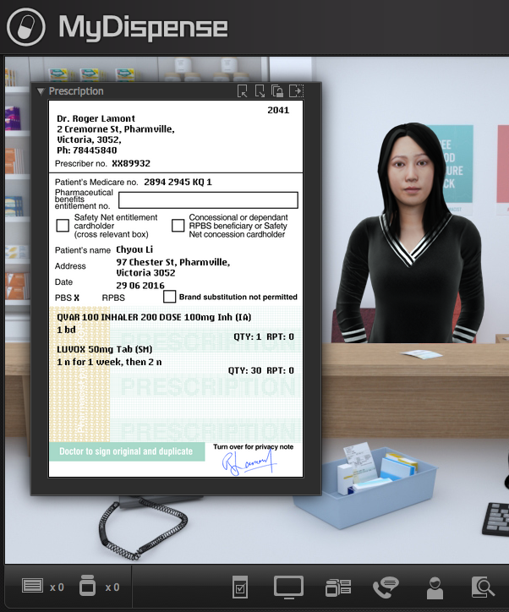
MyDispense
Dispense Exercise Guide

Version 5.2

Table of Contents
What is MyDispense? 4
Who is this guide for? 4
How should I use this guide? 4
Dispense exercise designer 5
Create a new dispense exercise 5
The Exercise Designer screen 6
Creating your exercise 7
More complex exercises 13
Patient and prescriber Fact finding 13
How to add patient fact finding to your exercise 14
Filling in patient responses 16
16
How to add prescriber fact finding to your exercise 17
Patient questions 18
How to add patient questions to your exercise 19
Counselling and handover 20
How to add patient counselling to your exercise 20
Additional information 21
How to add attached files to your exercise 21
Managing dates 21
Adding errors into exercises 22
How to add errors to your exercise – script error example 23
How to add errors to your exercise – additional information example 26

What is MyDispense?
MyDispense is a simulated learning and teaching environment that is designed to help students develop their skills and competency in dispensing medicinal products systematically, safely and accurately at a level of detail and difficulty corresponding to their knowledge and experience. It simulates the decision-making environment within which dispensing occurs, without reminders and prompts and with the opportunity for students to learn by making mistakes in a safe and secure learning environment. For an instructor, MyDispense is a framework allowing you to create a broad range of exercises and assessments from the simplest to the most demanding. The administrative interface is simple to use while giving you the control and flexibility to create challenging scenarios that best support your curriculum.

Who is this guide for?
This guide is a comprehensive guide on how to create dispense exercises in MyDispense. This guide assumes that the reader has previous experience in creating Exercises in MyDispense.

How should I use this guide?
You can either read the whole thing from beginning to end (but who does that with user guides?) or you can skim over the introductory sections to get a feel for how dispense exercises work, and then delve into the detail when you need it.
This guide has been designed to support the latter option.
You will find sections, titled in orange, which deal with specific and common tasks in MyDispense; hopefully these sections will get you where you need to be. If you need more detail, there will always be a more in depth description available.

Dispense exercise designer

Create a new dispense exercise
From the unit tutorial screen, click on the Create dispense exercise button at the button of the tutorial list.
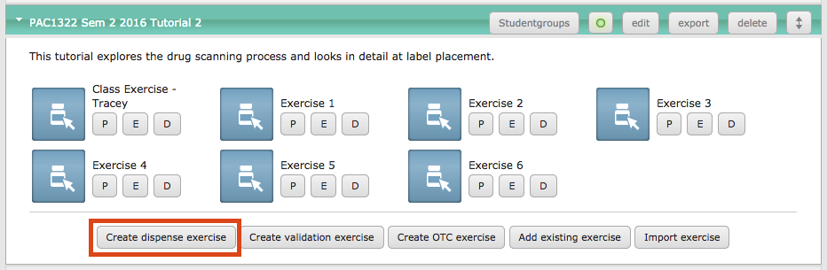
This opens the Dispense exercise designer.

The Exercise Designer screen
The Edit Exercise panel allows you to change all of the data and settings for the exercise.

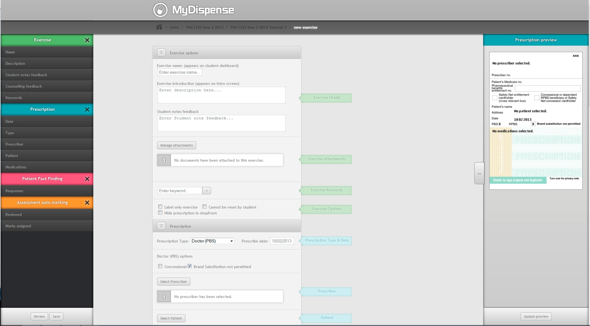

The Prescription Preview panel shows you the prescription as it will look to the student in the exercise.
The Review panel will alert you if there is anything missing from the exercise, or if you have invalid data.

Creating your exercise
STEP 1 - Set up the exercise options

1. | Add the exercise name. This is the name that will appear to students on the MyDispense dashboard. | 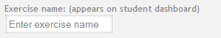
2. | Enter the exercise description. This text only appears in admin screens and allows users to more easily find exercises. | 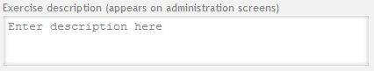
3. | The introduction text appears to students when they enter the exercise. Use this text to set the scene for the exercise. This is a required field, so at a minimum you should enter something like “Mr X would like you to dispense the medicine on his prescription”. | 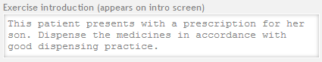
4. | You can add optional keywords to an exercise, such as “diabetes”, “dose change” etc. Keywords make it easier to search for exercises. | 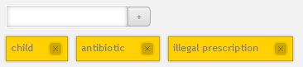
5. | Use the checkboxes to configure the exercise options, which are:  Labe only exercise – this is an exercise that only goes as far as the printing of a label. It is often used for novice students.  Cannot be reset by student – normally students are able to reset an exercise after completion so that they can try again. Checking this box prevents them from doing this for the current exercise  Hide prescription in shopfront – check this box if you want to create an emergency supply exercise where the patient does not have a prescription. | 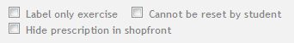
6. | Select the date management method.  You can choose to set the date manually or allow the date to be set automatically.  A manual date allows a specific timeframe to be set for an exercise; an automatic date is set when the student starts an exercise.  All dates in an exercise are set as the number of days + or - from the exercise date.  See the section on managing dates for more information. | 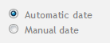
7. | The Manage Attachments button allows you to attach supplementary files to the exercise. This feature will be covered in a later section. | 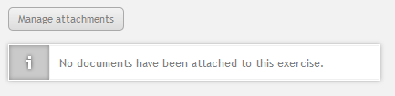

STEP 2 - Create the prescription

The prescription is at the heart of every MyDispense exercise. It identifies all of the key components within the exercise, such as medicine, patient, prescriber etc. Even emergency supply exercises have a prescription, which is hidden from the students.

 | Select the appropriate prescription type from the drop down list (see the appendix for a list of supported prescription types).  The prescription preview panel will display the type of prescription you selected. | 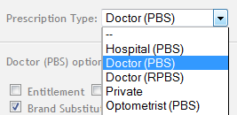
 | Set the prescription date offset.  The date on the prescription will be calculated with the offset you enter into this field. For example -5 will subtract five days from the date. | 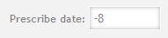
 | Set the prescription specific options.  The allowable options for the chosen type of prescription will be displayed beneath the prescription type. | 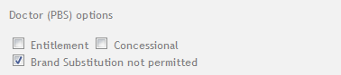
 | Select a handwriting font.  This is optional and is used for prescriptions that need to be handwritten. | 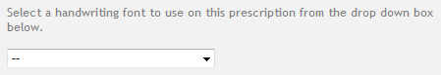
 | Select the prescriber.  Once a prescriber has been selected, their details are shown in the prescription panel. | 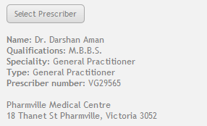
You can search for prescribers by first and last name.

If you are looking for a specific type of prescriber you can sort the list by the prescriber’s speciality.

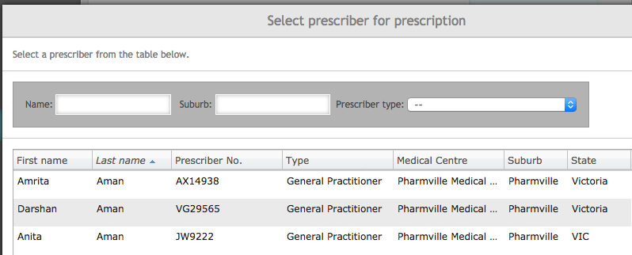

 | Select a patient to add to the prescription.  Once a patient has been selected their details are shown in the prescription panel. | 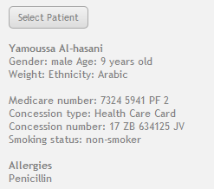
You can search for patients using firstname, lastname, gender and age.

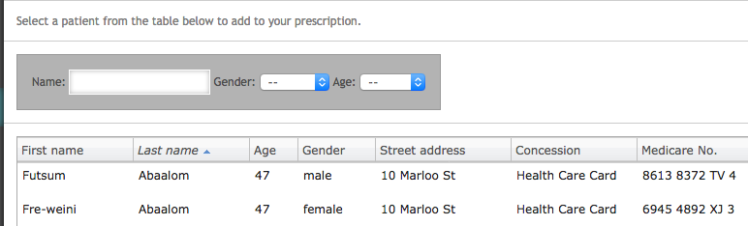

 | Select an image for your patient. This is the image that will appear in the pharmacy ‘shop front’ at the dispensary counter.  Some patients, such as our Pharmville characters, have a locked image that can not be changed. | 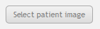  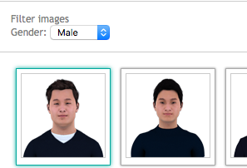
 | Add patient notes and feedback if required.  The patient notes displayed in the dispensing application can be ‘pre-loaded’ using this feature. | 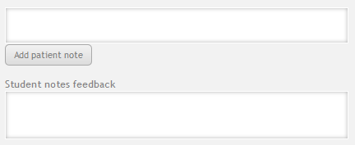
 | Add dispensing records if required. | 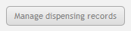
 | Add a medication to the prescription. | 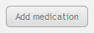
You can search for medications by generic and brand name. Results can be filtered by location (shelf, fridge, safe), controlled-drug status and drug form.

There are just over 1000 drugs in the MyDispense database including over 40 controlled drugs. Most drugs are on the shelf and over 50 drugs are in the refrigerator.
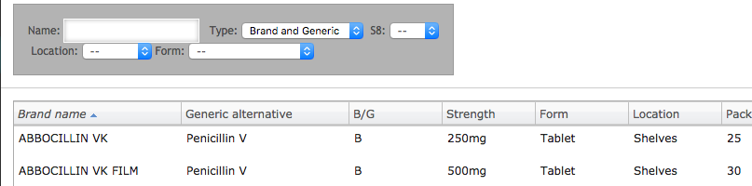

 | Fill in the fields on the New medication for prescription form (see below)
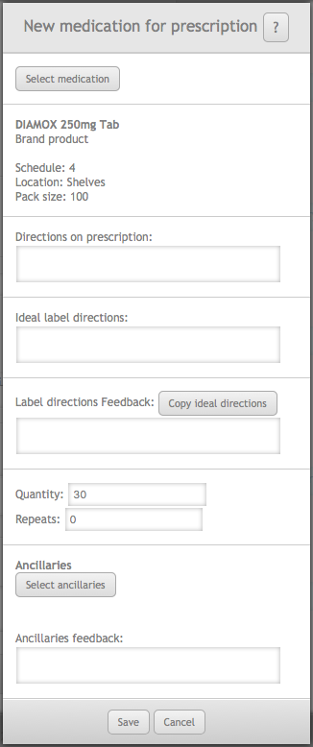
The Select Medication button allows you to select an alternative drug from the database.
Details of the selected medication
Enter the directions as they would appear on the prescription. Use normal prescriber shorthand and sig codes.
Enter the directions as they would appear on the dispensing label. Use accepted standards for labelling medicines.
The text you type here will appear on the ‘ideal’ label shown to students in the feedback section.
This field is also shown in student feedback and allows you to expand on the wording chosen for the ideal label.
Enter the prescription quantity and repeats. (Repeats value is always 0 in this version of MyDispense).
Select any required ancillary labels for this medication. Use the feedback box to explain why the chosen labels are necessary.

14. | Click the Save button on the new medication for prescription panel to save the medicine data.
15. | Repeat the above process if you wish to add more medicines to the prescription.  Note that some prescription types will not allow multiple items and that the maximum number of dispensable items on a prescription is three.
16. | This is all you need to do to make a simple exercise. You may save your exercise at any time using the save button.  However, students will not be able to view the exercise until you publish it. Publishing the exercise requires that you complete the exercise checklist, which is updated each time you attempt to publish an exercise. | 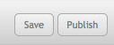
17. | Fix any issues.  The Exercise review panel will show any problems with the exercise when you click the Publish button.  If you see a red cross it means that information is missing or incorrect.  Clicking on the red cross will give you more detail on the problem allowing you to fix it.  Is the example here the instructor neglected to add a medication to the prescription.  Clicking on the green ticks will also give you some more information about that particular element. | 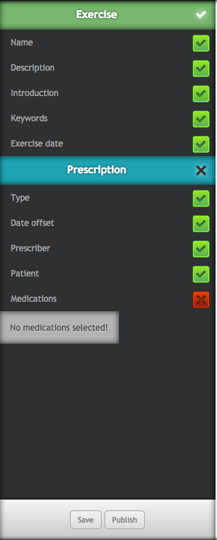
18. | When you are happy with the status of the review panel, click on the publish button.  You will be taken back to the tutorial manager screen and your new exercise will be there for you to preview.

More complex exercises
Simple exercises are just the beginning of what you can do in MyDispense. The following sections show you how to create more challenging scenarios for your learners.

Patient and prescriber Fact finding
Patient and prescriber fact finding is a feature in MyDispense that allows students to gather information from the patient or prescriber in order to make informed decisions. It is not intended to teach students communication skills. For that reason we did not design a conversation style interaction, instead there is a fixed list of topics that can be discussed with the patient or prescriber. Every patient or prescriber interaction has the same list of topics, only the answers change.

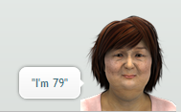
The Patient Fact Finding list of topics is:

- Age
- Alcohol consumption
- Allergies
- Breastfeeding
- Previous use of medication(s)
- Hospital admission
- Illicit drug use
- Other medications
- Pension/Entitlement/Medicare Number
- Pregnant
- Smoking status
- Symptoms
  - Other symptoms
  - Aggravating/relieving factors
- Weight
- Purpose of medication(s)
- Other symptoms

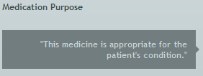
The Prescriber Fact Finding list of topics is:

- Medication purpose
- Dosing query
- Interaction
- Patient allergies
- Controlled Drug
- Paperwork issue
You may also define your own custom topics and answers as custom questions.
Patient and Prescriber fact finding have two options for feedback, basic and advanced. Basic fact finding feedback requires that feedback for the predefined and custom questions be entered in a single text field underneath all of the questions. Advanced feedback uses a separate field for each question, which is accessible when editing the question. Note that when using advanced feedback, Can Ask questions do not require feedback.
The feedback options allow exercise designers to manage the feedback for questions how they see fit. If basic feedback is selected, individual feedback cannot be set per question.
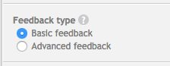
Completing predefined patient fact finding topics is optional, nor do all topics need to be defined. If a topic is not defined, it will still appear in the list of questions that the student can ask, but a random response (for example: “Huh?”, “I don’t know”) will be given instead. Thus only questions that an educator want students to ask need to be defined.

How to add patient fact finding to your exercise

To add patient fact finding do the following:

1. | Open the Patient fact finding panel.
2. | Select feedback type
3. | Click on the Add response button to create the patient’s answers for that topic.  You do not need to define all of the topics. | 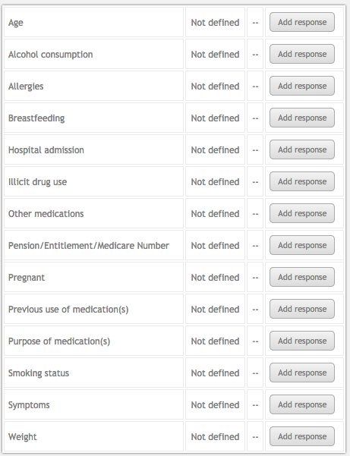
4. | Fill in the form for each response as shown in the example below.

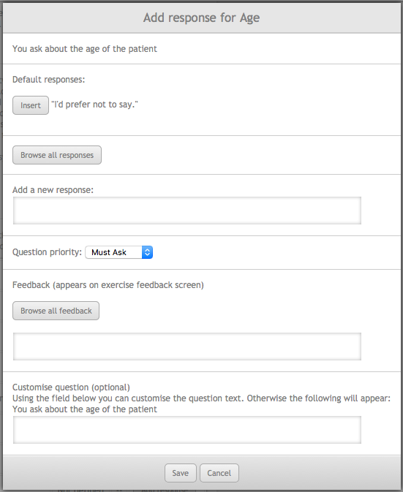
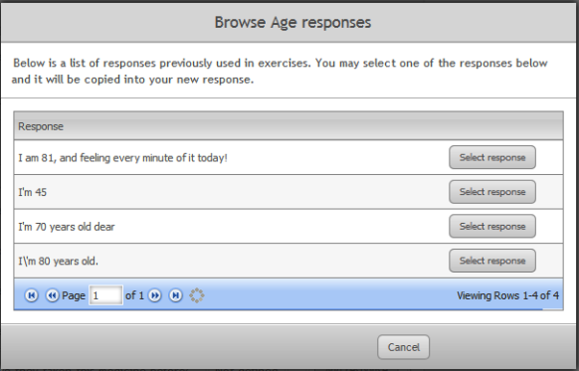
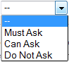
Filling in patient responses
You can choose to add the default answer for a question by clicking this button.
Alternatively, you can add your own response to the question by entering it into this box.
You can browse all of the answers that have been given in the past for this question by clicking this button.
Enter your own feedback for the question/response into this box.
Feedback is not required for Can Ask Questions.
This field will not appear if basic feedback has been selected.

You can choose feedback from all the feedback that has been entered in the past by clicking this button.
Set the question priority here.

Must ask questions are those that the student needs to ask in the given situation.

Can ask questions do no harm, but will probably not give any useful information in the given scenario.

Do not ask questions are those that may be inappropriate, such as asking a man if he is pregnant.

Enter your own question in this box. The question will default to a predefined value, but you can overwrite it here.

5. | Click on the save button to save that response. | 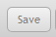

How to add prescriber fact finding to your exercise

To add prescriber fact finding do the following:

1. | Open the Prescriber fact finding panel. | 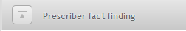
2. | Select feedback type
3. | The fact finding configuration panel will appear.  Each item for discussion requires you to enter the answer from the prescriber.  Click on the Add response button for each topic to create the prescriber’s answers for that topic. | 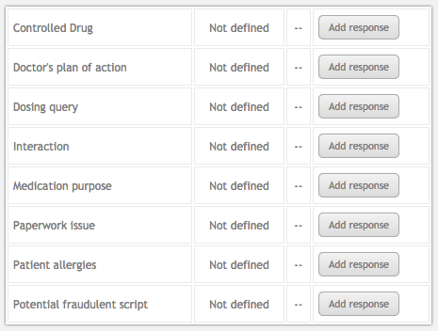
4. | Fill in the form for each response as shown in the patient fact finding example on page 18. | 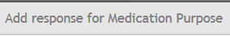
5. | Click on the save button to save that response.
6. | Choose whether you want to use prescriber frustration.  Sometimes a prescriber will not take kindly to being called several times by the pharmacist. You can enable frustrated prescriber mode and set the number of calls that the prescriber will take before they refuse to answer any more. | 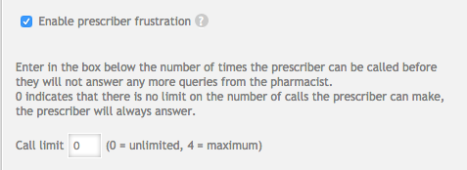

Patient questions
Patient questions are questions the student may prompt the patient to ask on the exercise hand over screen. Student answers to these questions are recorded and shown in the feedback screen alongside instructor feedback for the question.
Patient questions can be set to be asked before / after patient intervention or any time during an exericse. If a question is set to only be available before the patient intervention then that question will not be displayed after the student selects medications or counsels the patient. Counselling the patient / selecting medications is taken as interacting with the patient, so the questions will change.
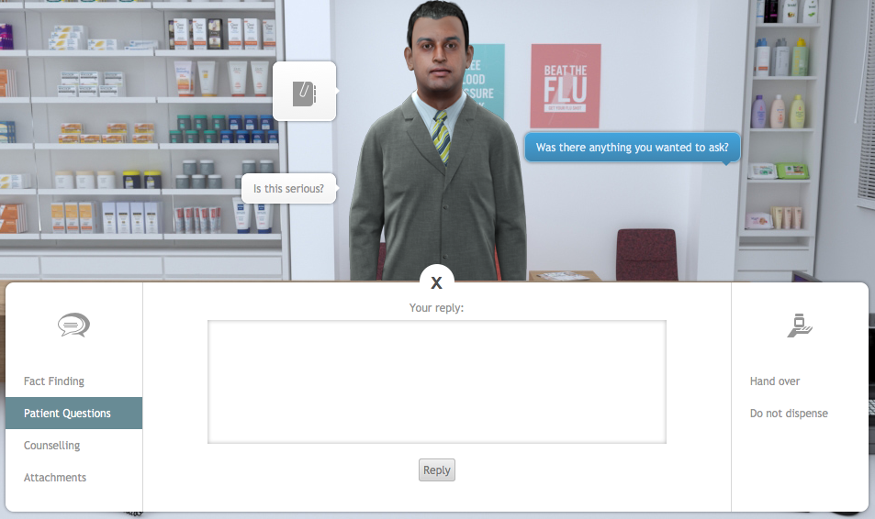

It is possible to enable a ‘pushy patient’ option. A pushy patient will tell the student that they have questions if the student attempts to handover without having prompted patient questions. The student will then choose to answer questions or continue with the handover.

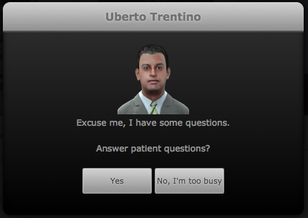

How to add patient questions to your exercise
To add patient questions, open the Patient questions panel:
1. | Click on the check box to enable patient questions. | 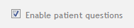
2. | You can enable the pushy patient option at this time or choose to do it later if you wish. | 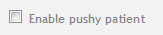
3. | To add questions, click on the Add question button | 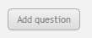
4. | Fill in the text boxes for the patient’s question and also the ideal answer that should be given to the patient.  This answer will appear in the feedback section for the exercise.  Select when the patient will ask this question. Before, After or before and after. | 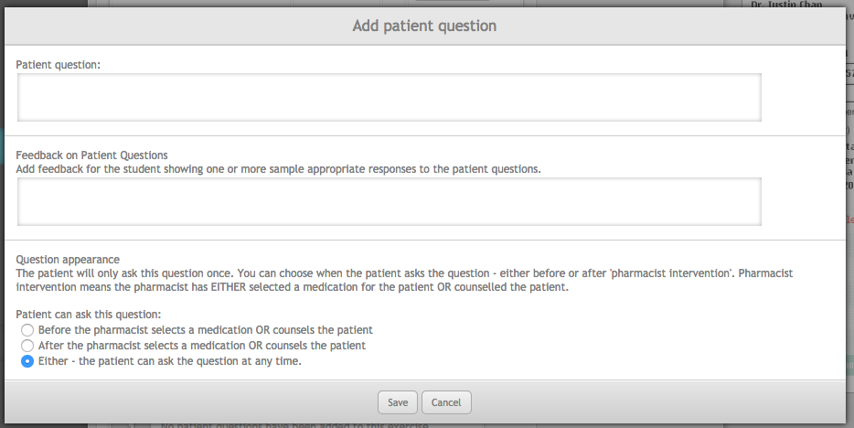
5. | Click on the Add question button if you want to add more questions.
6. | Your questions will appear in the Patient questions panel.  You can move questions up and down the order by using the arrow buttons. | 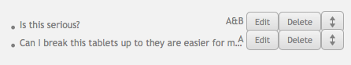

Counselling and handover
You can require that your students provide counselling to the patient during the handover phase of the exercise. You are also able to provide feedback on the professional notes that students make during the dispensing process.

How to add patient counselling to your exercise
To add Patient counselling, open the Counselling and handover panel:
1. | To enable patient counselling, check the Enable patient counselling checkbox. | 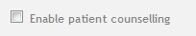
2. | Enter the ideal counselling points into the Counselling feedback text box.  This text will appear in the counselling section of the feedback screen for the exercise.
3. | You can also choose to provide feedback on professional notes that students take during the dispensing process.  The student’s notes will appear in the feedback screen alongside your feedback. | 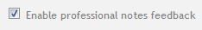

Additional information
You can add files to your exercise to give students more information, such as laboratory test results, patient discharge letters, GP letters etc. In fact, any file that can be saved in PDF or JPG format can be attached to an exercise.
You can attach up to 5 files to an exercise and each file must be no more than 20 MB. Please try to make sure that your attachments are as small as possible since large files will slow down the performance of MyDispense.

How to attach files to your exercise
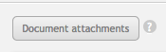
To attach a file - click on the Document attachments button.

The Exercise attachments panel will appear:
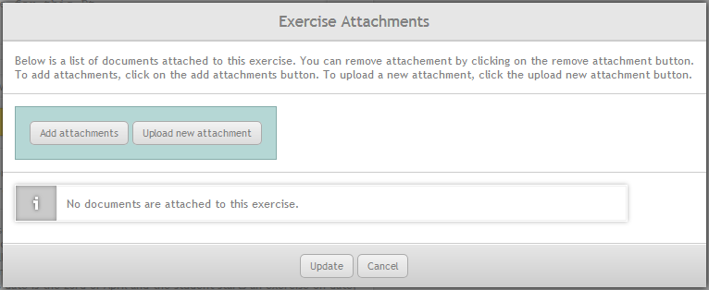

You can either add an attachment that is already in the MyDispense repository, or upload a new attachment from your computer.

Link attachments
Link attachments are links that you can add to the exercise. The links can be to anywhere on the internet and it could be a supporting article or a video for your students to watch. To add a link attachment, click the add link attachment button.
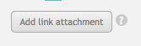
The add attachment link panel will appear. Enter the title of the link into the title box and the link into the link box. Please note that the link you put into the box must be a complete link. It needs to contain http:// at the start of the link to work. To ensure that the links work, please copy them from the address bar of your browser.

Managing dates
Dates in MyDispense are calculated relative to the date that a student undertakes an exercise (the exercise date).
By default the date on a prescription will beset to the exercise date. If you want to change the prescription date, for example, make the date on a prescription three days before the exercise date, you simply enter -3 to the date field in the prescription.
It is also possible to add relative dates to other elements of the exercise, such as patient notes, by adding a simple code in the format: [d]-x[/d]
If, for example, you wanted to add a patient note dated 14 days before the exercise date you could type “Patient has nut allergy KS [d]-14[/d]”.

Adding errors into exercises
The ability to add errors into exercises is a powerful feature that is new to version 4 of MyDispense.
Errors can take almost any form, and you can be quite creative in this respect. For example:
- You can introduce an error into the prescription, such as missing information or a dose problem.
- You can create a scenario where the prescription or medicine has expired.
- You can create a medication history for the patient that means the medicine on their current prescription will cause an interaction.
- There may be a potential interaction between the medicine on the prescription and something the patient is already taking, which can only be determined via patient fact finding or patient questions.
- You could create a situation where the patient’s medicine history leads the pharmacist to suspect that they are abusing their medication.
The above scenarios are just an example of the kind of challenges you can make for your students by enabling the errors feature in MyDispense.
Adding errors can add complexity to the design of your exercise, so it is important to understand how the process works.
When you enable errors in an exercise you are giving your students the challenge of deciding whether or not they should dispense the prescribed medicine in the given circumstances. To facilitate this decision making, exercises with errors have three possible outcomes:
- The student should dispense the prescription
- The student should not dispense the prescription
- It is feasible to either dispense or not dispense the prescription at the student’s discretion.
If a student chooses not to dispense, then they are required to give reasons for this. At the handover point in the exercise, students are required to check an appropriate box and also provide some text that supports their decision:
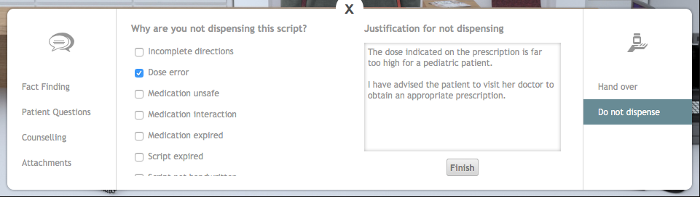
Two examples are given below to illustrate how to incorporate errors into exercises, the first example uses a script error, the second is more subtle and depends on the student finding out that the patient is pregnant.

How to add errors to your exercise – script error example
Example 1 – script error
To enable errors, open the Errors panel and check the box “Enable exercise errors”:
1. | Because we are adding a script error in this example, click on the Enable script errors checkbox. | 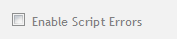
2. | Click on the Remove/Change scrip errors button.
3. | The remove/change script errors panel appears. | 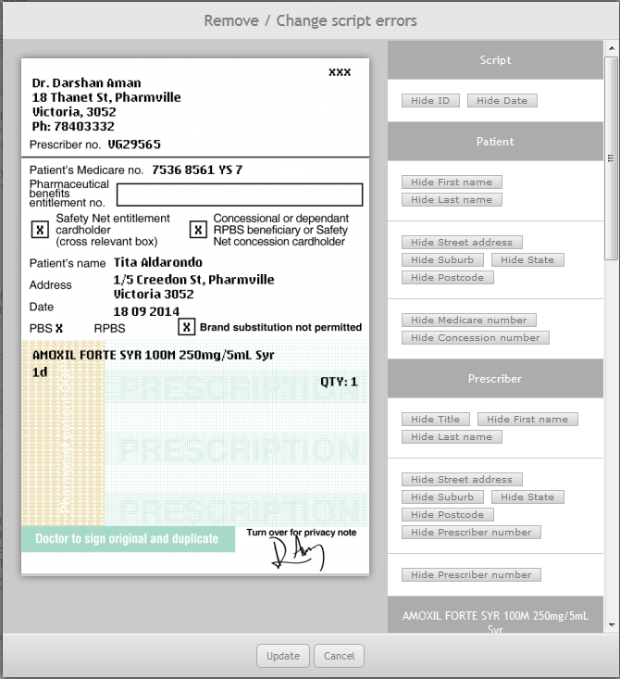
4. | In this example we are going to make an overdose by swapping the correct medication (for a child) with an adult dose and form. | 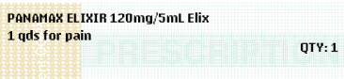

In setting up this exercise we already entered the correct medication and directions when we set up the prescription. We now need to alter the prescription that the students will see during the exercise.
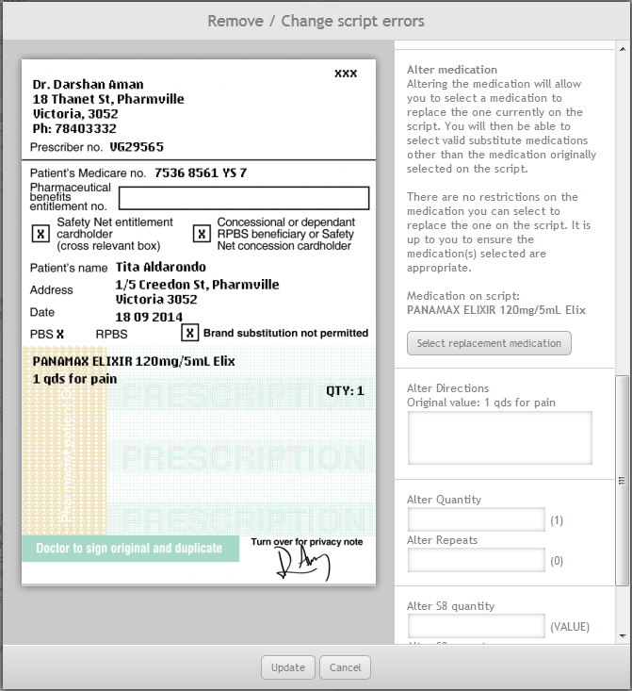
7. The select replacement medication panel appears. Use the search and filter tools to find an appropriate medication. In this example we are swapping Panamax 120mg/5ml elixir for Panamax 500mg tablets.
6. Click on the Select replacement medication button
5. Scroll down to the section titled Alter medication

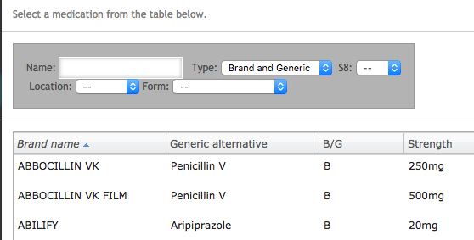

Notice that the Panamax 120mg/5ml elixir has now been replaced by Panamax 500mg tablets on the prescription:
The altered medication is shown in green.
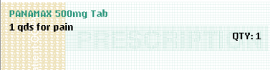

If we wanted to we could also alter the directions and quantity on the prescription. But since we want this to look like the prescriber has selected the wrong medication we will not alter the other prescription elements.
Selecting the correct outcome
We now need to determine what the correct outcome should be in this situation. In Australia, the pharmacists should spot that the dose and form are inappropriate for a child and instruct the Patient’s mother to return to the prescriber for another prescription. With this in mind we need to set the Outcome to “Do not dispense script”:
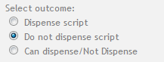
Upon selecting “Do not dispense script” you will see that several options appear in the outcome panel:
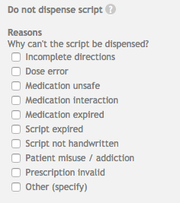
8. Select appropriate reasons for not dispensing the prescription.
More than one reason can be selected.

When you have selected the appropriate reason for not dispensing, you will need to provide feedback for the three possible student outcomes:
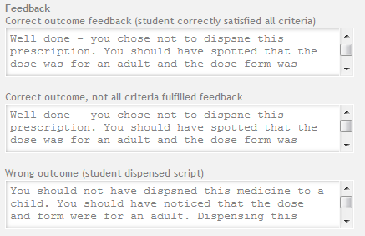
Wrong outcome – this feedback should address the situation where the student incorrectly dispenses the medication. You should outline the consequences of their decision and also possibly where they may have made the error.

Correct outcome – this option is for when you have specified that the only way to make the correct decision is by consulting another source, such as patient or prescriber fact finding.
If the student makes the correct decision of not dispensing but has not consulted an appropriate source, they may be guessing (or copying from another student).

Correct outcome – this feedback should address the situation where the student makes the correct choice of not dispensing.

You can now click on the review or save button. If there are any problems with your exercise they will appear in the review panel.

How to add errors to your exercise – additional information example
Example 2 – additional information
In this example we will build an exercise that at first glance seems to be straightforward but, in the patient fact finding section, the patient provides information that reveals a potential issue.
In this scenario the patient has been prescribed Minocycline 100mg Capsules for severe acne. In patient fact finding the patient reveals that there is a good chance that she is pregnant. Minocycline is contraindicated for pregnancy, so there is a clear problem dispensing this medication. Students can only discover the issue by using patient fact finding. Remember that students will receive negative feedback if they ask irrelevant or annoying questions during fact finding, so they need to be aware of the contraindication for pregnancy before they use this feature, and not use a ‘scatter gun’ approach to fact finding.
Step 1 - Set up the exercise as described on page 11, be sure to select a female patient of child bearing age. For the medication, select Minocycline 100mg Cap (AF) / AKAMIN 100mg Cap.
2. | Once the basic exercise is set up we need to enable fact finding. Open the Patient fact finding panel.
3. | Click on the Enable patient fact finding checkbox | 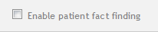
4. | The fact finding configuration panel will appear.  Complete each item for discussion as described on page 19. | 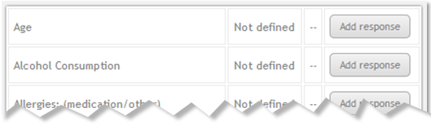
5. | Your patient responses should be something like those shown in this table.  You can decide on instructor feedback and also which questions should be can-ask must-ask and don’t-ask.  This is the key response; it needs to be ‘must-ask’. | Age | “I am 25”
 |  | Alcohol Consumption | "No, I don't drink."
 |  | Allergies: (medication/other) | “I have no allergies”
 |  | Breastfeeding | “No I am not breastfeeding.”
 |  | Have they taken this medicine before? | "No"
 |  | Hospital admission | "No"
 |  | Illicit drug use | “No, I don't use anything like that.”
 |  | Other medications | "I am not taking any other medication currently."
 |  | Pension/Entitlement/Medicare Number | "I have left my medicare card at home sorry."
 |  | Pregnant | “Actually, I think I might be pregnant. My husband and I are trying for a baby and I have missed a period. I'm quite excited about this, but did not want to say anything in case I am wrong. Is that a problem?”
 |  | Smoking Status | "No, I don't smoke."
 |  | Symptoms | “I have very bad acne. I find it very embarrassing.”
 |  | Weight of patient | “I don't actually know.”
 |  | What is the medication for? | “I have really bad acne.”

To enable errors, open the Errors panel and check the box “Enable exercise errors”:

Because the error we have introduced is to be revealed in patient fact finding, we need to check that the student has discussed the relevant topic with the patient. To do this we need to enable additional information. | 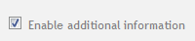
Click on the Enable patient fact finding questions checkbox | 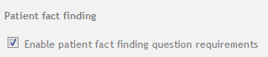
You can choose to specify any of the patient fact finding topics to be required for finding the error. In this case we only need to ensure that the student has asked the patient about pregnancy.

We now need to decide the outcome of the exercise. Should the medication be dispensed or not? In this case it would be dangerous to dispense the medication, so choose Do not dispense script.  There may be some circumstances where either outcome is acceptable. In these cases you can select the option Can dispense/not dispense. The feedback would need to take into consideration all of the possible factors leading to either decision. | 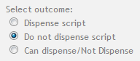
Upon choosing the option Do not dispense script, a set of possible reasons for not dispensing appears.  Choose at least one option.  Students will see the same list when they do the exercise if they choose not to dispense. They must also select a reason for not dispensing. | 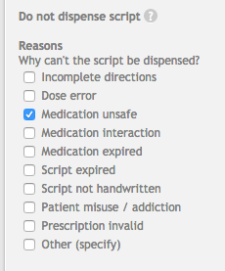
The final step is to enter feedback for each of the possible student outcomes:  - The student got the correct outcome and fulfilled any criteria that were set for information gathering.  - The student got the correct outcome, but failed to gather all of the information required.  - The student got the wrong outcome. | 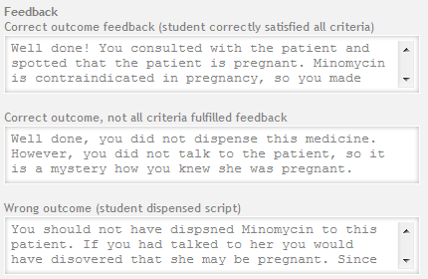

To complete the exercise, click on the review and save buttons in the review panel.

