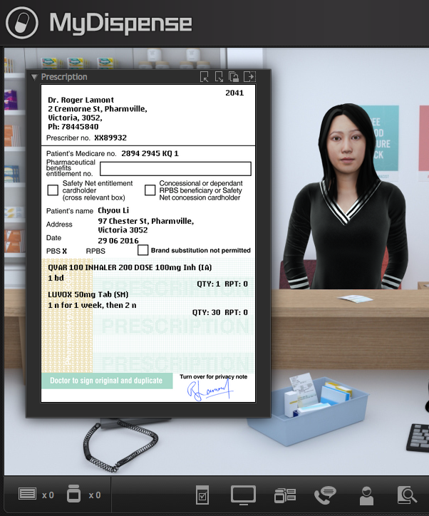
MyDispense
Import/Export Guide

MyDispense 5.1+

Table of Contents
What is MyDispense? 4
Who is this guide for? 4
Important note 4
Export 5
Unit 5
Tutorial 6
Exercise 6
Import 8
Resuming an import 8
Starting an import 8
Destination 10
Content 10
Review process 10
Finalise 10
After importing 11

What is MyDispense?
MyDispense is a simulated learning and teaching environment that is designed to help students develop their skills and competency in dispensing medicinal products systematically, safely and accurately at a level of detail and difficulty corresponding to their knowledge and experience. It simulates the decision-making environment within which dispensing occurs, without reminders and prompts and with the opportunity for students to learn by making mistakes in a safe and secure learning environment. For an instructor, MyDispense is a framework allowing you to create a broad range of exercises and assessments from the simplest to the most demanding. The administrative interface is simple to use while giving you the control and flexibility to create challenging scenarios that best support your curriculum.

Who is this guide for?
This guide is a comprehensive guide on how to Import and Export Units, Tutorials and Exercises in MyDispense 5.1 and later.

Important note
Export files made in MyDispense 4 and earlier will not work with MyDispense 5. This is due to major changes made in the import/export system. Backwards compatibility could not be maintained.
Importing and Exporting in MyDispense is available for Administrator users only.

Export
Exporting in MyDispense has been designed to allow for easy sharing of resources from one MyDispense site to another. You may export a whole unit, a tutorial or a single exercise and import it, along with any data used by those exercises into another MyDispense site seamlessly.
During export, all assets (patients, prescribers, ancillaries, medications, OTCs and patient images) used by exercises are identified and included in the export file. For example, if exporting a single dispense exercise, the patient, prescriber and medications used in the exercise are included in the export package, along with their images. This is so that if the MyDispense site you are importing into does not have one of those assets or something similar you may import the data into the new site.
Because the full amount of data is included in an export file, the size of an export file will increase based on the number of exercises you are exporting and the assets used by those exercises. A unit may range between 70mb and 140mb. MyDispense export files are downloaded in the .myde file format.
Please note that there is a standard 200mb file size limit on uploads to MyDispense servers. If you have a unit larger than this constraint, please contact the MyDispense team.

Unit
To export a unit, go to the unit page in administration. Find the unit you would like to export and select the Export option from the actions drop down list.
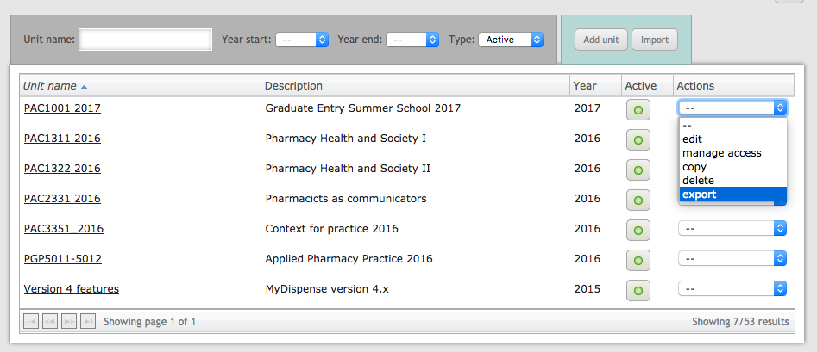

Selecting export will open a preparing export download window. The download will begin automatically and may take some time to prepare depending on the size of the unit.
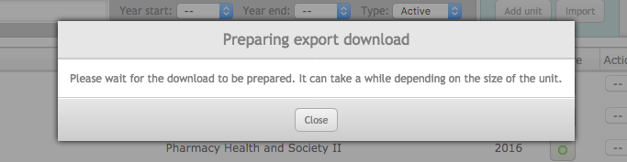

Tutorial
To export a tutorial from a unit, open the unit from the unit list. In the listing for each tutorial there is an export button. Clicking that button will start the export process for the tutorial.
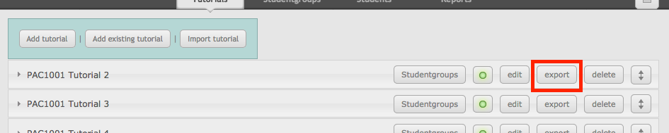

Exercise
Exercises may be exported from two locations, while editing an exercise and from the exercise list located in the admin options menu.

Editing an exercise
While editing a published exercise, the exercise may be exported by clicking the export button underneath the exercise checklist.
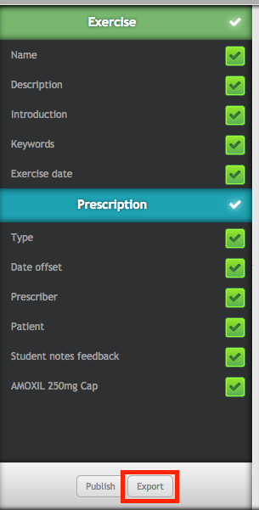

Exercise list
The exercise list is accessed via the admin options section in the administration menu. When inside the admin options section, click on the exercises button in the submenu.
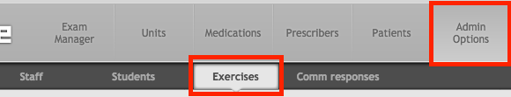
The list of exercises has buttons on the right side of each exercise entry. To export an exercise, click the export button.
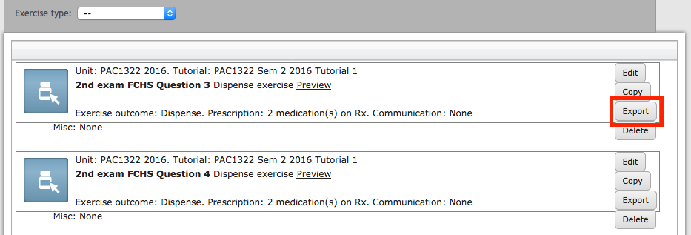

Export failure
When exporting, checks are performed on all assets (Attachments, Patients, Medications, Prescribers) used in the exercises inside that export. These checks verify that everything required for those exercises to be completed exists. If one of these checks fails, the export is halted and the export failure screen is displayed.
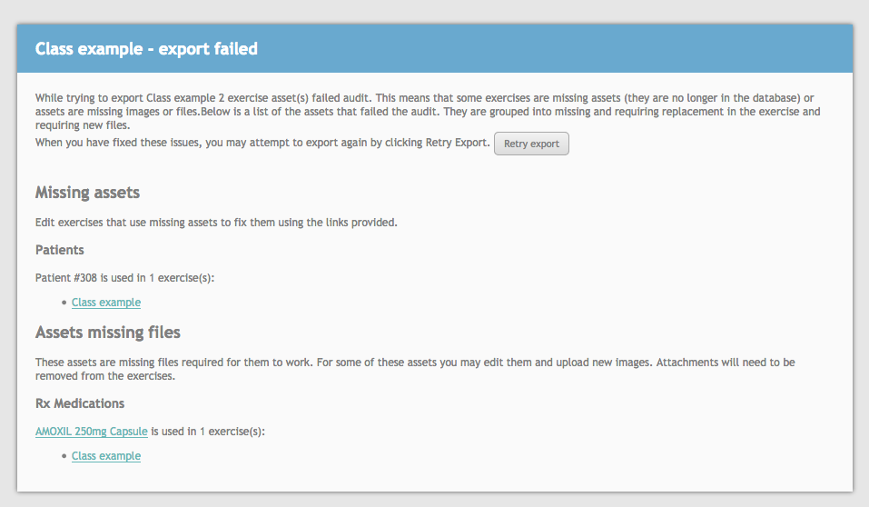
It lists the two types of errors that can occur: Missing assets and Assets missing files. A missing asset occurs when it cannot be found in the database. This means that the asset has been removed and no information can be found about it, other than the number ID of the asset that was stored in the database.
In the case of missing assets, the exercise must be opened and the missing assets replaced or removed. Underneath each missing asset is each exercise that uses the asset. Clicking on the exercise name will open the edit page for that exercise. Whereupon you should see the asset problem screen and can replace the assets.
The Assets missing files problem is when files that are needed by an asset are missing. For example, if you are exporting a medication that does not have all of its images, the check will pick up on this and will halt the export. When an asset is missing some files, you can click on the asset name to edit it and upload new files to replace the missing ones.
You may also click on the exercises listed underneath the assets to edit them. However, since these assets are not ‘missing’ the asset replace screen will not appear. For assets with missing images you will need to remove them from the exercises they are used in, or edit the asset and fix it that way.
Note that since attachments do not have an edit page, you will need to remove any attachments missing files from the exercise.

Import
There are several stages to importing in MyDispense. First you must upload an .myde file exported from MyDispense, select a destination for the item you are importing, review the assets used by the file and finally do post import checks.
Importing can be a lengthy process but you do not need to fully complete an import right away. Import progress may be saved at any time and any incomplete imports may be accessed through the import manager.

Resuming an import
The import manager can be found in user drop down menu in administration. To view the user drop down menu, click on your name next to admin options. In the menu that appears, click on the Import Manager button, which opens the import manager window.
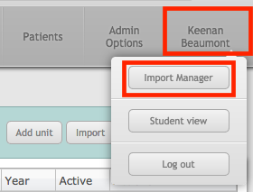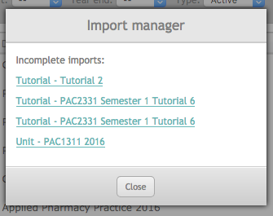
The import manager displays a list of all your incomplete imports. Clicking on an incomplete import will open the import page for that import. Note that you will only see your incomplete imports, you will not see imports started by anyone else.

Starting an import
There are three locations where an import can be started: the unit page and in two locations on the tutorials page, one at the top of the page and another location inside each tutorial. These locations make setting the destination for an import easier.
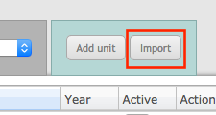
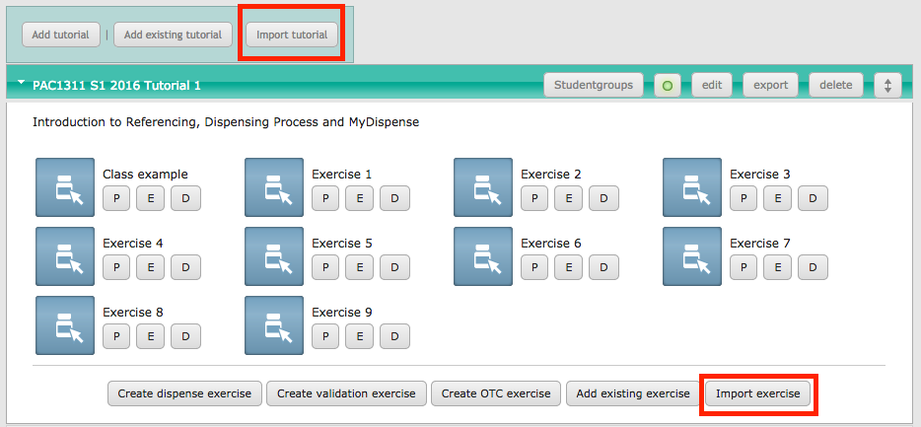
For example, if you wish to import a tutorial, you may open the unit you want to import your tutorial into and start your import there. The system will assume that is the unit you want your tutorial to go into and will set the destination appropriately. Import destinations are covered in depth in the next section.
Note that you can upload any export file to any location. You don’t specifically need to click the import exercise button when you’re importing a tutorial. If you don’t, the importer will detect that the type context doesn’t match and will help you set a new destination.
Clicking any of the import buttons will open the import upload window.
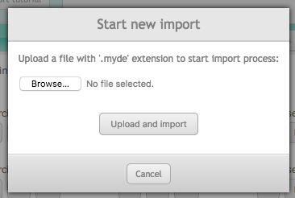
To start your import, click on the browse button and locate a .myde file. Once you have selected the file, click Upload and Import to upload and start the import process.

Import interface
Once an import file has been uploaded, you will be taken to the import page.
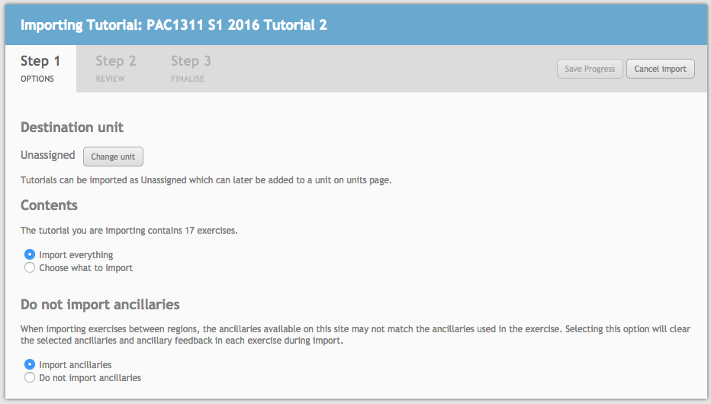
The import page is divided into three sections: Options, Review and Finalise. The options section contains options that pertain to the content you are importing, Review is for reviewing each asset contained in the import package and finalise is where you complete the import.
Whenever you make a change, the Save Progress button on the top right may be clicked to save the changes so you can come back and complete the import later. If you wish to cancel the import, click the cancel import button, also located in the top right.

Options

Destination
The destination, as described in the previous section is the final location for your import. This section only appears for Tutorial and Exercise imports, as units are at the top of the food chain and cannot be included inside other items.
If you import a tutorial while inside a unit using the import tutorial button, the destination will be set to the unit you were in. In a similar vein, when importing an exercise using the import exercise button inside a tutorial, the destination will be that tutorial.
The destination section allows you to review and change this destination by clicking the Change unit (for tutorials) or change tutorial (for exercises) button. From there you can search for a new destination for your import.
You may also clear the destination of your import. If you do this, the tutorial/exercise will not be associated with anything and will need to be manually added via the add existing tutorial/exercise buttons inside a unit.
If you try to import something that doesn’t match that original context, the destination will be cleared and it will appear as ‘unassigned’ instead. At that point you can select a new destination as normal.

Content
Available for Unit and Tutorial imports, the content option allows a subset of tutorials/exercises to be imported instead of everything in the import package. By default, everything in an import package is imported into the system.
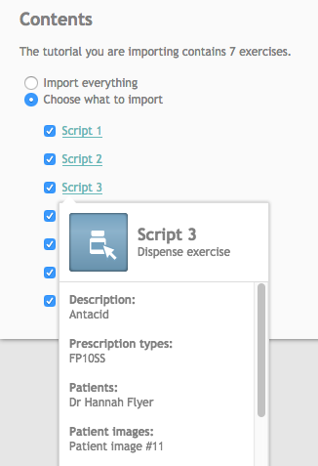
However, if you select the choose what to import option instead, a list of all tutorials (for units) and exercises appears.
In this screenshot an example of a tutorial import is used. In this case, the tutorial contains 4 exercises. If the checkbox next to an exercise is unticked, then that exercise will not be imported.
Details about the exercise can be displayed by clicking on the exercise name. This includes all assets used by an exercise.
The screenshot below displays the contents of a unit. When a tutorial is unticked, all of the exercises inside that tutorial will not be imported.
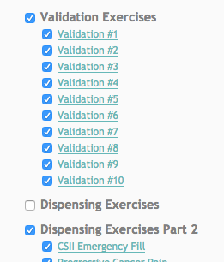
At least one exercise must be imported.

Do not import ancillaries
When importing between regions, such as Australia to USA the do not import ancillaries option will appear. Regions may not have the same ancillaries available or ancillaries in use may not be mapped directly to other ancillaries during the review process.
Therefore, selecting the do not import ancillaries option will remove all ancillaries and ancillary feedback from exercises that are to be imported.

Review
The review section is where all assets used by the exercises that are being imported are checked before import. Exercise assets are the following:
- Prescription type
- Patient
- Patient image
- Prescriber
- Medication
- OTC
- Ancillary
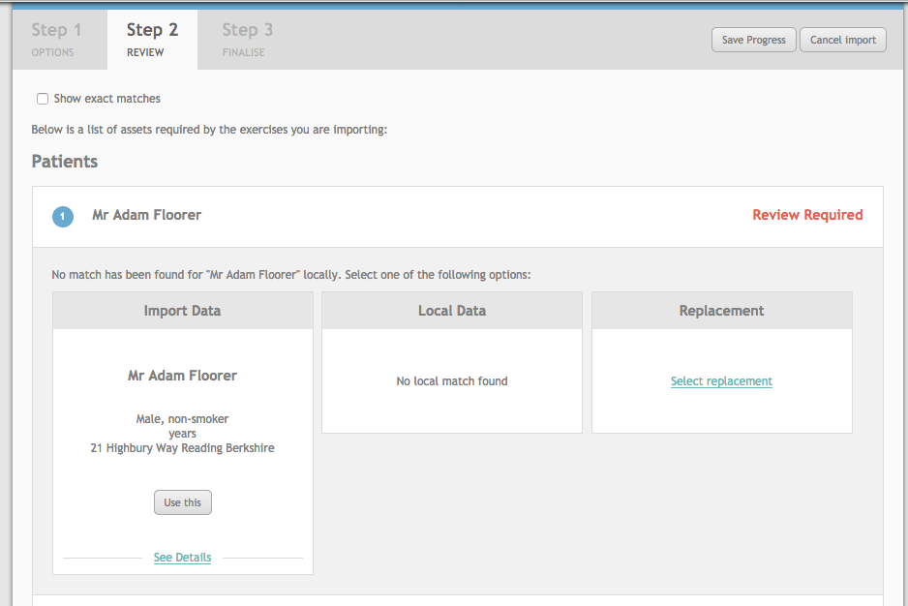
The review pane tallies up all of the assets that are used by the exercises you are importing (excluding those you have deselected if using the content option) and attempts to find matches on the import site.
When importing from another MyDispense site, the databases of the two sites may be very different. Your site may have everything their site has, or it might not; the importer tries to match everything up as best as possible, but sometimes a match may not be found. If an exact match is not found, it is up to you to decide on what happens with that asset.
For example, a dispense exercise uses a patient, a prescriber, a prescription type, a patient image and two medications. If exact matches are not found for some of these items, those items must be reviewed.
Note that only a single instance of an asset will appear in the list. For example, if a patient appears in 10 exercises, they will only appear in this list once. This also means that the review decision made on that patient will apply to all 10 of those exercises.

Asset usage
In the header of each section, there is a circle with a number in it. The number indicates how many exercises use that asset in the import file. Clicking on the circle will reveal all exercises that use that asset.
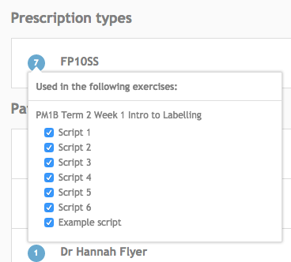
Next to each exercise is a checkbox. Unchecking the box will set that exercise to not be included in the import. Doing so links back to the content section on the options tab.
If the contents option is not enabled and an exercise is deselected, the option will be enabled automatically. The exercise will also be deselected from the content options list.

The number next to each asset is kept updated with the number of exercises that use it. If an exercise is deselected, the number is updated. Note that the asset usage number does not appear for exercise only imports.

Review options
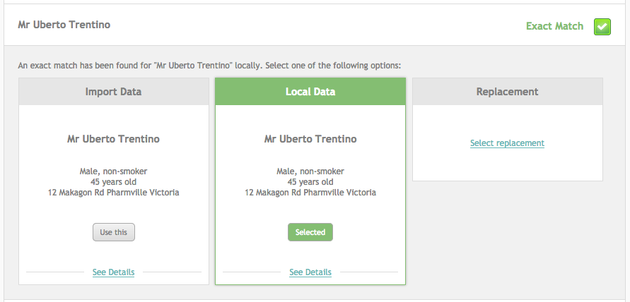
To select an option, click the Use This button. In the case of select replacement, the select replacement link must be clicked first.

Match
The match option is available when a match is found for an asset in the database. Selecting the match option will set the asset to use the match found on the system.
There are three kinds of matches: An image match and primary details match. Image matches and primary details matches are considered exact matches. When an exact match is made (image or primary details), that asset is hidden by default in the review pane. This is because it is fairly safe to assume that the assets match and don’t need to be manually reviewed.
If no match is found during the image and primary details searches, the asset is marked as having no match and therefore the match section will be left empty.
Image matches are performed when an asset type has an image associated with it. Patient images, prescribers, medications and OTCs use image matches.
Primary details match search for assets with the same main details as the imported asset. For example, a patient primary details are their name, gender and age. If these all match, a match is made.
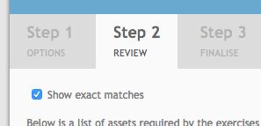
Automatically matched items can be viewed and changed by checking the show exact matches option at the top of the review screen. If an exact match option is changed, it will appear without having to check the show exact matches option.

Replace
The replace option allows you to search for and find a replacement asset. It is very similar to selecting a patient in an exercise. To select a replacement, click the select replacement button for that asset.
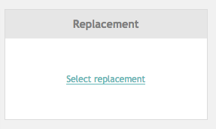
Doing so will open a search window where a new asset can be searched for and found. After selecting a replacement, it will be used in place of the original in all instances where it is used in exercises.

Import
The match and replace options use asset data that exists in the MyDispense site you are importing into. The import option creates a new copy of the asset in the MyDispense site. Importing a new asset does not affect any existing assets, it is a new copy of the item.
During the final import process, imported assets are flagged as being imported. What this means is that the asset must be opened and saved to ensure that all of the required fields for that asset have been completed.
The import system does not run a full validation check on imported items and relies on the exercise designers and asset editors to do those final checks. Resaving an asset with all the fields filled out will clear the import flag.

Import restrictions
Some assets from one region cannot be imported into other regions. The table below outlines the import support status for each asset type.
Asset type | Australia | USA | UK
Prescription type | No | No | No
Patient | Everywhere | Everywhere | Everywhere
Patient image | Everywhere | Everywhere | Everywhere
Prescriber | Everywhere | Everywhere | Everywhere
Medication | Aus / UK only | Everywhere | Aus / UK only
OTC | Everywhere | Everywhere | Everywhere
Ancillary* | No | No | No

* Ancillary review only appears when the export region of the package and the region of the MyDispense site you are importing into do not match.

Finalise
Once all assets have been reviewed and an import option chosen, the import package may be fully imported into the MyDispense site. To complete the import, click on the finalise section.
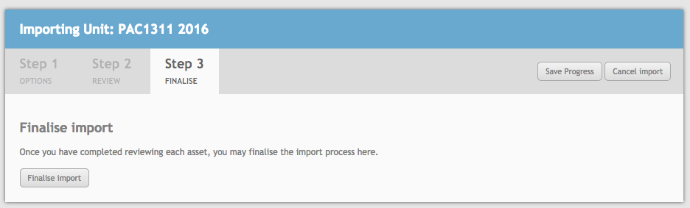
Then click on the finalise import button to complete the import.

Post-import
After the import is finalised, you are directed to the import location (if set) for the package. If no import location is set, then you will be redirected to the unit page. After import, all exercises that were imported as part of the package must be opened and resaved as they have been flagged as imported.
This is to ensure that the exercises will work correctly on the new MyDispense site. The import system does not have the same level of validation as the exercise designer. If students attempt to start an imported exercise, they will receive a message telling them that an administrator must look at the exercise first.
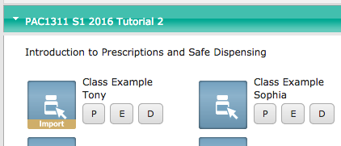
Exercises that have been flagged for import appear with a different icon. If this icon appears, then you must open and save the exercise to ensure compatibility.
The same applies to any imported assets. When opening an exercise, if it uses an asset flagged for import, a message will appear telling you that you need to open and resave that asset or replace it before continuing to load the exercise.
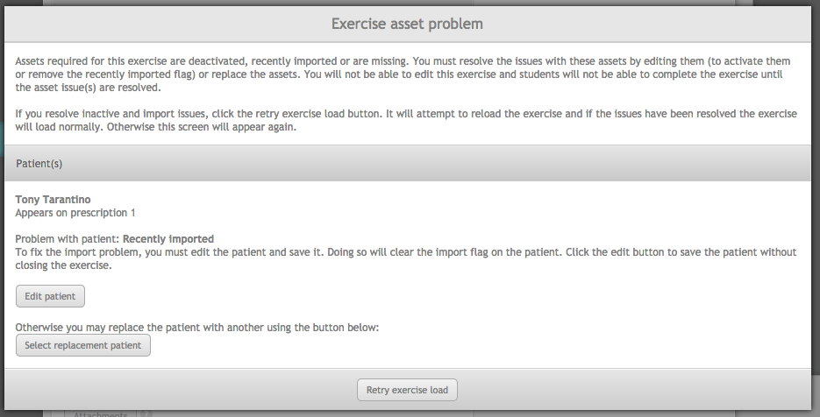
Once all imported assets have been resaved and all imported exercises resaved, importing is complete.

