Differences between basic and advanced OTC exercise modes

Basic mode is designed to allow instructors to make OTC exercises quickly by providing a broad overview of the patient’s symptoms and how the instructor would treat them. Medications are not directly compared and the feedback does not change based on student selections.

Advanced mode gives more in-depth feedback options, which change based on which medications that the student chooses to treat the patient. Feedback is set up using ‘treatment groups’ which group equivalent medications together and provide feedback to the student if one of those medications is used to treat the patient. This makes advanced feedback very flexible, but time consuming to set up.

Core differences
Basic mode | Advanced mode
Provides a general overview of the patient’s treatment | More in-depth feedback using treatment groups to give feedback on multiple groups of medications.
Does not compare medications selected by the student to medications selected by the instructor. | Compares medications selected by the student to treatment groups set by the instructor.
Feedback does not change based on student medications. | Feedback changes based on medications selected by the student. They are compared with the expected outcomes set using treatment groups.
Can not be automarked | Can be automarked
Easy to set up | Can be time consuming

Basic mode
To create an exercise with basic feedback, only three fields need to be filled out. These fields are: patient counselling feedback, wrong outcome feedback and correct outcome feedback.

Patient counselling
Feedback should contain the reason why (as if you were talking to the patient) medications should be recommended to the patient. This feedback field appears next to the student counselling notes on the feedback screen.

Wrong outcome
Feedback is displayed if the student does not recommend appropriate treatment when they finish the exercise. This feedback should explain the appropriate course of action the student should have taken.

Correct outcome
Feedback is displayed if the student recommends the appropriate outcome and should give a general overview of the exercise and how the patient should have been treated. Since medications are not being compared, correct feedback should explain what kinds of medications the student should have selected and whether any supplemental treatment could have been supplied.

Recommended medications option
Underneath the correct outcome feedback is the recommended medications option. Enabling this option adds the ability to display some medications that you would recommend in the given scenario

Even though medications are being selected, they will not be directly compared against the student’s medications and are displayed underneath the correct outcome feedback.

An additional feedback field for recommending these products must also be filled out. This will appear above the selected recommended medications and should explain why you would recommend them / or why these medications should be used.

Feedback example
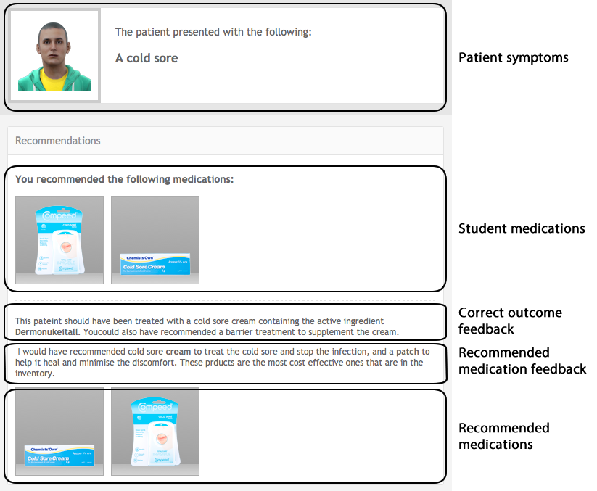

Advanced mode
The advanced mode is designed around the idea of treatment groups. A treatment group is a group of equivalent medications that could be used to treat the patient in the given circumstances. For example, a treatment group could be made up of equivalent cough medicines to treat a cough.

Treatment groups have feedback fields that are displayed based on what the student chooses. If the student recommends a medication set in the treatment group, correct feedback is displayed. Otherwise incorrect feedback is displayed for not treating that condition.

Treatment group types
There are two types of treatment groups. Required treatment groups and supplementary treatment groups. Required groups are groups of medicines that should be recommended to treat the patient properly. Thus using the cold analogy, cough medicines should be a required treatment group.

Supplementary treatment groups are extra treatments that the patient could receive but aren’t strictly necessary for a good result. For example, a supplementary treatment group could be made for a range of decongestants to go along with the cough medication.

The difference between the required and supplementary treatment groups is the feedback context. If the student does not recommend a medication from a required group that should be considered failure to treat the patient correctly. Supplementary groups aren’t required, so feedback should suggest that the patient could be given medicines for additional treatment.

Supplementary groups can be used to flesh out the exercise with more detail and are completely optional when creating an advanced mode scenario. However, at least one required treatment group must be set up.

Treatment group options
Described below are all of the options that can be set in a treatment group.

Name
Treatment group names are used to describe what the treatment group is treating. These names are not shown to students at any point and are used to identify groups in the exercise designer only.

For example, ‘Cough Medicines’ could be used for the cough medicines required treatment group and ‘Decongestants’ used for the supplementary group.

Description
Describe to the student what the products should be trying to treat. The description is displayed below the feedback given to the patient. For example ‘The patient’s cough could be treated using some of the following medicines.”

Beneficial medications
The beneficial medications in a treatment group are medications that will be benefit the patient or are the ‘correct’ medications. So long as the student selects one of these medications, the correct feedback will be displayed for this treatment group.

After selecting beneficial medications from the group, a ‘preferred’ medication out of the selection can be set for the group. The preferred medication indicates that there is a medication in the group that is most suited for the task at hand, either by the patient’s request or some other factor.

To set a preferred beneficial medication, click the preferred checkbox next to the medication in the beneficial medication list.

Harmful medications (optional)
Treatment groups have an optional set of harmful medications that can be set. Harmful medications are used to select medications that could potentially harm the patient if they were recommended. If the student selects a harmful medication, appropriate feedback is displayed. This feedback is displayed even if the student selects a beneficial medication for the treatment group, as the harm outweighs the benefit.

For example if the patient had an allergy to certain types of cough medicines, they would go in the harmful medications group. If the student recommended one of those medications, then the appropriate feedback would be displayed.

Feedback fields
Medication instructions (counselling)
The medication instructions appear in the counselling feedback section only if the student selects a beneficial medication from this group. The medication instructions have been moved inside the treatment groups because the student may not recommend medications from each treatment group in an exercise.

Thus only treatment groups that have had a beneficial medication recommended by the student will have their counselling feedback displayed, rather than displaying instructions for medications that have not been recommended properly.

Preferred medication feedback
Preferred medication feedback is displayed when the student recommends the preferred medication set in the beneficial medications list. The feedback should describe why selecting this medication over the others is a good choice for treating the patient.

If a preferred medication is not selected, this feedback field will not appear.

Beneficial medication feedback
Beneficial medication feedback is displayed when the student recommends a beneficial medication from the treatment group. The feedback should explain the reason why these medications will help the patient.

Harmful medication feedback
Harmful medication feedback is displayed if the student recommends a medication from the harmful medications list. If a harmful medication is selected, this feedback will be displayed even if the preferred or beneficial medications have been selected from the treatment group.

The feedback should explain why some of the medications are harmful to the patient and should not be recommended.

Student did not recommend a harmful or beneficial medication
The did not recommend field is catch all feedback that is displayed if the student does not recommend any of the beneficial/harmful medications set in the treatment group. The context of this feedback should be different based on whether the treatment group is required or supplemental.

If the treatment group is required, the feedback should inform the student that they failed to treat one of the primary conditions of the patient.

If the treatment group is supplementary, then the feedback should tell the student that further treatment is a possibility if they use some of these medications.

